http://www.nli.ie/1916/pdf/5.pdf

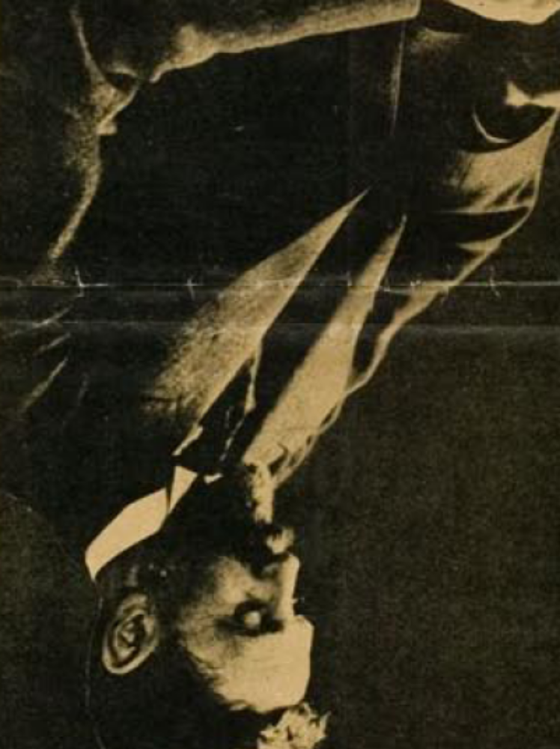

April 1915 with wing collar – same as RTE website and C4 movie pictures.



