[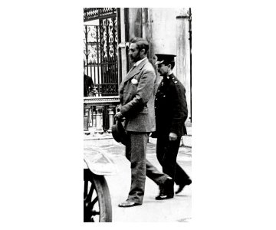](http://www.irishtimes.com/newspaper/images/2011/0411/1224294394275_1.jpg?ts=1302526494)