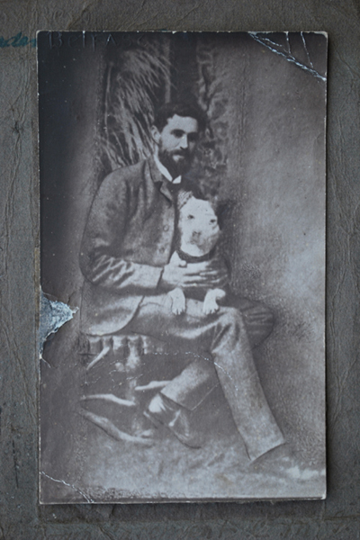
Roger Casement & Patrick Ni Houlihan

Belfast studio photograph (McCarry)
