Casement photographs discovered

Thursday, December 16, 2010
irishtimes.com
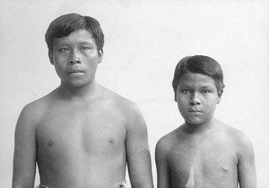
Photo of two native Amazonians who were brought to Britain in 1911 as part of efforts to highlight human rights abuses.

See also 2013 book Colombia's Forgotten Frontier: A Literary Geography of the Putumayo by Lesley Wylie
A university researcher has discovered photographic images of two native Amazonians who were brought to Britain in 1911 as part of efforts to highlight human rights abuses.
Dr Lesley Wylie, a lecturer in Latin American Studies at the University of Leicester, believes the images, which were presumed lost, are those of a man and a boy shipped to London by Irish revolutionary Roger Casement, who was hanged for treason in 1916.
Dr Wylie made the discovery among a photographic collection relating to the period of the rubber boom in Putumayo, a border region in the Amazon, held by a museum at the University of Cambridge.
The images depict the subjects naked to the waist against a pale background, in half-length front and profile shots, in accordance with the genre of anthropological photography of the time, and have been published as part of a research paper on Casement.
Casement made trips to the Amazon in 1910 and again in 1911 on behalf of the British government to investigate alleged atrocities against the indigenous population by a rubber company.
The diplomat who hoped to raise awareness of atrocities in Putumayo is known to have arranged for the two “natives” named Omarino and Ricudo to be shipped back so that he could introduce them to leading figures of the British establishment and arrange for them to be painted and photographed.
Dr Wylie, who has published the photographs in the Irish Studies Review, said:
“The photographs essentially reduce the subjects to racial “types” - the man and boy are no longer regarded as individuals but as physical specimens supposedly embodying certain racial characteristics.
“I came across the two photographs among a photographic collection held by the University of Cambridge’s Museum of Archaeology and Anthropology. Although the catalogue card identified the sitters simply as ‘Two slaves from Putomayo (sic) river, Up. Amazon, Colombia’, I suspected immediately that they were the two Amazonians that Casement had brought to London in 1911."
“I had previously seen a copy of William Rothenstein’s painting of the subjects, and there was a strong resemblance between it and the photographs."
“Although Casement mentions the existence of these photographs in his personal correspondence, scholars had assumed up to now that these images had been lost,” he said.
PA

Discovered after a century, the lost pictures of Amazonian tribesmen shipped to Britain
By Daily Mail Reporter
16th December 2010
- Comments (6)
They were brought to Britain almost 100 years ago to highlight human rights abuses in the Amazon rainforest.
The man and boy were shipped from their homeland in a bid to show officials how the boom in rubber production had affected tribesmen.
Now pictures of the pair which were thought to be lost after their 1911 visit have emerged.

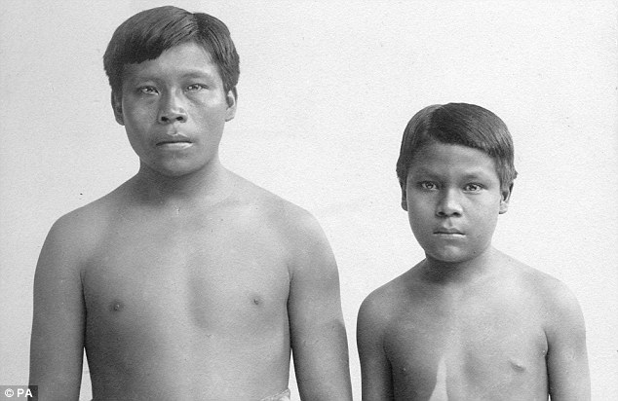
Tribesmen: The man and boy, known as Omarino and Ricudo, were brought to Britain in 1911
Dr Lesley Wylie, a lecturer in Latin American Studies at the University of Leicester, believes the images are those of a man and a boy shipped to London by Irish revolutionary Roger Casement, who was hanged for treason in 1916.
In 1903 Casement, then a British consul in the Congo, produced a famous report on human rights abuses in the country which was then part of King Leopold of Belgium's personal empire.
The Casement Report led to the state taking control of the Congo Free State from Leopold.
Dr Wylie made the discovery among a photographic collection relating to the period of the rubber boom in Putumayo - a border region in the Amazon - held by a museum at the University of Cambridge.
The images depict the subjects naked to the waist against a pale background, in half-length front and profile shots, in accordance with the genre of anthropological photography of the time, and have been published as part of a research paper on Casement.
Casement made trips to the Amazon in 1910 and again in 1911 on behalf of the British government to investigate alleged atrocities against the indigenous population by a rubber company.
The diplomat - who hoped to raise awareness of atrocities in Putumayo - is known to have arranged for the two 'natives' - named Omarino and Ricudo - to be shipped back so that he could introduce them to leading figures of the British establishment and arrange for them to be painted and photographed.
Dr Wylie, who has published the photographs in the Irish Studies Review, said: 'The photographs essentially reduce the subjects to racial "types" - the man and boy are no longer regarded as individuals but as physical specimens supposedly embodying certain racial characteristics.
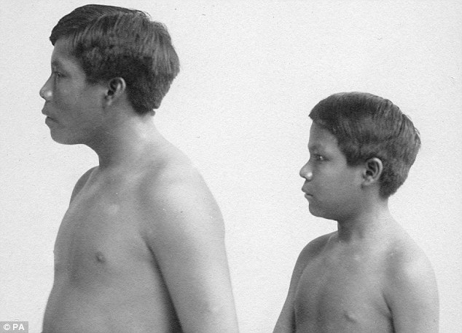
Human rights: The pair were brought to be studied and to highlight the impact of a rubber boom near their Amazonian home
'I came across the two photographs among a photographic collection held by the University of Cambridge's Museum of Archaeology and Anthropology.
'Although the catalogue card identified the sitters simply as "Two slaves from Putomayo (sic) river, Up. Amazon, Colombia", I suspected immediately that they were the two Amazonians that Casement had brought to London in 1911.
'I had previously seen a copy of William Rothenstein's painting of the subjects, and there was a strong resemblance between it and the photographs.
'Although Casement mentions the existence of these photographs in his personal correspondence, scholars had assumed up to now that these images had been lost.'
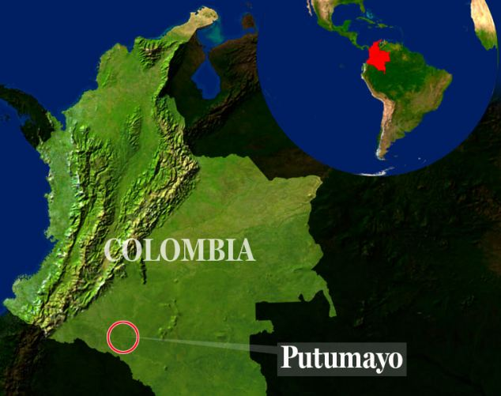

ROGER CASEMENT: REVOLUTIONARY, IRISH NATIONALIST AND ACTIVIST 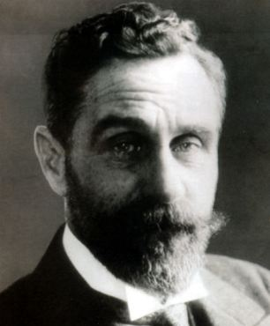
Roger Casement was hanged for treason aged 51
Roger Casement was an Irish nationalist who worked as a British consul before being hanged for treason after his involvement with the Germans before Ireland's Easter uprising in 1916.
He rose to prominence after the British government asked him to investigate human rights abuses in the Congo in 1903. His findings, published in the Casement Report, led to the Belgian government taking control of the country away from then King Leopold who had stripped the country of much of its natural resources.
Casement retired from the consular service in the summer of 1913 to concentrate on Irish politics. He formed the Irish Volunteers but it was his meetings with the German's during World War One that led to his downfall.
He met with top German officials to plan a revolution against the English leaving the army stretched while also fighting in mainland Europe.
But three days before the rising he was arrested and charged with treason, sabotage and espionage against the Crown. He was imprisoned in the Tower of London.
He was found guilty and hanged at Pentonville prison on August 3, 1916 aged 51.
Read more: http://www.dailymail.co.uk/news/article-1339057/Discovered-century-lost-pictures-Amazonian-tribesmen-shipped-Britain.html#ixzz18IAzOAvS
[Casement brought the boys home to Peru and they became servants to the British consul in Iquitos. But they wanted to go back to the forest. His wife, Mrs Michell, later wrote:
"About Ricudo and Omo, I was very sorry to leave Iquitos without knowing their whereabouts. I tried again and again to find out where they had gone but unsuccessfully, except for a report from a Spanish woman in the Arica who said Omo had gone away on a launch as he was bent upon getting to the Putumayo. When we moved to the Cazes’ flat, Ricudo and his wife seemed very pleased with the change and quite happy and we thought would perhaps stay especially as the Captain of Arana’s Company’s steamer refused to take them – but Ricudo hated work and said he was “tired of it” and must get away to the woods! We could not think where they had gone and never saw them after they left us. I knew you would be disappointed but it was inevitable.”]

