**NATIONAL PORTRAIT GALLERY – WILLIAM ROTHENSTEIN PORTRAITS OF CASEMENT**

Portrait - NPG 3867a

Top of Form

Bottom of Form

# Roger David Casement

1 portrait

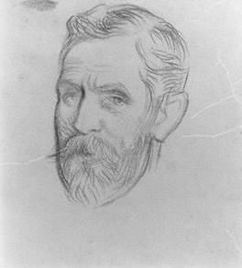

© estate of Sir William Rothenstein / National Portrait Gallery, London

* [Larger Image](http://www.npg.org.uk/collections/search/largerimage.php?mkey=mw01134)
* [Buy a print of this image](http://www.npg.org.uk/collections/search/getPrint.php?npgNo=NPG+3867a&title=Roger+David+Casement&option=0)

Roger David Casement

by Sir William Rothenstein  
pencil, 1911  
11 1/4 in. x 7 7/8 in. (286 mm x 200 mm)  
Given by Rothenstein Memorial Trust, 1953  
[Primary Collection](http://www.npg.org.uk/primcoll.asp)  
NPG 3867a

Sitter

[Roger David Casement](http://www.npg.org.uk/collections/search/person/mp00790/roger-david-casement) (1864-1916), Irish rebel. Sitter in 2 portraits.

Artist

[Sir William Rothenstein](http://www.npg.org.uk/collections/search/person/mp03885/sir-william-rothenstein?role=art) (1872-1945), Artist and teacher of art. Artist associated with 205 portraits, Sitter in 23 portraits.

This Portrait - Probably drawn when Casement took two of the indigenous inhabitants of the Putumayo to Rothenstein (c. 1911) to have their portrait painted. He had brought them to London with the intention of highlighting their plight. It was on this visit to London that Casement accepted a knighthood, offered in recognition of his work in exposing the atrocities carried out by the the rubber companies of the Putamayo in the Upper Amazon Basin.

Related Works

[NPG 3867](http://www.npg.org.uk/collections/search/portrait/mw01133/Roger-David-Casement): Roger David Casement (variant)

