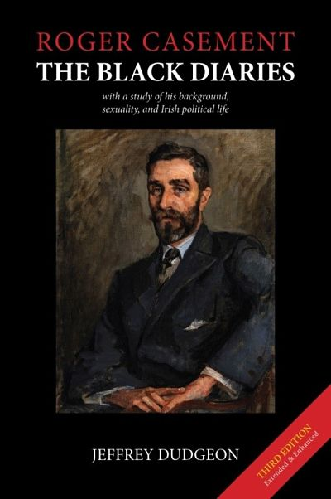

https://amzn.to/2uJCY6r
Amazon - paperback £26.00; $35.00; €31.00.
Kindle £8.25; $10.00; €9.00

The 3rd edition of Roger Casement: The Black Diaries – with a Study of his Background, Sexuality, and Irish Political Life (2019) by Jeffrey Dudgeon is published by Belfast Press in paperback (and Kindle) versions. 802pp. ISBN 978-1-9160194-0-9

In this, further extended and enhanced, edition, with many more photographs, all Roger Casement’s Black Diaries are again published together including, uniquely, a full version of the erotically-charged 1911 Diary over which London threatened an obscenity prosecution. The 1910 diary is also now published unabridged and the 1903 diary here considerably lengthened.
The volume provides both a comprehensive text of the diaries, with explanations for their cast of characters, famous, infamous, and fleeting, and a context for the author whose significance and seminal role in the political development of independent Ireland has been masked by the debates over authenticity. This remains a uniquely original look at the Irish patriot and humanitarian, hanged in 1916 for treason. It was the same Casement whose reports in 1904 and 1912 on rubber slavery and genocide in King Leopold’s Congo and the Peruvian Amazon, reflected in his diaries, which shocked the world.
The book also deals with the neglected sides of Casement’s life, his involvement in Ulster and Irish politics, his family background in Co. Antrim, his Belfast boyfriend Millar Gordon, and new discoveries about his sociopathic companion, the Norwegian sailor Adler Christensen. There is as well a comprehensive account of the authenticity controversies, Casement’s homosexuality, and his time in Africa and South America. Roger Casement had iconic status in life and, after death, was sanctified and vilified in equal measure.
His real self was thus obscured. This paperback edition combines a rigorous academic study of the public and political Casement (with over 1,200 references and an extensive bibliography updated to 2019), alongside an account of his personal life, sexuality, and consular career, and an informed view of how they all interlocked and originated. It also provides an analysis of his early and key role in the Irish separatist movement, and a full exposition of the controversies that have swirled around him to this day, including attempts made in Dublin to threaten the truth about the Black Diaries.
"No Roger Casement – No Easter Rising": Casement commissioned the first arms for the IRA in 1914 and again in 1916 while from 1904 he tutored many of the key personnel who by 1921 had obtained a separate Irish state. To know about Roger Casement is to know why Ireland achieved independence and why Ulster stayed separate, remaining for the next century in the UK. This volume provides an insight into the political conflict in the north and suggests how it could be diminished by both learning and respecting each other’s stories.

About the author:
Jeffrey Dudgeon was born in Belfast, educated locally and at Trinity College, Dublin. In 1981, he was the winning plaintiff at the European Court of Human Rights in a suit against the UK. This resulted in the decriminalisation of male homosexuality in Northern Ireland in 1982. For many years a civil servant in Stormont’s health department, he was, from 1995-8, parliamentary adviser to the UK Unionist MP for North Down. For the following two years, he was engaged in researching this book, first published in 2002 in hardback. Awarded an MBE in the 2012 New Year’s Honours List for services to the LGBT community, he was in 2013 one of two Ulster Unionist Party representatives at the Haass Talks.
In 2014, he was elected as an Ulster Unionist to Belfast City Council for the Balmoral DEA (but lost his seat to the DUP in 2019). A 2nd paperback edition (725pp) and the unabridged Roger Casement’s German Diary 1914-1916 both appeared in 2016. He published Montgomery Hyde Ulster Unionist MP, Gay Law Reform Campaigner and Prodigious Author and another work on Legacy issues in 2018.
New documentation on Casement, has been uncovered, much of it detailed in this 3rd edition, adding to our understanding of his life and times.
Jeff Dudgeon continues to speak on Casement and the diaries addressing a new and energetic campaign disputing their authenticity.

Contact details: jeffreydudgeon@hotmail.com Tel. 079 2125 1874 or 028 90664111

