THE BLANK CANVAS OF ROGER CASEMENT’S LIFE
Separate exhibitions highlight the complexities and ambiguities of Casement and explore the many identities that have been thrust upon him
Aidan Dunne
Irish Times
9 June 2016
Aidan Dunne
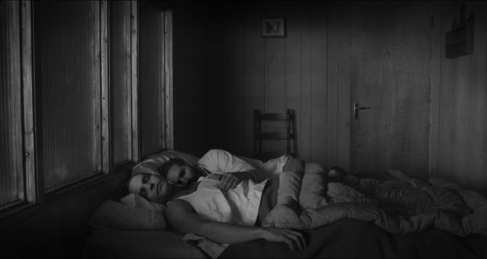
A still from Our Kind by Alan Phelan
- 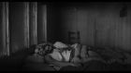
- 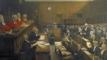
- 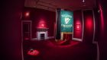
John Lavery’s High Treason: The Appeal of Roger Casement. The Court of Criminal Appeal, 17 and 18 July 1916 is monumental in scale. It is an extraordinary work and a significant historical document.
Lavery, who died in 1941, bequeathed it to the National Portrait Gallery in London, which declined the offer, and the Royal Courts of Justice, which grudgingly took it. Not surprisingly, perhaps, it was passed on “indefinite loan” to King’s Inns in Dublin in 1951, where it has remained since.
Currently, however, you can see it at the Hugh Lane Gallery as the centrepiece of an exhibition, together with Lavery’s much smaller – but livelier and more intense – oil study, which forms part of the permanent collection.
Here was Lavery, an Ulster Catholic, observing the trial for treason of a knighted Ulster Protestant, at the very heart of the empire. More, Lavery was the establishment portrait painter of choice – he was himself knighted in January 1918 – and he knew virtually everyone who counted in society. One of his sitters, Charles Darling, was the presiding judge, and Lavery said it was he who invited him to attend the appeal as an artistic observer. It’s unlikely that Darling anticipated the scale and nature of the work that emerged.
Lavery handles the scene in the manner of a formal record of a ceremonial occasion. Such paintings usually have an agenda of reassurance and aim to bolster the legitimacy of the ruling order: Darling imagined himself in a starring role. But viewing proceedings from the vacant jury box, Lavery places the hapless Casement at the centre of his composition, in the dock beneath a clock ticking towards high noon.
His confinement is emphasised by the way Lavery renders the structure and panelling of the courtroom as a series of enclosing, interconnected grids and boxes. Casement’s counsel, AM Sullivan, addresses the bench, where a row of red-robed judges is pressed in a foreshortened mass.

Dismaying spectacle

Lavery could have chosen to ignore Casement’s plight. His livelihood depended in no small measure on acceptance by the class who were set on destroying Casement’s reputation and putting him to death. He was publicly criticised for taking the appeal as a subject. To his great credit, rather than looking away, he throws into high relief the dismaying spectacle of a privileged elite, inflated with self- importance, flattering itself as a civilised institution, but all the while intent on eliminating an inconvenient subject as quickly as possible. We are left in no doubt that there is self-serving cruelty at the heart of the pomposity.

A peripheral role

Casement’s role in the 1916 Rising was in the event peripheral (he knew the arms he had been given by the Germans were inadequate, and was ill with malaria when he was arrested), but for many other reasons he remains a person of profound fascination, among writers and artists as much as historians. He was a pioneering humanitarian knighted for his work in detailing the brutality of King Leopold’s colonial regime in Congo, and the comparable excesses of cruelty in the rubber trade in Peru. He was also pro-German and a militant Irish nationalist. It’s hard to overestimate the importance of his humanitarian work. His detailed, exhaustive reports gave voice to those who were never heard: the abused and enslaved.
Different factions draw from the complex layers of his history and character a Casement who suits their own preferences and prejudices, from nationalist saint to treasonous sinner.
Nowhere is this more evident than in the long, fierce debate over the authenticity of the Black Diaries, used by the British to discredit him among his supporters but rejected by many, including creditable historians, as forgeries. Forensic analysis comes down on the side of authenticity – but even now, not everyone accepts that conclusion. In his fictionalised account of Casement’s life, The Dream of the Celt, Mario Vargas Llosa plausibly suggests that the diaries are partly fictional, recording sexual fantasies as well as sexual facts.
The extremes of Casement’s life have a cinematic sweep, and both Alan Phelan and Simon Fujiwara respond cinematically. It’s not so much the drama per se as Casement’s ambiguity that ultimately appeals to artists and writers. Phelan imagines a future for Casement had he not been hanged. Fujiwara pitches him as the subject of a Hollywood biopic, The Humanizer. Whereas Phelan presents us with an actual film to watch, Fujiwara works around the idea of a film that never was – tentative moves in the 1930s fizzled out – with a darkened gallery decorated like a cinema interior, fragments of a film soundtrack and a series of museum-like rooms with objects and documents on display.
The script we hear in snatches was shaped by Michael Lesslie to echo current Hollywood imperatives. The materials on view are either from the prop shop or facsimiles crafted by movie professionals: an allusion to the controversy over the authorship of the Black Diaries? Probably not. The absence at the heart of Fujiwara’s installation is, of course, Casement. Instead we have a sketch of a fictionalised representation. That may be Fujiwara’s point, but it’s frustrating that, despite the resources expended, the work doesn’t become more than the sum of its parts.
Phelan’s Our Kind multiplies the ambiguities. He proposes an exiled Casement living quietly in a secluded cabin in Norway under German occupation in 1941. His partner is Eivind Adler Christensen, who was his valet and may in real life – though he denied it – have betrayed him. They are visited by Alice Stopford Green, who first interested him in the nationalist cause.
A series of disconnected scenes ensues. The characters are at cross-purposes throughout. Historical inaccuracies and temporal discrepancies are casually deployed. Although it refers to the conventions of film narrative, and even throws in a visual quotation from A Streetcar Named Desire, Our Kind works actively against narrative cohesion.

Curiously hypnotic

Phelan’s Casement, evasive and noncommittal, seems worn out by the burden of the many identities that have been thrust upon him “as representative of Irish nationalism, gay liberation, revolutionary fervour, postcolonial guilt, etc”, or “victim, revolutionary, naïf, radical or traitor”, as enumerated by Chris Clarke in an accompanying essay. Yet in presenting us with a fractured, contradictory structure, peopled with equally inconsistent characters, Phelan manages to convey a sense of Casement’s identity as enduringly complex and elusive behind the many representations we have of him, and the film is curiously hypnotic. It’s also visually ravishing: Norway looks stunning in black and white.
Casement’s defence counsel, Sullivan, was Irish, and he retired to Ireland. It was he who ensured that Lavery’s painting went to King’s Inns, but he came to grief when he mentioned to a journalist that Casement had confirmed to him his homosexuality, and pointed out that he was but one among numerous others.
Battered by a storm of outrage in religiously conservative 1950s Ireland, Sullivan retreated. He had already alarmed observers with the vague suggestion that Casement’s sexuality was perhaps linked to his unorthodox political views. That was a subversive thought too far.

High Treason: Roger Casement; John Lavery’s monumental painting and related works from the collection; and Our Kind: a 30-minute film by Alan Phelan, is at Dublin City Gallery, the Hugh Lane, Dublin Until October 2nd, hughlane.ie

The Humanizer by Simon Fujiwara is at Imma, Dublin, until August 28th. imma.ie

