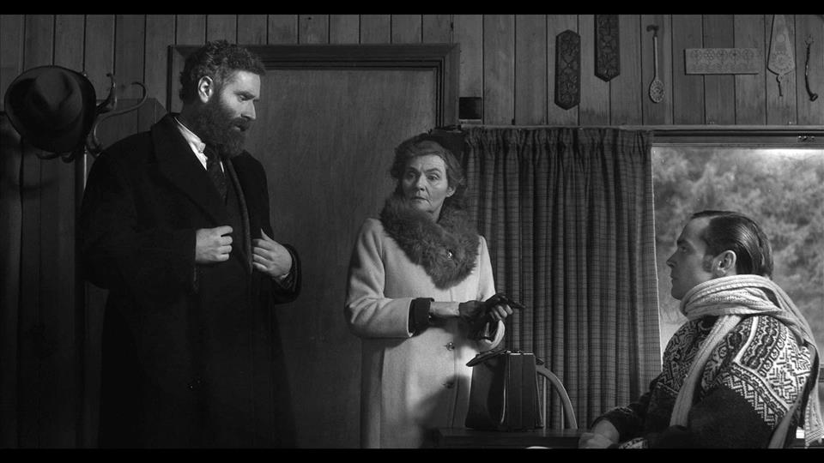
'Our Kind', a new film by Alan Phelan, The Hugh Lane, Wednesday, from 9 March 2016
in Dublin City Gallery The Hugh Lane, Charlemont House, Parnell Square North
Dublin D01 F2X9.

The exhibition runs until Saturday, 2 October 2016.
For more information see:
http://www.alanphelan.com/ourkind/index.htm
http://www.hughlane.ie/forthcoming/1442-alanphelanourkind
http://www.hughlane.ie/forthcoming/1440-hightreasonrogercasement

Our Kind is a new film and installation by Alan Phelan. The works are concerned with the legacy of Roger Casement who was one of the leaders of the rebellion in 1916 in Ireland against British rule known as the Easter Rising. He was executed in August 1916 several months after the other fifteen leaders. Despite the failure of the rebellion it did set in motion events that led to the Republic and is commemorated this year.
This project seeks to circumvent usual commemoration tactics by fictionalising alternatives and shifting timelines while navigating historical and revisionist assessments of Casement. Recent writing contrast him as a naive nationalist or flawed gay icon; an imperialist champion of human rights or self-accepting humanitarian. The history of Roger Casement is much contested and filled with many of the contradictions that surround the entire 1916 commemoration itself.
Dublin City Gallery The Hugh Lane commissioned Phelan in response to the concurrent exhibition which also opens on 9 March High Treason: Roger Casement which is centred on the Sir John Lavery monumental painting depicting the last day of the appeal trial against the sentence of death for treason before five judges of the Court of Criminal Appeal in London. What was essentially a show trial nevertheless produced several complex legal arguments, an iconic conviction speech by the defendant and fall from grace that was kept secret for decades after.
The 30 minute film Our Kind imagines a future for Roger Casement had he not been executed in 1916. It is set twenty-five years later in 1941, where Casement is in exile in Norway with his former manservant and now partner Adler Christensen. They are visited by Alice Stopford Green, a close friend and supporter of Casement. The story unfolds as Adler and Alice both betray their relationships with him, paralleling the isolation of Casement from his homeland, beliefs and the ideals of the Rising.
The film is counterfactual but reflects the subjectivity common in the genre of historical drama for film or indeed any historical interpretation. Much of the scholarship surrounding Casement is similarly muddled with subjective romanticism, political prejudices and, even still, an inverted homophobia that cannot come to terms with the personal and public lives of Casement. Several of these angles are woven into the story albeit mis-represented, unexplained and ambiguous.

Our Kind gets its title from the iconic speech Casement made on his conviction, and extracts of this speech are used in the film and adjacent installation. Similarly, the dialogue re-narrativises the English subtitles from a German film, which like other recent work by Phelan, is not openly credited here. Instead the re-staging of the text and dialogue drawn from these sources creates a whole new story. This allows the work to embrace a complex history and presents a challenge to audiences who need to be read between the lines to understand how fact and fiction have merged. For the artist, his better reflects the possible unforeseen consequences of the Rising rather than re-creating or re-enacting an idea of what that history was, or is believed to have been.
The film embraces the apparatus of cinema with art direction based on 1940s melodrama and the beautifully composed camerawork of Luca Rocchini. Noted Irish actors Bryan Quinn and Gina Moxley are joined by Italian, Aran Benetto, who perform these stories in static monochrome scenes which are also indebted to the background of Phelan in photography. The film was shot on location in Lough Dan, Co Wicklow and Hardanger Fjord, Norway.
The other works in adjacent gallery attest to the real Casement but again are highly subjective. Extracts from his private, so called, Black Diaries, are presented as white on white wall text. This simple act reveals yet conceals, using full unedited daily entries from published sources. Some of the extracts used here were circulated by the British government during the appeal trial and resulted in the loss of public support for Casement. A further vitrine work touches on the humanitarian yet colonial and imperialist aspects of his career. The piece is a portrait of the two native Indians from Putamayo in Peru who were brought briefly to Britain by Casement in 1910. They are represented here by the items for which they were exchanged or purchased, rather than the photographs or painting made of them during their stay.

A specially commissioned essay titled One of Our Kind by Chris Clarke, Senior Curator at the Lewis Glucksman Gallery, Cork, is published in the catalogue for High Treason: Roger Casement along with texts by Tacita Dean, Charles Esche, Sinead McCoole and others.
Our Kind was commissioned by Dublin City Gallery The Hugh Lane / An Hugh Lane Danlann Chathair Bhaile Atha Cliath.
Funded and supported by Dublin City Gallery The Hugh Lane / An Hugh Lane Danlann Chathair Bhaile Atha Cliath; The Arts Council / An Chomhairle Ealaion; Department of Arts, Heritage and The Gaeltacht; 1916-2016 Centenary Programme; An Roinn Ealaion, Oidhreachta agus Gaeltachta / Clar Comortha Cead Bliain; Bank of Ireland; and Fire Station Artists Studios.
Alan Phelan was born in Dublin, and studied at Dublin City University and Rochester Institute of Technology, New York. Recent exhibitions include Videonale.15, 2015, Bonn Kunstmuseum; Fragments, 2015, IMMA, Dublin; but what end?, 2014, Golden Thread Gallery, Belfast; if you aren't all mine, 2014, Detroit Stockholm, Stockholm; Mammoth, 2014, Treignac Projet, Treignac; Handjob, 2013, Oonagh Young Gallery, Dublin; False Memory Synrdrome, 2013, Temple Bar Gallery + Studios, Dublin; Changing States: Contemporary Irish Art & The Francis Bacon Studio, 2013, Bozar, Brussels. His work is included in the collections of the Irish Museum of Modern Art, Limerick City Gallery of Art, The National Self-Portrait Collection, the Office of Public Works and several private collections.

