'One Bold Deed of Open Treason': The Berlin Diary of Roger Casement 1914-1916 Paperback – 14 Mar 2016
by Angus Mitchell (Author)

Spelt Mitchel on cover!

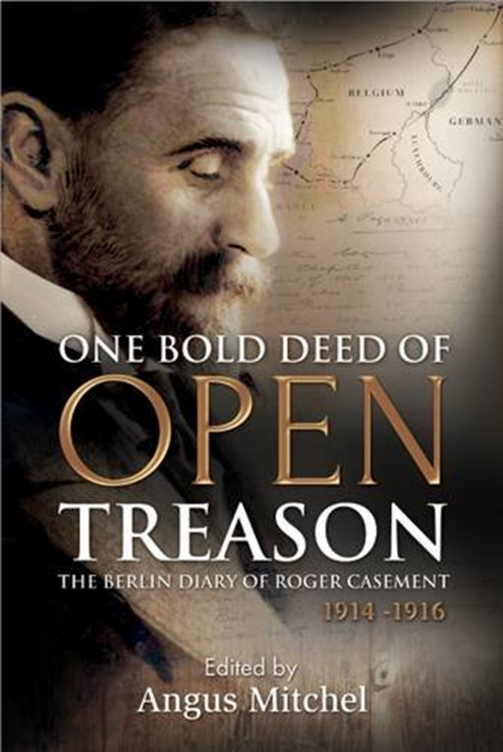
See all formats and editions
- Hardcover
£65.00 1 New from £65.00
- Paperback
£16.99 1 New from £16.99
Paperback: 288 pages
Publisher: Merrion Press (29 Feb. 2016)
ISBN-10: 1785370561
ISBN-13: 978-1785370564

About the Author
Angus Mitchell is a historian and cultural critic, who has spent the last twenty years investigating the life and legacy of the British consul and Irish nationalist intellectual, Roger Casement, and publishing widely on this subject. He is based in the Kemmy Business School at the University of Limerick.

'One Bold Deed of Open Treason' describes the astonishing journey by Roger Casement to Germany in 1914, via USA and Norway, to secure support from the German government for the Irish Volunteer's military plan against the British, and to recruit an Irish Brigade from the 2,000 Irish prisoners-of-war taken in the early months of the war. Through his vivid and gripping diary entries - that read like a spy novel and reveal the motives behind his pivotal role in the Easter Rising - his mission to seek arms and ammunition from Germany was to be the deciding factor in the outcome of the Irish insurrection. Casement's story is an essential component in understanding the European context of the Rising and the reference to 'our gallant allies in Europe' within the Proclamation of the Republic. A prolific diarist, Casement recorded his daily movements and efforts to complete his mission and ultimately return to Ireland with enough guns and ammunition for the planned Rising; but in a terrible irony, his diary was to seal his fate following his capture on the sands of Banna Strand in North Kerry in April 1916, on board the Aud Norge with a cargo of rifles, machine guns and ammunition. With an expert editorial hand, Angus Mitchell provides clear context to Casement's diaries, also revealing his gruelling visit to the Western Front, the shocking interplay between the Easter Rising and the international theatre of the First World War, and the grand, self-destructive conclusion of an unremitting life.

