Casement letters
Kieran
You have transposed the document photographs in your catalogue between lots 146 and 147 which will confuse potential buyers.
The 'Pat' referred to as at Tara in lot 147 was Pat Wilkinson as you will gather from the two Casement diary extracts below.
If you want future help at identifying Casement material I am happy to help.
Best wishes
Jeff Dudgeon (Author of 'Roger Casement: The Black Diaries - With a Study of his Background, Sexuality, and Irish Political Life')
Casement diary entries relating to Pat Wilkinson of Tara and his family:

22 May 1910 [Sunday] At Tara – with Harrie & family. [Harriette Wilkinson’s family house, not that of John Harris of the Anti-Slavery Society, as has been proposed. It had been a port of call for Casements as far back as the 1880s. A young man, Pat Wilkinson, presumably a son of the family was an irreverent correspondent from Quebec in 1913: Casement had introduced him to Count Markievicz whom he had frequently met thereafter, remarking of him in his letter “my admiration has always been divided between his rival capacities for childlike enthusiasm and for the wine of the country.”]

Monday 7th August 1911 In Dublin…Beggar 4d. Harrie & Annie Trams to Zoo 1/-. Entrance 1/-. To lion keeper Flood 2/-. To Rotunda Irish Pageant 3/-. Whiskey 6d. Harrie and Annie back at 6 to Baronstown. [Harriette Wilkinson née Dickey or Dickie, from Co Antrim, and her sister lived at a house named Tara in Baronstown, Co. Louth, which Casement visited in 1898, for the first time in over eight years, as he wrote. They were old family friends about whom Nina was naively concerned when, after the events of 1916, they failed to answer her letters from America.] I to meet enormous at 9. Will suck and take too. He was not there! I waited till 9.30. No sign. To H. Bwait [?Herbert ?Place] & Park. None…

From: kieran@adams.ie
To: jeffreydudgeon@hotmail.com
Date: Mon, 31 Mar 2014 22:46:08 +1100
Subject: 800 Years Irish Political, Literary & Military History - Catalogue Now Online
Whyte’s sale 15 April 2014

Photographs wrong way round

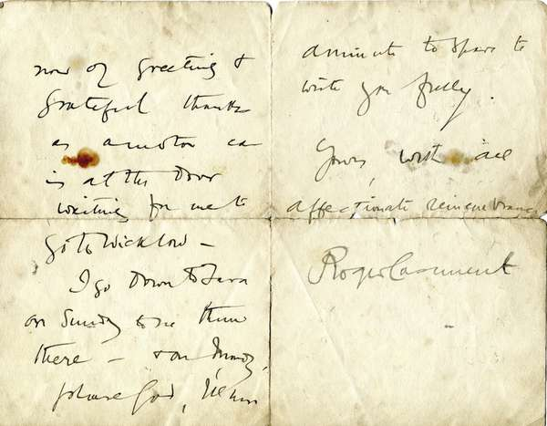
Enlarge
LOT :146
Estimate EUR : €1,500.00 - €2,500.00
Auction Date : 15-04-2014

Description
CASEMENT, Roger. An autographed letter signed in Irish, from the patriot Roger Casement to an unknown correspondent ''By the way Mrs. O'Neill of Dundalk gave £5 towards the Hall ... let it be as follows: Mrs. O'Neill, Dundalk £5 ... R.C. Ruaíri Mac Asmund £20''. He discusses the money he sent to Fr. Murray for the school prizes in Cloughaneely and Gweedore ''that the prizes will be of great stimulus this coming year to the children and teachers & the schools of the two Irish Speaking parishes ... tell old Canon McFadden (of Gweedore) that I often think of him ... Mise do cara Ruaíri Mac Asmund''. Undated, circa 1907, on Consulate of Great Britain and Ireland, Santos, Brazil headed paper. Three pages octavo, folded with crease marks. An interesting letter.

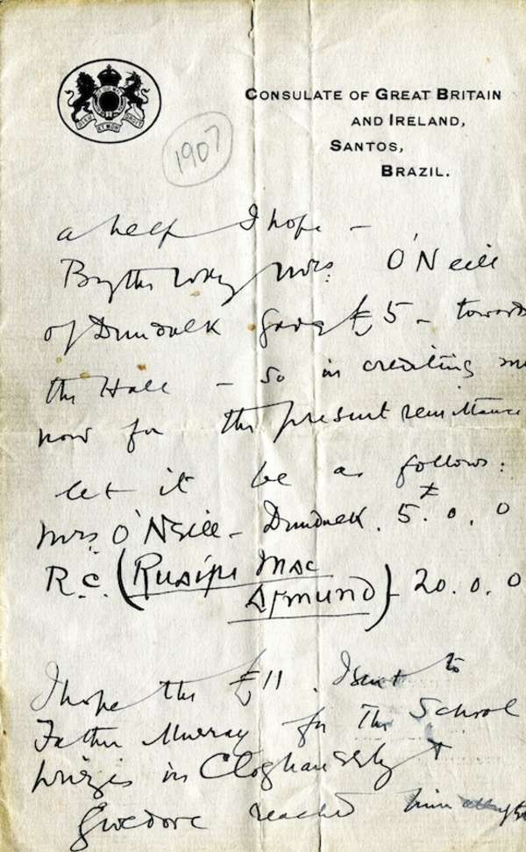
Enlarge
LOT :147
Estimate EUR : €1,500.00 - €2,500.00
Auction Date : 15-04-2014

Description
CASEMENT, Roger. An autographed letter signed, from the patriot Roger Casement to ''My dear, darling old Pat''. An interesting, but hurried letter to an unknown correspondent stating that there is a motor car waiting at the door to take him to Wicklow, and ''I go down to Tara on Sunday to see them there - & on Monday, please God, I'll have a minute to spare to write you freely. Yours, With all affectionate reminiscences, Roger Casement''. Three pages octavo, folded. Written at 55, Lower Baggot Street, Dublin, dated 20th June, 1913. Slightly soiled and with torn crease marks. Of the utmost rarity.

Casement diary entries relating to Pat Wilkinson of Tara and his family:

