'One of the more intriguing personalities' - executed 1916 Rising leader Roger Casement honoured at Glasnevin Cemetery

Robin Schiller
Published 03/08/2016 | 13:16
- 1 Comments
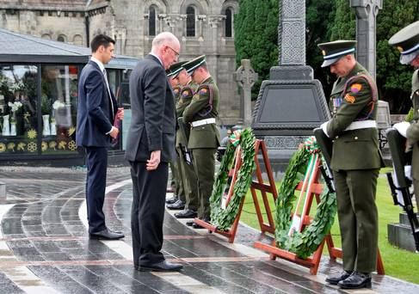
Niall Casement, a relative of Roger Casement and Charlie Flanagan TD Minister for Foreign Affairs and Trade pictured placing a wreath this morning at Glasnevin Cemetery at a commemoration ceremony and unveiling of a plaque on the one hundreth anniversary of the execution of Roger Casement at Pentonville Prison
A commemorative ceremony was held in Glasnevin Cemetery this morning for the last executed leader of the 1916 Rising.
Roger Casement (51) was killed 100 years ago today after being found guilty of treason in a British court. He was hanged at Pentonville Prison in London, with his remains only being repatriated back to Ireland in 1965.
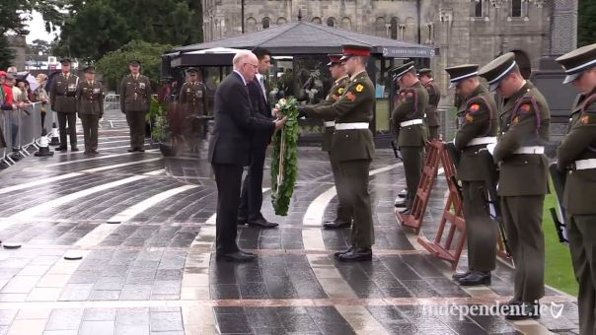
The event was attended by Foreign Affairs Minister Charlie Flanagan and Niall Casement, a relative of the Easter Rising leader. The ceremony included a wreath-laying service with a Military colour party followed by a minute silence to commemorate Casement.
A reading of the trial documents relation to the plea from the accused were also read out with a priest from the Irish Prison Chaplaincy Service in the UK also in attendance to recite a prayer.
Minister Flanagan described Casement as “one of the more intriguing personalities” involved in the 1916 Rising.
“His work to expose cruelty and abuse in Africa secured his legacy as one of the great Irish humanitarians of the early 20th Century, and his commitment is reflected in Irelands strong standing involvement with UN peacekeeping missions and out strong commitment to overseas development,” Mr Flanagan said.
“I am pleased to represent the Government here today as, together with members of his family, we remember Casement’s life and idealism and reflect on his legacy,” he added.

Britain refuses to hand over the 'Black Diaries'
Irish Independent
3 August 2016
- 5 Comments
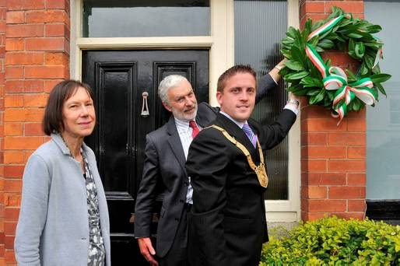2
Dr Anne Casement, Patrick Casement and Cllr Cormac Devlin at Doyles Cottage as Dún Laoghaire-Rathdown County Council announces a Roger Casement statue commission. Photo: Maura Hickey
The British government has refused to hand over the Roger Casement diaries to Ireland after Dublin City Council petitioned ex-prime minister David Cameron for them.
Five journals, known as the 'Black Diaries', which alleged he was a homosexual man, are kept in the UK Public Records Office in Surrey.
2 Irish patriot Roger Casement. Photo by Central Press/Getty Images
The council wrote a letter asking for the diaries to be donated to Ireland but Jeff James, the Keeper of Public Records, replied saying said that the diaries are the property of the UK.
Casement was hanged for treason in London 100 years ago today age 51, following a failed attempt to land German weapons, intended for use during the Easter Rising, at Banna Strand in Kerry.
His relatives, Patrick Casement and his wife Dr Anne Casement, travelled from their Co Antrim home to view plans for a statue in his honour in Sandycove, Co Dublin.
Events in Dublin to mark Casement's centenary today include an exhibition at Collins Barracks museum, a wreath-laying ceremony at Glasnevin, where he is buried, and an open day at Casement Aerodrome in Baldonnel, Co Dublin.
Irish Independent

