PSNI rejects plea to lend Dublin dead rebel's pistol for Easter Rising exhibition
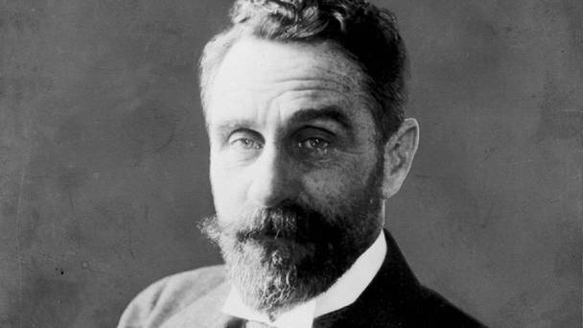
Roger Casement was executed for treason in 1916

Belfast Telegraph
By David Young 19 November 2014

The PSNI museum is under fire for refusing to lend out a pistol belonging to British knight turned Irish rebel, Roger Casement, for an exhibition ahead of the 1916 Easter Rising.
The gun owned by Casement, who was executed for treason in the wake of the failed uprising in Dublin almost 100 years ago, is held by the police museum in Belfast.
The former British diplomat who joined the fight for Irish independence was arrested in Co Kerry in April 1916 after disembarking a German U-boat following an ill-fated gun-running mission.
He was found guilty of treason and stripped of his knighthood before he was hanged in London's Pentonville prison in August 1916.
Sinn Fein Assembly member and Casement enthusiast Oliver McMullan had asked the PSNI museum to lend out the pistol so it could be incorporated into displays in Dublin marking the significant anniversary in 18 months.
But the museum authorities have told him it cannot leave.
In a letter, the museum cited rules that "prohibit artefacts being transferred outside of the UK".
It added: "The weapon has also not been deactivated and is held on the museum's firearms licence and therefore has to remain in police custody."
Mr McMullan suggested that deactivating the artefact would not be difficult. He continued: "Art museums around the world exchange valuable collections and the PSNI is telling us they can't lend a weapon down to Dublin?"
Mr McMullan said his grandfather Daniel, a tailor in Cushendall, Co Antrim, was a great friend of Casement.
The East Antrim MLA said the pistol would be a "pivotal exhibit" in any collection marking the rising. "Roger Casement played a key role in the events surrounding the 1916 Easter Rising and that role will be commemorated during the upcoming centenary," he said.
Mr McMullan added: "I am calling on the PSNI museum to review this decision and allow this important piece of our history to be included in the 1916 centenary celebrations."
A PSNI spokesman said: "The Police Historical Society is unable to accede to this request as the pistol is not deactivated and is therefore held on a firearms certificate."
Born in Dublin and educated in Ballymena, Sir Roger Casement compiled a groundbreaking 1904 report on human rights abuses in the Congo Free State. In 1891 he was appointed as a British consul, but later developed anti-imperialist views and joined the republican fight for Irish independence. He was imprisoned in the Tower of London for trying to import arms, and executed for treason.

Facebook 2014
As I said, I am sure arrangements could be made to loan the Casement Mauser to Dublin so long as it was deactivated which should probably have been done long ago.
It has to be pointed out however that Casement, despite his willingness to bring German guns in for the Rising actually did his best to have it cancelled, sending a Scots-Irish-American messenger John McGoey, from Germany to so advise. (He disappeared but turned up in England after the events having joined the Royal Navy!)
Casement even told the authorities much of this, both in Tralee when he was captured and at Scotland Yard after he was shipped to London but they amazingly failed to act on the information. Indeed key details of what was about to happen came from both Casement and his other companion, Daniel Bailey (nom de guerre Beverley) who was eventually re-admitted to the Army.
A quid pro quo for loaning the pistol might be to return the painting by Belfast-born Sir John Lavery of Casement's appeal which is presently in Kings Inn Dublin and place it in the Ulster Museum. It was loaned to Kings Inn in 1950 by the then Lord Chancellor on the vaguest of terms – presumably because they were embarrassed by the whole Casement affair. It belongs here.
Jeffrey Dudgeon

