https://www.herald.ie/news/casement-statue-for-dun-laoghaire-jetty-to-be-unveiled-in-april-39424373.html

Casement statue for Dun Laoghaire jetty to be unveiled in April
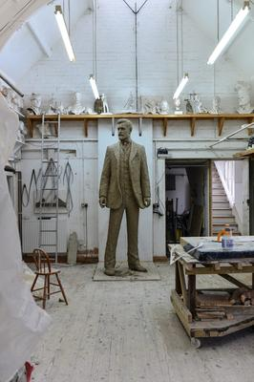
The Roger Casement sculpture designed by Mark Richards
Sarah Slater
August 05 2020
A three-metre statue of Irish nationalist and human rights activist Roger Casement is to be erected next April, nearly a year behind schedule.
The Mark Richards-designed sculpture will be situated on Dun Laoghaire pier.
The memorials committee of the county council commissioned the statue of Casement, who was sentenced to death in 1916 for his role in planning the Easter Rising.
Casement was born into an Anglo-Irish family in Sandycove in 1864 and served as a British diplomat before helping to establish the Irish Volunteers.
Wreath
News of the delay in unveiling the bronze sculpture comes as members of the DLR Roger Casement Summer School and Festival placed a wreath outside what was once the Casement family home, at Doyle's Cottage on Sandycove Road, marking the day of his hanging - August 3, 1916.
The wreath-laying ceremony is in its third year due to the demand to mark Casement's legacy as a nationalist and humanitarian, Roger Cole of the Summer School said.
Acclaimed Welsh sculptor Richards said the completion of the work has been delayed due to the pandemic and the ditching of his original sculpture, when he realised it would not suit its environs on the sea front.
"Covid-19 did affect work on the sculpture in one way as it hindered me being able to get supplies," he said.
"I also use models for creative insight and they couldn't travel due to restrictions, so that set me back."
The statue will stand on a bronze base on an already created plinth on the pier, and is being created to withstand whatever nature might throw at it.
"The piece is so large, it allows me to reflect Casement's stature, defiance and confidence, along with his hope and sensitivity," said Richards.
"Last September, I was three- quarters of the way through, but when I visited Dun Laoghaire to meet with council members I realised what I was creating wouldn't work.
"It would be lost in its surrounds as it would be too small and I had to scrap that work. I didn't panic, instead I felt liberated by being able to change the sculpture.
"This time I know I've got it right. I can't wait for it to be unveiled to everyone as I feel Casement is coming back home."
Richards is known for specialising in fine figurative work, with his previous Irish commissions including the Nicky Rackard Statue in Wexford and the Athy Shackleton.
The €10m redevelopment of Dun Laoghaire Baths will be unveiled to coincide with the raising of the Casement sculpture, which is costing €120,000.
The incident-hit baths project had originally been due to be completed earlier this year, but that was pushed out to the middle of the summer following a site spillage that resulted in up to a million plastic shards used in construction work spilling into Dublin Bay.
Storms and the reinforcement of marine walls had not been envisaged, then the Covid- 19 crisis hit, delaying the project even further.
Iconic
Bob Hannon, a senior architect with the local authority, said the sculpture was the first it had ever commissioned.
"The location is on a plinth at the end of the jetty that will be constructed as part of the baths project," he said.
"This location has been chosen specially for its dramatic position overlooking Dublin Bay and for the potential of an iconic relationship with the water.
"Because of the location, the sculpture will have a changing relationship also to the street level opposite the People's Park, the intermediate walkway and as experienced from the lower level of the jetty.
"By placing Casement amid the arrangement of levels, it suggests that he is stepping ashore."

