Roger Casement: from "Speech from the Dock" (1916)

The third of a series of excerpts from Handbook of the Irish Revival: An Anthology of Irish Cultural and Political Writings 1891-1922
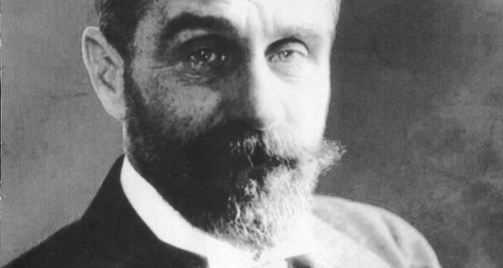
Roger Casement
Thu, Jul 2, 2015, 16:28
First published: Thu, Jul 2, 2015
Editor's note:
Roger Casement had been one of the authors of the Irish Volunteer manifesto, and he visited the United States to raise funds. He was a major strategist in the Howth gun-running of July 1914. At the start of the first World War in August of that year, he proposed that Germany should supply guns to Irish rebels, thereby opening a new front in the war against Britain. He travelled from Germany with a shipment of arms on the Aud: but the ship was intercepted and he himself arrested on Good Friday at Banna Strand and charged with treason.
The case against him was argued by Edward Carson [wrong], the lawyer who had hounded Oscar Wilde in the witness-box in 1895 and had gone on to found the Ulster Volunteer Force in 1912 - hence the bitter lucidity of Casement’s references to loyalist leaders in his speech, which contended that as an Irishman he had a right to be tried only by his own people. He was hanged in August 1916.
Roger Casement From: "Speech from the Dock" (1916)
Then came the war. As Mr Birrell has said in his evidence recently laid before the commission of inquiry into the causes of the late rebellion in Ireland, "the war upset all our calculations."
It upset mine no more than Mr. Birrell’s, and put an end to my mission of peaceful effort in America. War between Great Britain and Germany meant, as I believed, ruin for all the hopes we had founded on the enrolment of Irish Volunteers. A constitutional movement in Ireland is never very far from a breach of the constitution, as the loyalists of Ulster had been so eager to show us.
The cause is not far to seek. A constitution to be maintained intact must be the achievement and pride of the people themselves; must rest on their own free will and on their own determination to sustain it, instead of being something resident in another land whose chief representative is an armed force—armed not to protect the population, but to hold it down. We had seen the working of the Irish constitution in the refusal of the army of occupation at the Curragh to obey the orders of the crown. And now that we were told the first duty of an Irishman was to enter that army, in return for a promissory note, payable after death - a scrap of paper that might or might not be redeemed. I felt over there in America that my first duty was to keep Irishmen at home in the only army that could safeguard our national existence. If small nationalities were to be the pawns in this game of embattled giants, I saw no reason why Ireland should shed her blood in any cause but her own, and if that be treason beyond the seas I am not ashamed to avow to it or to answer for it here with my life. And when we had the doctrine of unionist loyalty at last - "Mausers and Kaisers and any King you like", and I have heard that at Hamburg, not far from Limburg on the Lahn - I felt I needed no other warrant than that these words conveyed - to go forth and do likewise.
The difference between us was that the unionist champions chose a path they felt would lead to the Woolsack; while I went a road I knew must lead to the dock. And the event proves we were both right. The difference between us was that my "treason" was based on a ruthless sincerity that forced me to attempt in time and season to carry out in action what I said in word—whereas their treason lay in verbal incitements that they knew need never be made good in their bodies. And so, I am prouder to stand here today in the traitor’s dock to answer this impeachment than to fill the place of my right honourable accusers.
Handbook of the Irish Revival: An Anthology of Irish Cultural and Political Writings 1891-1922 by Declan Kiberd and PJ Mathews and published by Abbey Theatre Press (€18.90)

CORRECTION LETTER TO IRISH TIMES
Sir,
It is important to correct mistakes especially in political articles. Where Sir Edward Carson is frequently concerned they betray a certain bias or careless enthusiasm.
The author in Roger Casement: from "Speech from the Dock" (1916) states Casement was prosecuted by Edward Carson at his treason trial in 1916. Not so, for it was F.E. Smith, the Attorney General, later Lord Chancellor with the title 1st Earl of Birkenhead who prosecuted. He was also known as 'Carson's Galloper' which may partly explain the slip.
Smith's inexcusable decision was to refuse Casement an appeal to the House of Lords, something he had the power separately to exercise. Obviously a reprieve was nigh impossible politically but the rapid change of mood in nationalist Ireland could, within a month or two, have provided the impetus. No matter how effective, and long constructed in his mind, Casement's speech from the dock was, his technical treason, as he recognised, would earn a death sentence.
He also did not travel to Ireland in the arms ship The Aud but on submarine U19 which landed him off Banna Strand.
The constant confusion in such matters relating to Carson is plainly derived from prejudice. He is often stated to have prosecuted Oscar Wilde (although not on this occasion) when in fact he defended the Marquess of Queensbury whom Wilde had foolishly brought to court on a charge of criminal libel. Had Carson failed, Queensbury, not Wilde, would have ended up in jail, like his son Lord Alfred 'Bosie' Douglas did in similar circumstances in 1928.
Carson was many things, indeed Smith in 1918 described him as "sickly and nervous, a very high-strung and intensive man" but he did not prosecute the two most prominent gay Irishmen of his and later eras.
As a biographer of Casement, I believe he had a huge role in the successful development of Irish separatism, not least in the manner of his dying. However that separatism, contrary to his hopes and expectations, led to a century of partition.
Yours sincerely
Jeffrey Dudgeon

