http://www.bbc.co.uk/news/uk-northern-ireland-31987997
[TNA Kew HO 144/1636 Irish Prisoner Hoy to Admiralty, 12 May 1915 ‘Hoy, an Irish prisoner of war exchanged for German prisoners, gives a statement to Admiralty Intelligence’.]

Sir Roger Casement helped to save First World War internees

21 March 2015
Sir Roger Casement, the son of a British Army officer who later became a prominent Irish republican, was hanged for treason in 1916
Sir Roger Casement's role in securing the release of three Irishmen interned in Germany during the First World War has been recalled exactly 100 years on.
Casement was a British diplomat who became a prominent Irish republican.
He was executed for treason after he tried to import arms from Germany for the Easter Rising - an ill-fated Irish rebellion against British rule in 1916.
Now, a granddaughter of one of the WW1 internees Casement helped has uncovered new details about the turbulent period.
Maureen Waugh has carried out extensive research on the fate of the wartime internees while delving into her own family history, trying to find the truth behind claims that her grandfather later "betrayed" the man who secured his release.

'Humanitarian agenda'
At the outbreak of WW1, her grandfather, Gerald Hoy, from Dungannon, County Tyrone, was a language teacher living in Germany with his German-born wife and their small two children.
Ms Waugh said her grandfather was among the British civilians imprisoned without trial because they were considered to be "hostile aliens".
Mr Hoy was detained at a makeshift prison camp on a racecourse outside Berlin.
"The conditions of internment were dreadful," she told BBC Radio Ulster's Your Place And Mine programme.
"They were put into horse boxes - six men to a horse box which was ten feet square, so it was very crowded, cramped conditions and very poor food."
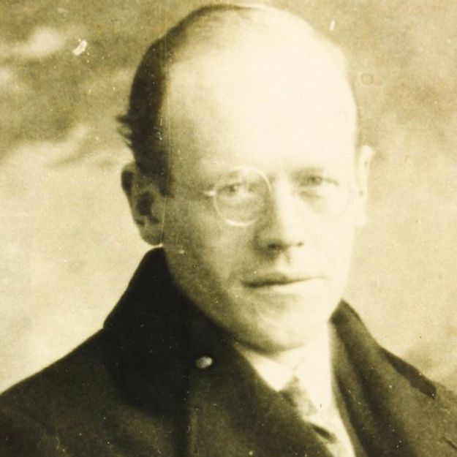
Gerald Hoy, from Dungannon, County Tyrone, who was interned during the First World War
Casement was in Germany at the time, trying to convince the German authorities to support plans for an Irish insurrection.
He also tried to recruit Irish prisoners of war, asking their German captors to release the men so they could fight against the British in Ireland.
"He wanted arms, he wanted finances, and he knew of the Irish internees and his objective was to get them released," historian Keith Beattie told the programme.
"It would have been, in some respects a humanitarian agenda for Casement. He had been knighted, in fact, for his humanitarian work in Congo and in Peru.
"So he wanted to get these men released from their terrible conditions, but he also knew that it would work to his advantage. In the end he only managed to get three of them released," Mr Beattie said.

'Personal memoir'
The other men Casement succeeded in securing the release of in March 2015 were John Patrick Bradshaw from Ballymoney, County Antrim, and William Coyne from County Mayo.
Mr Beattie works at Ballymoney Museum in County Antrim, and has invited Ms Waugh to the town this week, to tell the wartime story in a public lecture.
[John Patrick Bradshaw of Ballymoney, County Antrim, who was also a prisoner of war]
Ms Waugh has studied, in detail, the personal memoir kept by Bradshaw which was written shortly after his release from internment, a document now in the care of the National Library of Ireland in Dublin.

'Family secret'
She has also drawn on archive papers and personal family documents to discover what happened to her grandfather.
During her research, she uncovered a family secret, and came across a great reluctance by her older relatives to discuss the story.
"It was thought that Gerald Hoy had betrayed Casement to British intelligence after he was released," Ms Waugh told Your Place and Mine.
"So his family were deeply ashamed of him, because he'd betrayed Casement who had helped him, and he'd betrayed him for money."
However, Ms Waugh said that through her own studies, she was able to debunk part of that myth and reinstate her grandfather's reputation within her family, "to some extent".
"It was not an entirely true story," she said of the alleged betrayal. "It was an exaggeration by Gerald Hoy's uncle who worked at naval intelligence and had got Gerald Hoy to make a statement."
The claims were included in a book written by the naval intelligence officer in the 1930s.
But Ms Waugh has concluded: "It was an exaggeration because actually my grandfather had very little to tell."

Ulster Protestant
On Tuesday, she will deliver her lecture at the Northern Ireland school where Casement made his first public speech.
The son of a British Army officer, Casement was born in Dublin but was from an Ulster Protestant family and had many links to County Antrim.
Orphaned by the age of 13, he was looked after by relatives in Ballymena, and was educated at Ballymena Academy.
He served 20 years in the British consular service where he gained an international reputation for exposing European colonial exploitation in Africa and South America.
He eventually converted to Catholicism and became involved in armed Irish republicanism.

Hanged for treason
Casement's attempt to recruit Irish POWs to the fight against British rule failed, as many of the captives regarded him as a traitor.
His bid to import German arms to Ireland also ended in failure. Just days before the Easter Rising he was arrested on the coast of Kerry, after landing from a U-boat.
British intelligence had intercepted messages from Germany and the arms shipment was seized by the Royal Navy.
After the failed rebellion, the leaders of the rising were imprisoned and executed.
Casement was hanged for treason in London's Pentonville Prison in August 1916.
More details on Sir Roger Casement's WW1 rescue mission can be heard on Saturday's edition of Your Place and Mine, available on the BBC iPlayer.

