ROGER CASEMENT’S GERMAN DIARY
1914-1916
Including ‘A Last Page’ and associated correspondence
Edited by Jeffrey Dudgeon

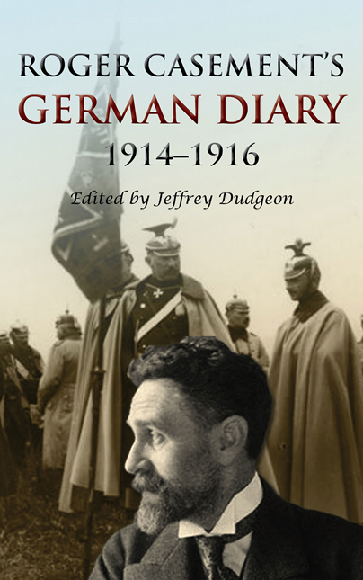

Roger Casement’s German Diary 1914-1916 including ‘A Last Page’ and associated correspondence

Edited by Jeffrey Dudgeon
Belfast Press
2016

ISBN 9780953928750 Paperback $19.99 post free from Amazon.com (£13.88)
https://amzn.to/2MpNaaD

ISBN 978-0-9539287-6-7 Kindle $9.99 with Amazon ASIN: B01HQRSY5C
https://amzn.to/2NDXGzt

See also my new publication: H. Montgomery Hyde
http://amzn.to/2BCOp0J (Amazon paperback)
http://amzn.to/2GtS705 (Kindle)

This is the definitive unabridged version of Roger Casement’s German Diary covering the years 1914 to 1916 when, after the war started, he went to Berlin seeking support for Irish independence. Published in August 2016, it has 367 pages in over 150,000 words with 45 illustrations.

It is a companion volume to the 2nd edition of Roger Casement: The Black Diaries – with a Study of his Background, Sexuality, and Irish Political Life which was published in February 2016: Paperback http://www.amazon.co.uk/dp/095392873X; Kindle http://www.amazon.co.uk/dp/B01AXB9754
The German Diary consists of another, and the last surviving, Casement diary, and deals with that most interesting, dramatic and penultimate period of his life in Germany and Berlin prior to his departure to Ireland for the Easter Rising.
It was not a private diary in any sense as Casement left instructions for its future publication. Much of what he wrote was designed to provide a record justifying his time in Germany. He was of an age to have his eye on history while knowing the accusations of treason he had, and would, face, Casement was desperate to have his actions understood. A secondary prompt in the last months was to indicate just how disgraceful and intransigent he felt the behaviour of the Germans had become and how the decision to start the rebellion in Ireland was something he did not agree with for tactical reasons, being an event he hoped to prevent or at least postpone. The final section describes his frantic attempts both to get sufficient arms shipped to the separatist Irish Volunteers and to travel by submarine to Kerry with a view to getting the Easter Rising called off.
The diary and many linked letters give a vivid impression of a man under stress in an alien environment who still manages to observe, describe and appreciate what he sees around him. He writes as an outsider of a nation at war with England and France. His growing frustrations however come to the point where his own mental health is destabilised.
There is a cast of the usual characters that Casement mixed with, political, often aristocratic, although also frequently military men. There were to be none of the street cruisers or lovers that his earlier, more sexual, diaries detailed. In Germany, probably for security reasons and lacking the language, he chose not to wander city streets. He was also getting on. His Norwegian companion and betrayer, Adler Christensen, looms large, tricking and twisting his way round Germany and America, while draining much of Casement’s time and common sense.
The text is laid out in as close a way as possible as the actual manuscripts to provide an impression of the original. The appendices include correspondence and newspaper articles from the time, while bringing the reader up to date with recent articles in relation to Casement in Germany, the Easter Rising and the role of British and German Intelligence, as well as the ongoing Black Diaries authenticity debate which is, if anything, accelerating. That controversy tells of a still contested issue in modern-day Ireland, despite the immense strides made towards gay equality and emancipation, most recently in the Republic.
The diary was in two notebooks in the National Library of Ireland and essentially covers the eight months from July 1914 to February 1915. It begins being written on 7 November 1914 and takes Casement retrospectively from England, to the US and to Germany and then includes a tour of war-torn Belgium. It effectively concludes on 11 February 1915 with him in a sanatorium. At the end, however, there is a brief account dated 28 March 1916 of events later in 1915. Separately, ‘A Last Page’ picks up the narrative on 17 March 1916 running it to Casement’s final days in Berlin.
Casement, a man who wrote too much, drafted many hundreds of other letters and memos when in Germany of which a number of the more significant, particularly those related to the arrangements for his departure to Ireland, are reprinted along with the full, unabridged diary where another writer Angus Mitchell has edited out nearly a quarter of the original text in his book sub-titled The Berlin Diary. Those cuts are at times from the most sensitive of areas, including the behaviour of the German Army in Belgium and Casement’s increasing disillusionment with the Kaiser’s Imperial Government and Prussian militarism. Being complete in its narrative, makes it vastly more readable and comprehensible.
jeffreydudgeon@hotmail.com
Tel 079 2125 1874 / 028 90664111

NVTV (Channel 7 in Belfast) interviewed the author in discussion with Dr Margaret O’Callaghan for its ‘Novel Ideas’ series in July http://www.nvtv.co.uk/shows/novel-ideas-roger-casement/.

