Whytes auction
Irish Brigade lot 132
26 January 2013
1914-18: The Betrayal of Roger Casement and the Irish Brigade original unpublished manuscript by Sergeant Francis Kavanagh
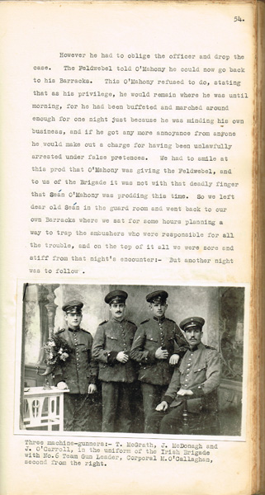
Dimensions:13 by 8.5in.
Auction Date/Lot No.:
26 January 2013/ 132
Published Estimate:
€2000-3000
Price Realised:
€
A large 274 page typescript unpublished manuscript with photographs written by Francis Kavanagh in 1955 as a history and a personal memoir of Roger Casement's German Irish Brigade during the First World War. A historically important item charting not only the history of the Brigade but also Kavanagh's personal story and feelings in relation to it. An invaluable source for anybody studying the period albeit, as the title of the manuscript suggests, not the most neutral of accounts. Kavanagh was born in 1890 in Dublin and enlisted in the South Irish Horse prior to the outbreak of the First World War. He served on the Western Front from August 1914 and was taken prisoner during the early stages of the British retreat. As a POW he became an early recruit into Casement's ill-fated Irish Brigade and was therefore in an excellent position to witness the history of the Brigade from start to finish. In 1955, ten years prior to his death, he completed this book which never found a publisher. This appears to be one of very few manuscripts of Kavanagh's work which was produced and also has a number of hand written alterations to the original text.

