1st EDITION:
Roger Casement: The Black Diaries - With a Study of his Background, Sexuality, and Irish Political Life
A book of record including the never-before-published 1911 diary
by Jeffrey Dudgeon, Belfast Press 2002
679pp. launched by Professor Paul Bew (now Lord Bew of Donegore) of Queen’s University Belfast on 21 November 2002 at the Linen Hall Library in Belfast.

LAUNCH OF NEW BOOK ON ROGER CASEMENT

The publication of Roger Casement: The Black Diaries, by Jeffrey Dudgeon, claims to settle once and for all the controversy over the Irish patriot’s private writings. Believing them to be authentic, his book describes the various forgery theories and why they do not stack up. He supplies evidence in the form of previously unseen letters and photographs which prove Casement’s homosexual orientation, and confirm the events, big and small, that the former British diplomat wrote up in his diaries.

Casement, who defected to Germany in October 1914, was hanged in August 1916 for treason, after landing in Co Kerry from a submarine in April of that year for the Easter Rising. In 1965 his body was exhumed from Pentonville Prison. He was then given a state funeral in Dublin.

Mr Dudgeon, before the launch of his 680-page book, stated “It can never be argued again that the Black Diaries are other than authentic. Where the recent handwriting tests may have indicated that Casement penned the words on the page, this book supplies the background detail which proves they were his diaries and that the events he described actually happened. His lovers in the ports and cities right around the Atlantic Ocean are also revealed as real people.” It was Casement whose investigations for the British government into rubber slavery and genocide in the Congo, and the Peruvian Amazon, in 1903 and 1910, investigations outlined in the Black Diaries, alongside his private pursuits, which brought him a knighthood in 1911.

The author, a leading human rights campaigner who won a key victory for Northern Ireland homosexuals at the European Court of Human Rights in Strasbourg in 1981, said “I started this research with the intention of putting all five of Casement’s diaries into the public domain, for the first time, especially as his highly erotic 1911 diary has never previously been seen, the London government threatening any publisher with an obscenity charge. But gradually I came to realise how the story of Casement’s developing Irish separatism and his connections to the early Republicans of Belfast, which revealed many other links to present-day Sinn Féin, needed to be told. The result is a book which opens up those previously untold areas of his Ulster background and Irish political contribution.”

He continued, “What I believe I have achieved is closure on the forgery issue. The importance of Casement as the man who arranged the first arms for the IRA in 1914, and followed that up with a second shipment in 1916, for the Easter Rising, can now emerge from behind the dirty tricks allegations. To know how and why those first arms were commissioned is to know how they might be decommissioned, for Casement’s hardline views and anglophobia were to become an integral part of the ideology of the new movement that swept all before it in Ireland in the decade from 1916, one which re-emerged thirty years ago in the north.”

Mr Dudgeon concluded, “The book can assist peace and reconciliation as it removes one obstacle to better relations between Britain and Ireland, an obstacle that has now little or no substance, but was an important example as to how perceived wrongs can lead to a high-powered response of rage.” Casement who is usually described as an Ulster Protestant is revealed in the book to be deeply antagonistic to what was thought to be his own Co. Antrim background while an explanation is offered for his hostility to the Ulster Scots and to Unionism.

This new book, published by Belfast Press, provides considerable biographical detail on a number of Casement’s boyfriends including the Belfast Bank official Millar Gordon, and the sociopathic Norwegian sailor Adler Christensen who twice betrayed his benefactor. It deals with the Easter Rising, offering new information on London’s inability to read or understand the intelligence signals they were receiving from intercepts, and details the attempts in the 1930s to stifle the truth concerning Casement’s homosexuality. Significant information on Casement’s formative years in Ballymena and on his troubled family background are also detailed.

2ND EDITION:
Extended, and enlarged with a post-1st edition bibliography of nearly fifty new entries, this edition has 10% more text (725pp.) and a dozen new photographs. It includes improved and extended versions of the 1903 and 1910 Black Diaries, and for the month of September in the 1911 Diary and Cash Ledger. New characters are outlined like the Bavarian schoolboy, Max Zehndler, and the Batavian Casement aficionado, Heinrich d’Oleire. The birth name and progressive origins of Casement’s mother Anne, a Dublin Protestant, have been ascertained. The ultimate fates of Casement’s comrades on the submarine and in Germany – Daniel Julien Bailey, John McGoey, and Adler Christensen are discovered and described. The mystery of the missing money that Michael Francis Doyle brought over from America in 1916 is investigated and solved.
Newly revealed Gertrude Parry and Elizabeth Bannister papers, bought by the NLI in 1952, but never catalogued, have added considerably, since the first edition, to the documentation now accessible in digitised records.
Casement’s 1881 Scribbling Diary was tracked down by the author in the NLI, within a batch of significant papers that had been catalogued and numbered, but not indexed. The diary was thought lost or stolen since B.L. Reid saw it in the 1970s, and tells more about ‘The Sweet Boy of Dublin’.

3rd EDITION:
The 3rd edition of Roger Casement: The Black Diaries – with a Study of his Background, Sexuality, and Irish Political Life (2019) by Jeffrey Dudgeon is published by Belfast Press in paperback (and Kindle) versions. 802pp. ISBN 978-1-9160194-0-9

In this, further extended and enhanced, edition, with many more photographs, all Roger Casement’s Black Diaries are again published together including, uniquely, a full version of the erotically-charged 1911 Diary over which London threatened an obscenity prosecution. The 1910 diary is also now published unabridged and the 1903 diary here considerably lengthened.
The volume provides both a comprehensive text of the diaries, with explanations for their cast of characters, famous, infamous, and fleeting, and a context for the author whose significance and seminal role in the political development of independent Ireland has been masked by the debates over authenticity. This remains a uniquely original look at the Irish patriot and humanitarian, hanged in 1916 for treason. It was the same Casement whose reports in 1904 and 1912 on rubber slavery and genocide in King Leopold’s Congo and the Peruvian Amazon, reflected in his diaries, which shocked the world.
The book also deals with the neglected sides of Casement’s life, his involvement in Ulster and Irish politics, his family background in Co. Antrim, his Belfast boyfriend Millar Gordon, and new discoveries about his sociopathic companion, the Norwegian sailor Adler Christensen. There is as well a comprehensive account of the authenticity controversies, Casement’s homosexuality, and his time in Africa and South America. Roger Casement had iconic status in life and, after death, was sanctified and vilified in equal measure.
His real self was thus obscured. This paperback edition combines a rigorous academic study of the public and political Casement (with over 1,200 references and an extensive bibliography updated to 2019), alongside an account of his personal life, sexuality, and consular career, and an informed view of how they all interlocked and originated. It also provides an analysis of his early and key role in the Irish separatist movement, and a full exposition of the controversies that have swirled around him to this day, including attempts made in Dublin to threaten the truth about the Black Diaries.
"No Roger Casement – No Easter Rising": Casement commissioned the first arms for the IRA in 1914 and again in 1916 while from 1904 he tutored many of the key personnel who by 1921 had obtained a separate Irish state. To know about Roger Casement is to know why Ireland achieved independence and why Ulster stayed separate, remaining for the next century in the UK. This volume provides an insight into the political conflict in the north and suggests how it could be diminished by both learning and respecting each other’s stories.

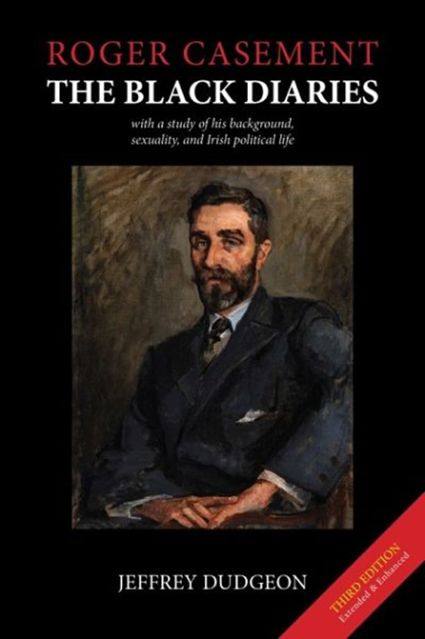

https://amzn.to/2uJCY6r
Amazon - paperback £26.00; $35.00; €31.00.
Kindle £8.25; $10.00; €9.00

About the author:
Jeffrey Dudgeon was born in Belfast, educated locally and at Trinity College, Dublin. In 1981, he was the winning plaintiff at the European Court of Human Rights in a suit against the UK. This resulted in the decriminalisation of male homosexuality in Northern Ireland in 1982. For many years a civil servant in Stormont’s health department, he was, from 1995-8, parliamentary adviser to the UK Unionist MP for North Down. For the following two years, he was engaged in researching this book, first published in 2002 in hardback. Awarded an MBE in the 2012 New Year’s Honours List for services to the LGBT community, he was in 2013 one of two Ulster Unionist Party representatives at the Haass Talks.
In 2014, he was elected as an Ulster Unionist to Belfast City Council for the Balmoral DEA (but lost his seat to the DUP in 2019). A 2nd paperback edition (725pp) and the unabridged Roger Casement’s German Diary 1914-1916 both appeared in 2016. He published Montgomery Hyde Ulster Unionist MP, Gay Law Reform Campaigner and Prodigious Author and another work on Legacy issues in 2018.
New documentation on Casement, has been uncovered, much of it detailed in this 3rd edition, adding to our understanding of his life and times.
Jeff Dudgeon continues to speak on Casement and the diaries addressing a new and energetic campaign disputing their authenticity.

Contact details: jeffreydudgeon@hotmail.com Tel. 079 2125 1874 or 028 90664111

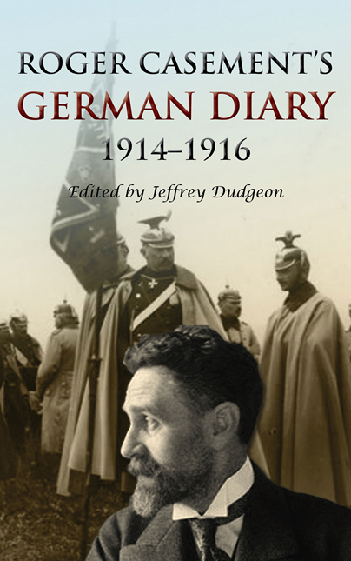

Roger Casement’s German Diary 1914-1916 including ‘A Last Page’ and associated correspondence
Edited by Jeffrey Dudgeon
Belfast Press 2016

ISBN 9780953928750 Paperback $19.99 post free from Amazon.com (£13.88)
https://amzn.to/2MpNaaD
ISBN 978-0-9539287-6-7 Kindle $9.99 with Amazon ASIN: B01HQRSY5C
https://amzn.to/2NDXGzt

This is the definitive unabridged version of Roger Casement’s German Diary covering the years 1914 to 1916 when, after the war started, he went to Berlin seeking support for Irish independence. Published in August 2016, in 367 pages and over 150,000 words and with 45 illustrations. It is a companion volume to the 2nd edition of Roger Casement: The Black Diaries – with a Study of his Background, Sexuality, and Irish Political Life which was published in February 2016. The German Diary consists of another, and the last surviving, Casement diary, and deals with that most interesting, dramatic and penultimate period of his life in Germany and Berlin prior to his departure to Ireland for the Easter Rising.
It was not a private diary in any sense as Casement left instructions for its future publication. Much of what he wrote was designed to provide a record justifying his time in Germany. He was of an age to have his eye on history while knowing the accusations of treason he had, and would, face, Casement was desperate to have his actions understood. A secondary prompt in the last months was to indicate just how disgraceful and intransigent he felt the behaviour of the Germans had become and how the decision to start the rebellion in Ireland was something he did not agree with for tactical reasons, being an event he hoped to prevent or at least postpone. The final section describes his frantic attempts both to get sufficient arms shipped to the separatist Irish Volunteers and to travel by submarine to Kerry with a view to getting the Easter Rising called off.
The diary and many linked letters give a vivid impression of a man under stress in an alien environment who still manages to observe, describe and appreciate what he sees around him. He writes as an outsider of a nation at war with England and France. His growing frustrations however come to the point where his own mental health is destabilised.
There is a cast of the usual characters that Casement mixed with, political, often aristocratic, although also frequently military men. There were to be none of the street cruisers or lovers that his earlier, more sexual, diaries detailed. In Germany, probably for security reasons and lacking the language, he chose not to wander city streets. He was also getting on. His Norwegian companion and betrayer, Adler Christensen, looms large, tricking and twisting his way round Germany and America, while draining much of Casement’s time and common sense.
The text is laid out in as close a way as possible as the actual manuscripts to provide an impression of the original. The appendices include correspondence and newspaper articles from the time, while bringing the reader up to date with recent articles in relation to Casement in Germany, the Easter Rising and the role of British and German Intelligence, as well as the ongoing Black Diaries authenticity debate which is, if anything, accelerating. That controversy tells of a still contested issue in modern-day Ireland, despite the immense strides made towards gay equality and emancipation, most recently in the Republic.
The diary was in two notebooks in the National Library of Ireland and essentially covers the eight months from July 1914 to February 1915. It begins being written on 7 November 1914 and takes Casement retrospectively from England, to the US and to Germany and then includes a tour of war-torn Belgium. It effectively concludes on 11 February 1915 with him in a sanatorium. At the end, however, there is a brief account dated 28 March 1916 of events later in 1915. Separately, ‘A Last Page’ picks up the narrative on 17 March 1916 running it to Casement’s final days in Berlin.
Casement, a man who wrote too much, drafted many hundreds of other letters and memos when in Germany of which a number of the more significant, particularly those related to the arrangements for his departure to Ireland, are reprinted along with the full, unabridged diary where another writer Angus Mitchell has edited out nearly a quarter of the original text in his book sub-titled The Berlin Diary. Those cuts are at times from the most sensitive of areas, including the behaviour of the German Army in Belgium and Casement’s increasing disillusionment with the Kaiser’s Imperial Government and Prussian militarism. Being complete in its narrative, makes it vastly more readable and comprehensible.
jeffreydudgeon@hotmail.com

H. MONTGOMERY HYDE
Ulster Unionist MP, Gay Law Reform Campaigner and Prodigious Author
by Jeffrey Dudgeon (pictured below right reading Hyde’s Oscar Wilde trial book in 1968)

Belfast Press, ISBN 9780953928798 (paperback), 56 pp.

1st edition February 2018; 2nd edition March 2018
H. Montgomery Hyde died in 1989 by which time he had become history. Only a very few remembered him or his gay campaigning role, let alone the fact he had been an Ulster Unionist MP throughout the 1950s. Thirty years later, he can hardly be conceptualised. Too many, at best, see him as an aberration for Belfast but he was a recognisable type of progressive, yet traditional, British politician. No one else played as long or as effective a part in changing the views of people towards gay people when only a handful of MPs put their head above the parapet.
"Harford" as he was known to his friends, "H. Montgomery Hyde" to his readers, and "Montgomery Hyde" to the electors of North Belfast, led the battle in the House of Commons for decriminalisation of homosexuality. And he paid as great a price as any parliamentarian could for his courage – he lost his seat.
Very much a child of the 1920s, he was dedicated to researching and writing about those two most prominent gay men of the 20th century – Oscar Wilde and Roger Casement, both Irish outlaws. None the less, he managed to publish another forty books on a wide range of subjects including perhaps his finest works 'The Rise of Castlereagh' and 'The Other Love'. A cheerful and good natured figure, Harford lived and loved well and is deserving, at the least, of this short book outlining his struggles and achievements.

H. Montgomery Hyde: Ulster Unionist MP, Gay Law Reform Campaigner and Prodigious Author
http://amzn.to/2BCOp0J (Amazon paperback)
http://amzn.to/2GtS705 (Kindle)

