Broadsides

John McGuiggan

A collection of bits and pieces….

The Road to the Rising – The Big Personalities – Sir Roger Casement
Posted on April 11, 2015 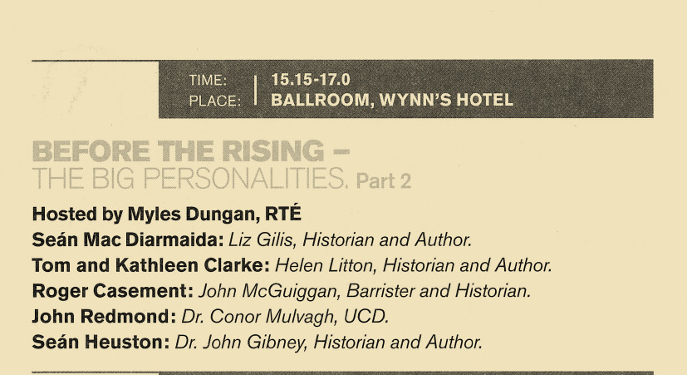
https://broadsidesdotme.wordpress.com/2012/03/05/review-of-roger-casement-the-black-diaries-with-a-study-of-his-background-sexuality-and-irish-political-life-by-jeffrey-dudgeon/
The Road to the Rising was an RTE History Festival held on O’Connell Street in Dublin on Easter Monday the 6th April. Over 50,000 people attended, dipping into and out of exhibits, street theatre, lectures, music, re-enactments and the screening of historical films. The Big Personalities series of lectures were limited to 20 minutes for each of the speakers. This is the talk on Roger Casement.
It is 1915. Sir Roger is in Germany, as a guest of Kaiser Wilhelm II and the Imperial German Government. He is engaged in a secret and dangerous mission on behalf of the Irish Republican Brotherhood. 1915 will not be his finest year but it is a year of great personal danger and risk.
He is not happy in Germany. He is isolated from the planning of the rebellion. He has no direct contact with Ireland and can only write and cable Dublin via America. He cannot speak German and will converse with the German Foreign office officials in French, the language of diplomacy, or with the help of interpreters.
He has been in Germany now since October of last year, 1914. He travelled there from New York, on a Norwegian passenger ship, in a false name, with false papers and with forged papers in order to bluff his way past the Royal Navy who now, in the second year of the war, routinely board and inspect the passenger lists all neutral ships.
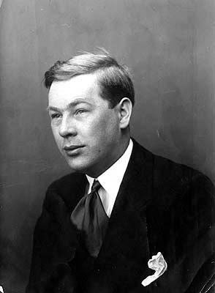
He is accompanied by what the history books will describe as his servant or companion, Adler Christensen. Future generations, we, might well call Adler his partner, but such terms cannot be used in homophobic world of 1915. Adler was his closest confidente and he shared with him all the secrets of his mission to Germany and entrusted to him the custody of secret documents relating to the mission. Adler would travel all the way with him to Berlin but his stay with him in Germany would only be for a few months before he returns to the United States.
Another reason contributing to why Sir Roger is so isolated and unhappy, in Germany. Christensen was a sailor, a Norwegian sailor who Casement will say he had met on the streets of New York. They enjoyed a sexual relationship but were also genuinely affectionate of each other. But Christensen has betrayed Casement. In Oslo, where their New York ship docked, Christensen had gone at once to the British Consulate and told them all they needed to know of Sir Roger: who he was, who he had met in New York, in particular the German ambassador, his intention to travel to Berlin, details of his mission in Germany. He showed them the secret papers. And he told them, that his relationship with Sir Roger is “improper” and un-natural.
He was an unpleasant man was Christensen. He has betrayed Sir Roger for money. And then, bizarrely, he told Sir Roger part of the story and became a double agent; Sir Roger believing he was a republican supporter acting for the cause in “going along” with the British skulduggery, and the British believing he was their agent acting for money and prepared to be a deep informer at the heart of a great Irish-American- German conspiracy and a republican plot.
So from the very beginning of his Secret German mission, the British Secret Service, thanks to Christensen, knew all about it. And Sir Roger knew they knew. It played on his mind and he became, at times, paranoid about the British plans to capture or kill him. He was obsessed by it all, and it will not add to his health or his happiness in Germany.
He knows now that they know of his treason. He writes desperately to America urging them to arrange with Belfast and London for his papers to be recovered and destroyed. He has trunks of diaries and papers, with his friend Dr. Bigger, in Belfast, and stored at his London lodgings. He knows the British Secret Service would now collect everything they can about him and he knows that some of the material will support charges against him and will not reflect well upon his reputation.
The Germans are wary of his obsession with the Oslo incident, they do not see as important as does Casement and it is leading, unfortunately, to a growing disquiet within the German Government about this obsession with the affair.
And Casement is unhappy about their lack of enthusiasm with his great grievance against the British.
His mission, audacious and dangerous and of the utmost importance to the cause, is to persuade the German Government to enter into a treaty with the IRB by which they would undertake, should they win the war, to recognise Ireland as an Independent and free Nation. And more, Germany was to provide arms for the rebellion, Artillery, mortars, machine guns rifles ammunition, high explosives, detonators, three ships loads. And soldiers, German soldiers to fight alongside the Irish in Ireland and to train the volunteers.
And he has persuaded them! Wonderful news that has now been officially announced in the German Press. A declaration that Germany will recognise us a free and independent Nation: should they win the war. And there is an agreement. Sir Roger will call it a treaty.
The Agreement, or treaty, has not been published and its terms remain secret.
But it provides for the German Government to bring together all the Irish prisoners that they have captured in the early months of the war and who are held by them, scattered in prisoner of war camps across Germany. They are to bring them together in one single prisoner of war camp, Limburg, 60 miles south east of Cologne.
Those early months of the war had gone well for Germany; they had stormed across the free an independent nation of Belgium and made deep inroads into France. They had captured thousands of allied prisoners, Russian soldiers, French soldiers, British soldiers. Among the British are thousands of men from the Irish Regiments. Regular soldiers. Professional soldiers, from the Leinster Regiment, the Munster Regiment, the royal Dublin Fusiliers, the Irish Guards, The Connaught rangers The South Irish Horse: regiments predominantly recruited in the catholic south of Ireland. And Germany, as asked by Sir Roger has gathered them all together, from their scattered POW camps throughout Germany and assembled them at Limburg.
They have excluded from the assembled prisoners of war any protestant Irish soldiers, the Ulster regiments are left in their scattered camps. Only the Catholics, only the southern Irish regiments are gathered now in Limburg.
Sir Roger will try to recruit from them a brigade of Irish Freedom fighters who will come to Ireland next year, or whenever the rebellion is to commence, and fight the British, with the help of the Germans, and throw them out from Ireland. He is to persuade them to abandon their regiments, take an oath for Ireland and join him in the great republican rebellion to liberate Ireland from British rule. They will be trained by the German Wehrmacht, fed housed, paid, given splendid uniforms and trained on German weapons and tactics
Article 7 and 8 of the treaty that has now been agreed is also secret. It provides that should Germany not send the recruited Irish Brigade to Ireland, because of the Royal Navy blockade, or for any other reason, then they will go instead to the Middle East and fight with the Turkish Army, the army of the Ottoman Empire, against the British in Arabia. A provision which raises the theoretical possibility of a meeting in the great deserts between Sir Roger and Lawrence of Arabia.
These are great secrets for not everyone in Ireland will be happy to know of such a level of collaboration with Germany. Germany has vanquished little Belgium, little catholic Belgium, there have been atrocities, She is engaged in a world war, Europe is in flames. Next month a German submarine, off the coast of Cork, will sink the Lusitania, a neutral American passenger ship; the sinking will not be met with widespread jubilation among the Irish. And over at Liberty Hall, even as we speak, the unions have erected a great banner declaring that “We serve neither King nor Kaiser” And yet the treaty commits Irish Freedom fighters, former British soldiers, to fight in Arabia for the German and the Ottoman Empires. Never mind the nationalism of the Arabs.
So the great assembly of prisoners at Limburg is now organised. Sir Roger has arranged with the Germans for priests to be amongst them who will aid him in the persuading of the soldiers to abandon their regiments. 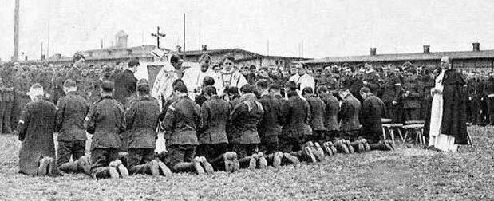. And he too will go amongst them and seek to recruit them to his Irish Brigade. He is an experienced recruiter and only a year or so ago, he was engaged here in Ireland in a very successful recruiting campaign for the Irish Volunteers, In Cork, Limerick, Kerry all over Ireland he had been a major recruiter of men to the cause.
There are two priests; Father Crotty who has been sent from Rome. He is a Dominican. He previously taught at Newbridge College, Newbridge is of course a garrison town. He will not go along with Sir Roger’s plan. He will care for and look after the prisoners spiritual needs, take mass, take confession, give communion, but he will encourage them to stay loyal to their regiments and not engage with Sir Roger’s mission to recruit an Irish Brigade. The second priest is Father Nicolson, he has been sent by the Irish Americans to assist in the recruiting campaign. He is virulently anti English, a burn everything but their coal, evangelical zealot. He will do everything in his power to encourage the prisoners to desert their regiments and fight the English. Too much I think, for his evangelism will backfire. These men, these prisoners, are regular soldiers. Hard bitten, experienced, veterans. Men who have served in India and South Africa and every possible corner of the Empire. Yet there can be no doubts that are many many nationalists amongst them. As we are all nationalists in 1915. All of us are home rulers, we are all Constitutional nationalists and supporters of John Redmond . They are good Catholics too, as we are all good Catholics in 1915. But this zealot, father Nicolson will do no good, either for their faith or their loyalty. Few of the prisoners will be persuaded by the zealous priest.
And Casement himself is received with no greater warmth by the soldiers, than is Nicolson. The prisoners, I must report to you, have booed him, hissed at him, shouted “three cheers for John Redmond” , for they are nationalists amongst them for sure; and they have called out insults, as only soldiers can, “How much are the Germans paying you” they shout.
There was a sketch of him addressing the soldiers. 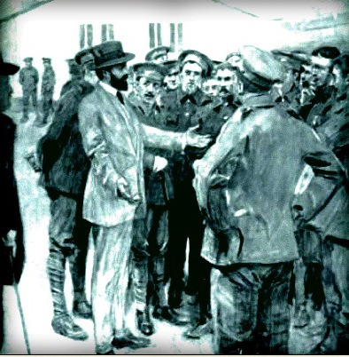Here. It is published in an English periodical. For the English, it is a portrait of a knight of the Realm, an honoured knight of the realm in the very act of committing Treason.
He will hang for this.
The Germans have assembled over 2500 Irish catholic prisoners of war. Sir Roger and his priest has managed to persuade 56 to join the Irish Brigade. 56. that is just over 2%. The priests were of little help. The American Irish sent him Capt. Monteith, from Limerick, to command the Brigade and to try and recruit more men, And Joseph Mary Plunkett has come over from Dublin to help in the recruitment. But for all their efforts they recruit no more than the 56 men. It is a misnomer to call it a Brigade, there is hardly enough men to form a platoon.
It is a depressing result and will not add to Sir Roger’s happiness in Germany. And they are a motley lot. These men he has recruited to his Irish Brigade. There are, I regret to say, reports of in-discipline, heavy drinking. Insolence, fighting with German soldier. I am told that one fight broke out between members of the brigade and their German hosts following a football match. It had to be broken up by the firing of shots into the air. What can we say? Indiscipline amongst soldiers is hardly unusual, it is often endemic, do not read too much into the reports of in-discipline, or of drinking. They are common prevalent offences for soldiers in barracks. Perhaps the firing of a shots is unusual but they will surely give a good account of themselves should they ever land in Ireland. 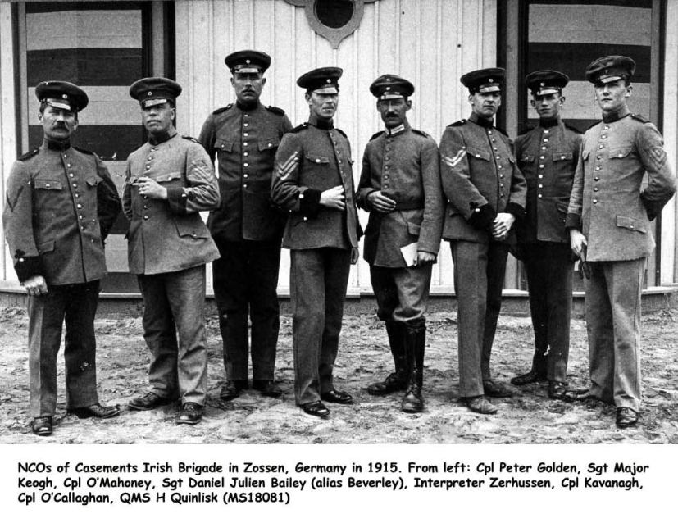
They have been training now, under Wehrmacht instructors, for four or five months. Their commanding officer is Capt. Monteith and it is he who has become, for the IRB in New York and in Dublin and for the German authorities, the key Irish representative in Germany. For Sir Roger is not well, his malaria has returned and he suffers from arthritis. He is kept out of the loop. He will be told of the date fixed for the Rising by Monteith and Monteith knows the date because the Germans, now tiring of the Irish Brigade and of Casement’s obsession with the Oslo affair, choose to tell Monteith first, rather than sir Roger of the news they had received from America and Dublin.
So there are many reasons for Sir Roger to be unhappy in Germany.
And now, he knows the date for the Rising and must decide whether to bring the brigade to Ireland. And he is angry and in some despair at the Germans. The three promised ships of arms have gone. There will only be one. There will no artillery, no mortars, few machine guns, just rifles, 20000 rifles and a few clockwork bombs. And there will be no German soldiers, no German boots on the ground.
Will he bring the Brigade? He now believes the Rising will fail. He knows that the 1798 rebellion failed because the French soldiers failed to land. There was no French or insufficient French boots on the ground. And now there would be no German boots on the ground, no jackboots on the turf. He decides that the Rising must be stopped, cancelled, deferred. He must get this message to Dublin, get to Dublin himself, make them understand, tell them the Germans had let us down, that the Rising will fail.
He is not afraid of a fight, he wants to and is prepared to strike a decisive military blow against the British in Ireland, but he knows without German aid, without the artillery machine guns and mortars, without German boots on the ground, it will be impossible. Good men, the volunteers in Ireland will be led to slaughter and defeat. He was not interested in a blood sacrifice. He wants a decisive military victory. A coup de main.
And he knows this; if he takes the brigade with him… well he is not confident of their loyalty to the cause when they actually face the British guns, he fears that some of them, on landing in Ireland will desert the cause, re-join the British army or disappear into the townlands of their native land. And perhaps some of them will. ‘But more importantly for Sir Roger, these men are still British Soldiers and if, as he now believes, the Rising will fail and they were captured then they would all, each and every one of them, face military discipline and be put before the firing squads. So he will decide to go to Ireland without the Brigade. He will go alone, to stop the Rising. He will take only Capt. Monteith and one of the Sgts of the brigade, Sgt Bailey
Germany sends us a ship for the Rising, a single ship, the Aud, loaded with rifles and ammunition and clockwork bombs. And they send us, return to us, Sir Roger Casement and two of his comrades from the Brigade. They provide him with a submarine. He is not well. He is now 53 years old, He suffers from arthritis, is recovering from Malaria, his energy is at a low, he leaves Germany un-happy and burdened by the urgency of stopping the Rising.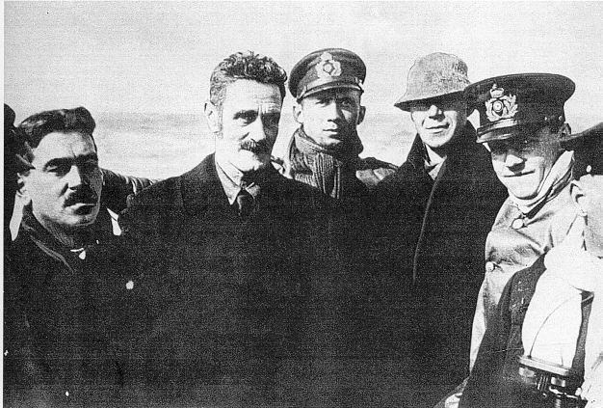
Look at him on the submarine, he looks like an old man.
He rows towards Ireland in a rough sea, in a small boat of wood and canvas. 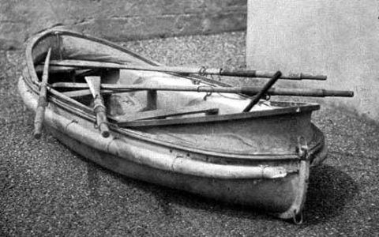Three men.
Before he reaches the shore the boat capsizes and he must struggle ashore soaking wet, dragging the sodden boat onto the beach at Banna strand, where he will collapse with exhaustion.
And yet he will write of this:
“When \i landed in Ireland that morning, swamped and swimming ashore on an unknowns strand, I was happy, for the first time for over a year, although I knew that this fate waited on me, |I was for one brief spell, happy an smiling once more, I cannot tell you what I felt, the sand hills were full of skylarks rising in the dawn, the first I had heard for years, the first sound I heard through the surf was their song as I waded in through the breakers, and they kept rising all the time up to old rath at Currahane, and all around were primroses and wild violets and the singing of the skylarks in the air, And I was back in Ireland again.
And he was happy now. Within hours he would be arrested by local constables, his clothes still wet from the sea. Later the same day Sgt Bailey of the Irish Brigade, formally of the Royal Irish Rifles, would also be captured by local constables. Within a further four months they would both be in the dock at the Royal Courts of Justice, charged with High Treason. Bailey would turn Kings Evidence and tell the British everything he knew of Casement in Germany and of the Irish Brigade. Within the same four months Bailey would re-join the British Army and return to the war.
Casement would be found guilty of High Treason and sentenced to death. To hang. For his dreams of the destiny of Ireland, free and independent, he would hang.
We should remember he was, he still is, a humanitarian figure of astonishing international reputation. He was the friend, the admired and noble friend of diplomats, academics, politicians, liberals, activists; he was a hero to every anti-slavery movement in all of Europe and beyond, he was known in governments on four continents. If ever a man could call upon an international network to provide the most eminent and eloquent of testimonials and petitions for clemency then it was Sir Roger Casement. I cannot stress to you how powerful was his reputation how admired he was in Africa, South American, North America and Europe.
But the diaries now enter upon his fate. 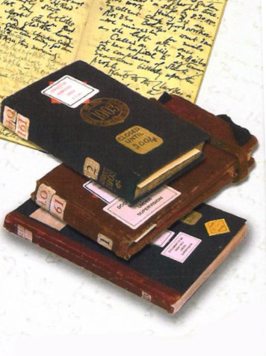The Black diaries that recorded his sexual activities. They had fallen into the hands of the British Secret Service and now they used them to stifle his network of friends and admirers throughout the world.
Had it not been for those diaries, had not been for the filthy unconscionable use that the British put them too, showing them to ambassadors and bishops and princes and newspaper editors, he would have had such a petition for clemency as no man, in no generation would ever have; everyone would have signed, everyone; even Bono would have signed, that is how important Sir Roger Casement was to his contemporaries.
But they did not sign. A few did, some important people did, but it was a handful when it should have been hundreds, perhaps thousands. It should have included governments, the Americans in particular. But they did not sign.
And on August the 3rd, the morning of his execution, he took mass. The evening before he had been received into the catholic church and had made his first confession. Now he took his first communion. And it was also his last.
He walked to the scaffold, according to Father Carey, the prison Chaplin, with the dignity of a prince. He was courteous to his executioner Ellis who called him “the bravest man it ever fell to my unhappy lot to execute.”
And he stepped into the English noose that was ever his fate to do.
And he dropped.
Straight into the hearts of the Irish people. And whether you believe the diaries were forged, or whether they were not, he will long remain in the hearts of the Irish.
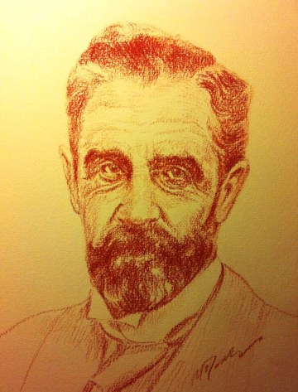May He Rest in Peace
Posted in Uncategorized | Tagged Germany, Ireland, Irish Brigade, Roger Casement, The Big Personalities, The Road to the Rising | Leave a reply

