The Tablet
30 June 2012
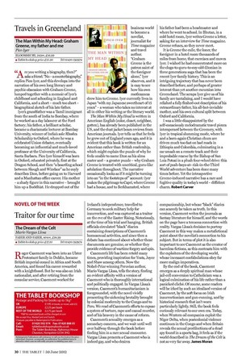
Traitor for our time
The Dream of the Celt
Mario Vargas Llosa
FABER AND FABER, 404PP, £18.99
■ Tablet bookshop price £17.10 Tel 01420 592974
Roger Casement was born into an Ulster Protestant family in Dublin, became British imperial consul in Africa and South America, and found his career rewarded with a knighthood. But he was also an Irish nationalist, and after retiring from the consular service, Casement worked for
Ireland’s independence, travelled to Germany to seek military help for insurrection, and was captured as a traitor on the eve of the Easter Rising. Notoriously, at the time of his trial and hanging, British officials circulated “black” diaries containing descriptions of Casement’s homosexual activities, and since then a debate has continued about whether these documents are genuine, or whether they provide evidence of wartime forgery and spin.
Casement’s life has been retold many times, providing inspiration for Yeats, Joyce and Shaw among others. Now the Nobel-Prize winning Peruvian author, Mario Vargas Llosa, tells the story, finding an evident affinity with a version of Casement who is thoroughly international and politically engaged. In Vargas Llosa’s version, Casement’s humanitarianism is foregrounded, with the novel vividly presenting the sickening brutality brought by colonial modernity to the Congo and to Peru. We read of Casement’s efforts to expose a system of torture, rape and casual murder, and of his bravery in the cause of reform.
Casement’s sexuality emerges as a secondary concern, and we wait until well over halfway through the book before finding him in a rare sexual encounter. Vargas Llosa presents a Casement who is indeed gay, and who desires companionship, but whose “black” diaries can scarcely be taken as truth. In this version, Casement writes the journals as fantasy literature for himself, and the words on the page have a tenuous connection with reality. Vargas Llosa’s decision to portray Casement in this way makes a metafictional point about the novelist’s connection to his subject. But in terms of plot it is also important to see Casement as the creator of harmless fictions, as this contrasts him with the exploiters of the developing world, whose incessant confabulations obey far more malign imperatives.
By the end of the book, Casement emerges as a deeply spiritual man whose jail-cell conversion to Catholicism was a logical culmination of his life rather than a panicked cliché. Of course, some readers will be irked by such an idealised version of Casement, by the soft focus on Irish insurrectionism and gun-running, and by historical research that isn’t worn particularly lightly. Still, the book feels curiously relevant to our own era. Today, when Western oil companies exploit the Niger Delta, when postcolonial violence continues in the Congo and when Britain reveals the sexual predilections of a dead spy found in a sports bag, it feels as if the world described in The Dream of the Celt is not so very far away. James Moran

