https://pjmedia.com/lifestyle/new-book-on-roger-casement-doubts-the-gay-irish-heros-prison-conversion-to-catholicism/?fbclid=IwAR2DH0Tte7s6dp9AKzv6yB70deudeMfoI5d8loBCSWgZv7zw4s0GgW8nxHg

New Book on Roger Casement Doubts the Gay Irish Hero's Prison Conversion to Catholicism
By Thom Nickels January 16, 2019
chat 3 comments
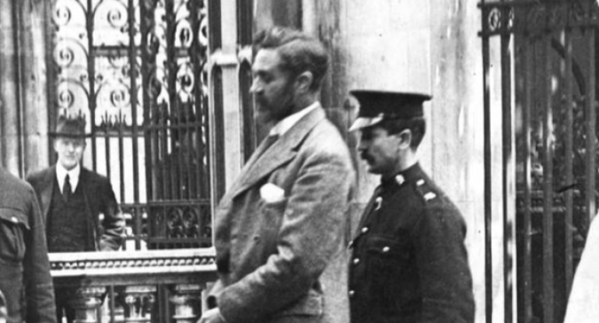
Casement being escorted to the gallows in 1916.
When Roger Casement, born in 1864 and one of the greatest heroes of Irish history, was led to the hangman at London’s Pentonville Prison in August 1916, he was accompanied by two Catholic priests: Father James Carey and Dean Timothy Ring of the East London parish of SS Mary and Michael. Casement, a former knight of the United Kingdom, had just made his first confession to Father Carey after a prison conversion to Catholicism. Eyewitness accounts of the day report that Casement’s confession was tearful and that the aura around him was “saintly.” One eyewitness declared that Casement was a saint, and that “instead of praying for him we should be praying to him.”
Some in the intellectual community question the authenticity of Casement’s conversion. Martin Duberman, in his new book Luminous Traitor, The Just and Daring Life of Roger Casement, writes that Casement’s decision to be received into the Catholic Church shocked some of his friends. “They’ve known Roger in the past to have mocked the Church’s self-importance and retrograde conservatism, once going so far as to assert that the Catholic Church ‘has done more to injure Ireland than the foreign Church [Anglicanism] could ever accomplish.’”
Duberman, the author of over 30 non-fiction books, plays, and novels, including Howard Zinn: A Life on the Left (2012); Paul Robeson (1989); and Cures: A Gay Man’s Odyssey (1991, 2001), can hardly be described as religious. Duberman has always been an impressive writer despite his often Kool-Aid-drinking Leftist leanings. I wondered while reading the book how Duberman would handle Casement’s conversion to Catholicism in light of the latter’s homosexuality.
A conversion to Catholicism, especially in 1916, would by necessity include a rebuke of the sins of the flesh (or the passions). The sins of the passions are non-negotiable when one is serious about asking forgiveness before the hangman’s noose sends the soul into the vortex of eternity. Personal priorities and former allegiances have been known to change radically at the hour of death, so it’s more than likely that Casement repented of his homosexuality to Father Carey.
Casement was also wildly, and perhaps uncontrollably, promiscuous. In his “Black Diary” he kept a record of his numerous sexual exploits around the world, complete with physical descriptions of his conquests that included age, location of the act, and penis size. The Black Diary is highly reminiscent of Paul Goodman’s Five Years, a modern diary of the New York writer’s promiscuous exploits around the globe, a document that the “verve-driven” Susan Sontag once derided as pathetic in its sexual compulsiveness.
Of course, the dichotomy of sinner to saint is an old one. Saint Augustine had male and female lovers, although he never kept a record of these physical checks and balances. One has to wonder if during his confession to Fr. Carey, Casement regretted leaving a diary of his sexual exploits behind. We don’t know the answer to this but we can say with certainty that Casement was much more than the Black Diary.
When Casement’s body was removed from the gallows it was thrown into a pit in the prison yard next to two other prisoners named Kuhn and Robinson. This was the final insult from British authorities, who ignored Casement family requests that the body be interred in his beloved Ireland.
He was arrested in Kerry on Good Friday, 1916, for attempting to smuggle weapons from Germany for the famous Easter Rising in April of the same year. Northern Irish Protestant by birth, he spent many years working for the British Foreign Office in Africa and South America where he became known worldwide as a great humanitarian activist and civil rights champion for indigenous peoples. Casement’s field work as a freedom fighter brought him to the realization that Ireland was not free, and that as an Irishman he had a duty to advocate for Irish independence. He came to believe that one cannot serve two masters. When he was knighted by the Crown and became Sir Roger Casement, he accepted the honor with embarrassment and hid the medals and regalia of his new status.
In his “White Diary,” Casement detailed his activist and political exploits on the world stage. After his arrest in Kerry, news of the Black Diary spread and helped to seal his fate. In those days, people could not understand how an Irish patriot could also be homosexual.
Well before his conversion, Casement had little tolerance for anti-Catholic sentiment. Duberman quotes Casement as the latter witnesses an anti-Catholic parade in Ulster: “The Church parade has begun past my windows -- heavens, how appalling they look, with their grim Ulster-Hall faces all going down to curse the Pope and damn Home Rule in Kirk and Meeting House and let their God out for one day in the week -- [one] poor old man with his teeth broken with the cursing.” Duberman adds: “Within a few short years, as Ulster’s fierce determination to remain part of Protestant Britain deepens, the more Roger will move away from the Protestantism that typifies the county -- and edge toward the Catholicism that predominates in the ‘disloyal’ rest of Ireland.”
Duberman remains skeptical of Casement’s religious conversion, however, which recalls for me the Janis Joplin song “I Need a Man to Love” in which the diva belts out “Oh no … Can’t be now … Oh no … Can’t be now,” when the life of the important world revolutionary shows an act of subservience and contrition before a power far greater than his own. The fact is, it’s highly unlikely that Casement went to his grave shaking his fist like a fiery Nietzsche or an unrepentant Christopher Hitchens.
Duberman writes: “When Father Carey’s superior stipulates that Roger must express sorrow ‘for any scandal he might have caused by his acts, public or private,’ before he can be received into the Church, Roger flatly refuses.” Duberman quotes Casement: “They are trying to make me betray my soul,” and adds “that a way out is found when Father Carey learns that Roger’s mother had him baptized as a young child. That means he can be regarded as already Catholic, one simply in need of reconciliation with the Church.”
The reconciliation we are talking about here, however, has nothing to do with the ambiguities surrounding Casement’s political quest, but rather the deeds that fill what would later become known as the Black Diary.
World figures like George Bernard Shaw, William Butler Yeats, Joseph Conrad, G.K. Chesterton, and Beatrice Webb came to Casement’s defense. “Even the Catholic primate Cardinal Michael Logue, an implacable opponent of the [Irish] nationalists, places himself prominently on the side of ‘mercy and charity,’” Duberman writes.
Imprisoned in the Tower of London, Casement had no visitors, no lawyers, no change of clothing from dirty garments he was arrested in. His shoelaces and suspenders were removed as a precaution against suicide.
Casement’s legacy was overturned in 1965 when his remains were repatriated to the Republic of Ireland. In 1965, the UK Cabinet also restored his knighthood when they referred to him, once again, as Sir Roger Casement.

