I read the three parts in 2010 which are all in one QUB 1999 bound volume, in PN2.
Brief notes below.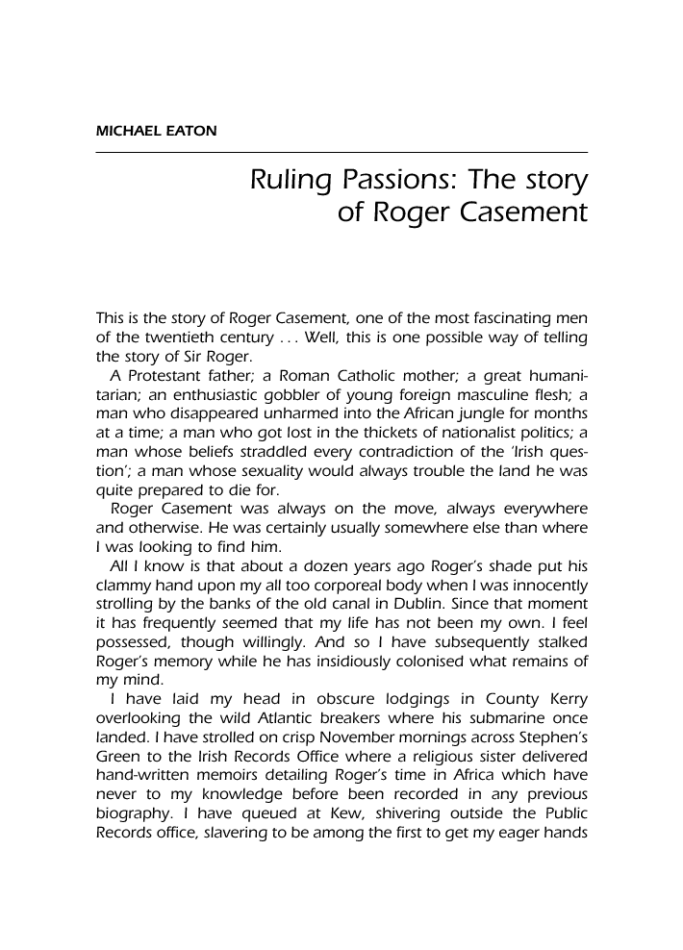

[ I Read the three parts all in the same bound 1999 volume of Critical Quarterly part-founded by AE Dyson [Homosexual law reformer in 1950s] (QUB library PN2.C9 Journals, 2nd floor) on 2 November 2010. Eaton wrote/directed ‘Shoot to Kill.’
p. 142 “decked out in a ludicrous semblance of a Celtic outfit with a winged helmet and cross gartered socks.” - Young Joseph Mary Plunkett (major character)
p. 83 (3) “built like a cart horse”
PC Gill’s name mentioned (note taker at interrogation) but not used.
Adler over-written as bossy.
Casement strangely invisible. Gertrude in love with him. Half a dozen very good lines.

