HISTORY IRELAND (Vol 24/4)
JULY/AUGUST 2016

CASEMENT ARTICLES BY PAUL HYDE AND ANGUS MITCHELL

[I responded to the Paul Hyde article on the finding of the diaries]

JEFFREY DUDGEON 2ND EDITION LISTING

http://www.historyireland.com/volume-24/reputations-roger-casement-history-question/

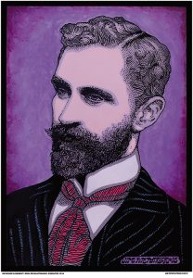

REVISION: Casement tried and tested—the Giles Report on the Black Diaries

A VERBAL SMOKESCREEN OF AMBIGUITY, REPETITIONS, IRRELEVANT DATA, DECEPTIONS, OMISSIONS, EX CATHEDRA PRONOUNCEMENTS AND DISINFORMATION
Published in Features, Issue 4 (July/August 2016), Volume 24
By Paul Hyde
The results of the 1959 test cannot be found; the 1972 test was amateurish; the 1993 test was inconclusive. Then in 2002 the Giles Laboratory was commissioned by Professor W.J. McCormack to examine the controversial diaries and subsequently declared them authentic. In the years since, work on Casement has progressed, and different questions might now be asked of the McCormack–Giles intervention.
The initial proposition given to document examiner Dr Audrey Giles was that she authenticate the questioned documents: ‘The Steering Group have set the initial proposition to be that the documents at Kew known collectively as Roger Casement’s Black Diaries are genuinely written in his hand throughout’. This instruction is fundamentally biased and compromises both examiner and the subsequent examination. For this reason alone the report would not have been accepted by any court of law.
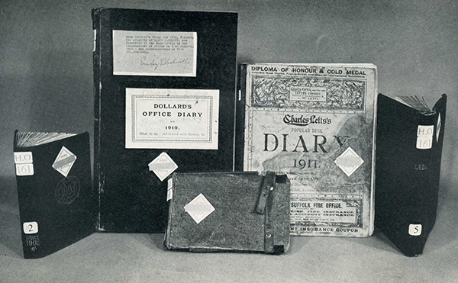
Above: The five Black Diaries—1 (centre), the Army Book, a small field service notebook [Feb. & July 1902]; 2 (from left to right), Lett’s Pocket Diary & Almanac [Feb. 1903–Jan. 1904]; 3, Dollard’s Office Diary for 1910; 4, Charles Lett’s Popular Desk Diary 1911; 5, Cash Leger [1910 & 1911]. (UKNA)
Scientific investigation seeks falsification, not verification
Dr Giles should have pointed out the limitations of handwriting examination and that it might be impossible to reach a definitive conclusion. Having accepted the commission, she proceeded to authenticate the documents. But it is axiomatic that scientific investigation seeks falsification, not verification. The dominant paradigm is tested by looking for weaknesses, contradictions, anomalies. Therefore the Giles investigation cannot claim scientific validity because it started from compromised premises. Further, the report does not fulfil the requirements of a forensic report to be demonstrated in a court of law because it lacks scientific detail, definitions and clear parameters. Quite simply, the conclusion is not demonstrated. Furthermore, there is an astonishing statement by Dr Giles confirming that certain tests were not carried out because she had already foreseen the results of those tests without performing them. She stated in RTÉ’s March 2002 Alan Gilsenan documentary, The Ghost of Roger Casement:
‘We could go ahead and carry out analysis of the inks, there are some problems there. There has to be a recognition that if indeed the Diaries are substantial forgeries, then they would have been produced at about the same time as the documents are dated or not long afterwards. So they are going to be produced using materials of the age, so I doubt whether in the end any close analysis of the ink is going to tell us a great deal about them.’
This statement alone is sufficient to convince the ‘forgery theorists’ that the Giles/McCormack enterprise was planned as a media event rather than an impartial scientific investigation. It perfectly demonstrates the error of seeking verification rather than falsification of a thesis: the examiner uses only those tests and methods that will produce the desired result. In this case the methods used were those of comparative handwriting analysis, which, by Dr Giles’s own admission, are subjective: ‘Handwriting examinations are necessarily to some extent subjective. It relies on my judgement to determine whether features are the same or different.’
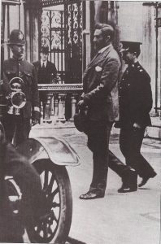
Above: Roger Casement leaving court after the appeal against his conviction had been dismissed. (Daily Mirror Picture Library)

If anything, the Giles Report raised more doubts than existed before. According to Marcel Matley, a US document examiner, in his sixteen-page devastating critique: ‘Even if every document examined were the authentic writing of Casement, this report does nothing to establish the fact’. Apart from scientific inadequacy, media publicity (including two TV documentaries) caused doubts that the entire enterprise was a political/publicity stunt masquerading as scientific investigation, an impression compounded by press misreporting that ink, pollen and DNA tests had given definitive conclusions when no such tests had been carried out.
The report was peer-reviewed by US document examiner James Horan:
‘As editor of the Journal of Forensic Sciences and the Journal of the American Society of Questioned Document Examiners, I would NOT recommend publication of the Giles Report because the report does not show HOW its conclusion was reached. To the question, “Is the writing Roger Casement’s?”, on the basis of the Giles Report as it stands, my answer would have to be I cannot tell.’
Nevertheless, the media campaign proved successful not only in perpetuating the official thesis of authenticity but also in regenerating that untested thesis as definitively proven. Doubters became heretics as scientific investigation became propaganda.
Cognitive bias
Leading US experts, including Andrew Sulner (Fellow of the American Academy of Forensic Sciences, lawyer and former state prosecutor) and Professor Dan Simon, have explored cognitive bias and flawed forensics. Sulner has pointed out that too many handwriting experts still believe that training and experience shield them from the biasing influences proven to impact the accuracy of visual observations and decision-making by ordinary mortals. In his paper ‘Cognitive and motivational causes of investigative error’, presented to the American Academy, Professor Simon explained how errors can compound with each other and demonstrated various dangers in forensic investigations, such as selective framing (the inquiry is framed in terms designed to influence the outcome), selective exposure (the information provided is chosen to influence the outcome) and selective stopping (the inquiry ends when the hypothesis appears to be confirmed). The Giles Report is afflicted by all three defects.
It is now increasingly recognised in the US forensic science community that experts are reluctant to acknowledge the possibility of mental contamination of evidence in the form of cognitively biased evaluations. As highlighted in the 2009 National Academies of Science report Strengthening forensic science in the US, research in behavioural science and information obtained from reviews of errors in high-profile cases have clearly established the adverse impact that contextual and motivational biases have on human judgement and on the accuracy of forensic evaluations of evidence.
Scrutiny
Deep scrutiny exposes the following lethal defects in the Giles Report. Firstly, whereas document examiners do use the term ‘consistent with’ despite its lack of precision, ‘consistent with’ says no more than ‘might be’ owing to a degree of observed similarity. But an imprecise degree of similarity is insufficient for positive identification and therefore is inconclusive.
A series of ‘consistent with’ results is more persuasive than one or two such results because the apparently repeated similarity suggests lower probability of error in each observation. It does not, however, guarantee error elimination—the key word is ‘suggests’. It is here that cognitive bias plays a determining role by unconsciously programming the search for repeated similarity. The subjective perceptive mechanism becomes less impartial as it is progressively conditioned by a cognitive bias created by previous observations; we see what we have been previously conditioned to see. The process is called recognition.
Dr Giles reaches ‘conclusive’ evidence by repeating the expression ‘if taken together’ in the preambles to her conclusions; this expression, following the imprecise ‘consistent with’, overlooks the distinct features of single contentious entries. A number of ‘consistent with’ assertions grouped under ‘if taken together’ produce what she calls ‘conclusive evidence’. But ‘consistent with’ is not a constituent of conclusive evidence because it is an intermediate term on the scale of value determination; any number of identical inconclusive terms cannot produce a conclusive result.
This is a misapplication of the Law of Large Numbers, which requires variant input values in order to produce a result higher than some of the input values: 2+3+4+5 divided by 4 = 3.5, which is higher than two of the input values, but 3+3+3+3 divided by 4 = 3, which is identical to all input values. Therefore a series of ‘consistent with’ input values cannot produce a result higher than any single input value. Identical inconclusive values cannot produce conclusive results. The final Giles conclusion ought to be ‘consistent with’, which is inconclusive. This outcome would be ‘consistent with’ the 1993 result of ‘correspond closely’.
Secondly, the term ‘consistent pattern’ appears on six different occasions in the report. What is meant by ‘consistent pattern’ goes unexplained, however, but it clearly refers to the ‘contentious entries’. Regarding the possibility of forged entries, Dr Giles states: ‘… I would expect to find evidence of this in the form of a consistent pattern of contentious entries’. Without an explanation, one must guess at possible meanings. Does she mean that the contentious entries should show features that distinguish them as a group from innocuous writings? Does she expect the questioned writings to be labelled for easy identification? If they were easy to identify by virtue of shared distinctive features, then the hypothetical forger would have utterly failed. Dr Giles does not even explain why she would expect to find any pattern. Surely a repeated detectable pattern acts like a label and is exactly what the forger would avoid?
At another point, she discusses the difficulty of simulating another person’s handwriting owing to the need to suppress the writer’s own handwriting during simulation. ‘Whereas this may be done over a small portion of handwriting, this becomes extremely difficult over more than a few lines of handwriting.’ But is she referring to a beginner or to an experienced forger? No one disputes that the writings, if forged, were done by an expert. But even this misses the point. The fact is that the contentious entries are all relatively brief. Dr Giles states many times that the entries are ‘restricted in quantity’, ‘limited quantities of comparable material’, ‘the contentious entries represent a small amount of comparable material’. The contentious entries never amount to ‘more than a few lines of handwriting’—frequently much less. Thus this brevity facilitates the experienced forger, who never needs to simulate extended handwriting such as a letter might contain.
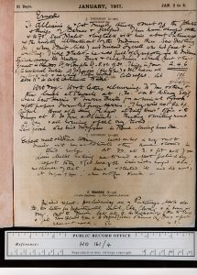
Above: The 1911 Lett’s Diary, 5–8 January, which, according to Dr Giles, contains contentious writings ‘on virtually every page … It is easier to identify areas where the entries are non-contentious rather than where they are contentious’. No explanation is given for this easier distinction. (UKNA)
When Dr Giles discusses the 1911 Lett’s Diary, which contains contentious writings ‘on virtually every page’, her argument does not improve. A curious comment follows: ‘It is easier to identify areas where the entries are non-contentious rather than where they are contentious’. No explanation is given for this easier distinction. This is strange, because the two types of entries are, by her own account, free of any ‘significant differences’ and therefore should be indistinguishable. The only difference would then be semantic: one with sexual references, the other without. To someone without English, these writings would be identical if there are no significant differences. Dr Giles is English, so we must assume that she detects the difference without noting semantic content, but on what basis she does not explain. This distinction, however, would constitute a significant difference requiring reasoned explanation. Even stranger is her later comment: ‘The contentious entries are a large and integral part of the entries of this Diary and cannot be separated in any way from the innocuous entries’. This contradicts her earlier separation of contentious and non-contentious entries.
In her quest to provide another form of ‘proof’, Dr Giles explains that special instruments were used to detect alterations, deletions and erasures. On two separate occasions she states that limited testing for erasures was done on blank pages and no evidence was found. The tests were limited because ‘unfortunately, without some manipulation, the Diary pages cannot be subjected to ESDA (Electrostatic Detection Apparatus) examination’. On a separate occasion, the erasure test is again performed on blank pages; again these pages ‘are not suitable for’ the ESDA technique. No evidence was found. Therefore limited erasure tests were applied only to pages without writing and by chance those blank pages—and only those—were unsuited to ESDA testing. No erasure tests were done on any written pages to detect suspected interpolation of contentious writing.
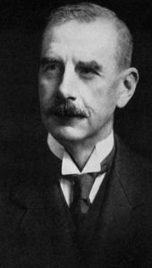 Basil Thomson

Perhaps the most awkward facet of Dr Giles’s approach is when she noted differences in the questioned writings but made them ‘disappear’ by not counting them as significant because such differences must be explained. Unable to find reasonable explanations for significant differences, they became insignificant. Nevertheless, she did not find comparable significant differences in the unquestioned writings. Their absence in the unquestioned writings constitutes sufficient reason to consider the significant differences as evidence of forgery. This point was also made by US document examiner Marcel Matley in June 2015: ‘In reality Giles unwittingly proved at least some “contentious entries” were by a different hand’.
Does the Giles Report actually demonstrate the falsity of its own conclusions? Instead of lucid exposition, what precedes the conclusion is a verbal smokescreen composed of ambiguity, repetitions, irrelevant data, deceptions, omissions, ex cathedra pronouncements and disinformation. A century on from their miraculous appearance, the provenance of the Black Diaries has not been determined. The release of the ‘discovery’ document (MEPO 2/10672) in 2001 after 85 years of secrecy met with ominous silence. This police list of personal effects allegedly found in Casement’s trunks, date-stamped 28 July 1916, adds one more version to Thomson’s four conflicting versions and to that recorded in the interrogation transcript. The Giles Report, despite its scientific veneer, cannot eliminate the fact that there are now six versions of discovery of the diaries. That a single credible account of the provenance of the crucial documents cannot be produced after 100 years reveals dangerous instability in the foundations of the authenticity edifice.
Paul Hyde is a retired university lecturer.
FURTHER READING
Mary E. Daly (ed.), Roger Casement in Irish and world history (Dublin, 2005).
P. Hyde, ‘Lost to history: an assessment and review of the Casement Black Diaries’, https://breac.nd.edu/articles/65746-lost-to-history-an-assessment-and-review-of-the-casement-black-diaries
REPUTATIONS: Roger Casement and the history question

IRRESPECTIVE OF THE QUESTION OF THEIR AUTHENTICITY, IT IS NOW UNIVERSALLY AGREED THAT THE BLACK DIARIES WERE INTEGRAL TO A SMEAR CAMPAIGN CONJURED UP IN 1916 TO RAILROAD CASEMENT TO THE GALLOWS AND DENY HIM THE MORAL HIGH GROUND THAT HELPED TO JUSTIFY THE IRISH REBELLION.
By Angus Mitchell
One bold deed of open treason: the Berlin diary of Roger Casement 1914–1916 becomes my third edited volume in the retrieval of the Casement archive. This project began back in 1997 with the publication of The Amazon journal of Roger Casement and was followed by Sir Roger Casement’s heart of darkness (reviewed in HI 11.4, Winter 2003). These initial two volumes enabled a deeper reading of the critical years 1910 and 1911. This third edition covers Casement’s time in Germany following the outbreak of the First World War. Cumulatively, the volumes provide insight into one of the more complex and misunderstood Irish activists of the revolutionary generation and his internationalism. On another level, the texts facilitate a new way of analysing the Black Diaries’ controversy (see HI 9.2, Summer 2001, pp 42–5).
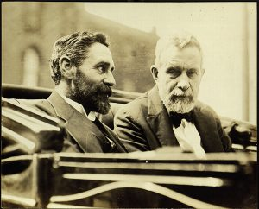
Above: Casement with John Devoy, leader of Clan na Gael, in New York during the July crisis of 1914, where the Berlin diary narrative begins. (Villanova University)
Berlin diary
In his Berlin diary, Casement divulges his deeper political intentions behind diary-writing. On his departure from Germany for Ireland in April 1916, he left clear and explicit instructions for the safekeeping of this document, despite the fact that it was intentionally self-incriminating and explained the logic behind his treason. In his own words, the reader is led into an entangled conspiracy against his former British Foreign Office colleagues. The narrative begins during the July crisis of 1914, with Casement arriving in New York (spied on from every side) to liaise and plot with the Irish Republican Brotherhood executive. His own credibility with other revolutionary leaders reaches a high point in the wake of the successful landing of guns at Howth and Kilcoole. In late October, after leaving the US, Casement passed through Christiania (Oslo) on his way to Berlin. By then he had become a high security risk and efforts were made by British secret services to have him ‘knocked on the head’—in short, assassinated.

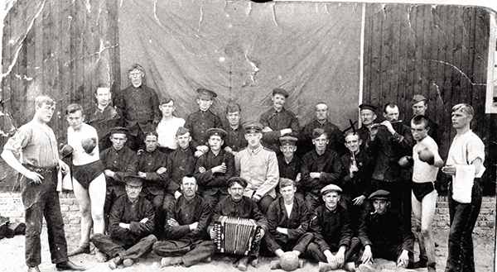
Above: Recruits to Casement’s Irish Brigade pictured in Germany—half of the total of 56 who joined up. His largely futile efforts to raise an Irish Brigade caused him deepening levels of frustration. (NMI)
In Berlin, Casement entered into a long process of negotiations with different tentacles of Imperial Germany’s wartime government. His journey through Belgium to the Western Front to meet senior officers in the German general staff is described. He details his subsequent conversation with the chancellor, Theobald von Bethmann Hollweg, and other senior politicians. His largely futile efforts to raise an Irish Brigade display deepening levels of frustration. The diary cuts out from late February 1915 to March 1916; then it revives as Casement prepares to leave Germany for Ireland to try and stop the rebellion or stand and die beside his comrades.
Beyond what the diary tells us of Casement’s ‘treason’, the narrative provides intriguing insight into the covert world of both British and German wartime intelligence agencies. His heated encounters with the German spymaster Rudolf Nadolny (grandfather of the acclaimed German novelist Sten Nadolny, author of The discovery of slowness) afford insight into the inner workings of the Prussian war machine. On another level, the deepening intrigue exposes further motives as to why the question of Casement’s diaries persisted as an issue. In the course of his Berlin confession, Casement describes how he consciously forges extracts from his diary in a scheme to deceive the British Foreign Office. When lengthy excerpts from the Berlin diary were published in the US, Ireland and Germany during the signing and implementation of the Anglo-Irish treaty between November 1921 and February 1922, the spectre of the Black Diaries returned.
Homophobia
In a sense Casement was a ‘gay martyr’: the incitement of popular homophobia was intrinsic to ensuring his execution and denigrating his meaning among his national and international networks of support. Moreover, there are revealing links between his trial and the later negotiations of Irish independence. Casement’s prosecutor, Lord Birkenhead, and his defence solicitor, George Gavan Duffy, were both signatories of the Anglo-Irish Treaty. Authentication of the Black Diaries became part of the secret negotiation in the background to the treaty. Their endorsement was part of the secret history of the Irish independence struggle. Why else would Collins have opened an official file series in 1922 labelled ‘Alleged Casement Diaries’?
This set the Irish state down the road of a deeply ambivalent relationship with both the Black Diaries and Casement. On one side, there was a need to recognise the role that Casement played in the move towards and justification of rebellion and as a founding father of an independent Irish foreign policy. On the other side, accepting the authenticity of the Black Diaries was an undisclosed element in the Irish Free State deal. This unplayable hand would define the dispute over Casement’s legacy in the Anglo-Irish history wars of the next century and culminating in this year of commemoration.
In England, the diaries helped in a different type of cultural construction, leading to the disremembering of Casement within British imperial history. After years of denial of their very existence, the Black Diaries passed in 1959 into the custody of the Public Record Office, rebranded today as the National Archives (UK). Researchers seeking access were carefully vetted by the Home Office and required permission from the incumbent home secretary. On the return of Casement’s bones to Ireland in 1965, a further understanding was agreed between London and Dublin that essentially closed down open discussion on the diaries’ controversy for another 30 years.
Psychological biographies
During that period, public consensus regarding the veracity of the Black Diaries was built through the publication of a steady stream of psychological biographies that locked the Black Diaries into the heart of Casement’s life. This intervention primed Casement to become a ‘gay icon’ as much as a national liberator. But messages remained mixed.
In the summer of 1994, on the release of the Black Diaries into the public domain, Professor Paul Bew wrote a controversial article in History Ireland (HI 2.2, Summer 1994, pp 41–5) arguing unequivocally for the authenticity of the diaries. A few months later, Professor Stephen Howe, reviewing Edward Said’s Orientalism for the New Statesman (24 February 1995), commented that ‘the diary was almost certainly forged by the British government to aid in railroading Casement to the gallows’.
Howe’s comment hinted at a ‘knowingness’ or subjugated knowledge that has informed the view about Casement from within the historical academy. But in Howe’s Ireland and empire (2000) Casement received passing mention, despite a deepening recognition amongst post-colonial theorists of the latter’s damning critique of western imperialism. Tension and dissonance within élite academic circles was set to continue.
Publication of The Amazon journal in 1997 had drawn attention to the fact that there was much confusion over the relationship between ‘Black’ and ‘White’ diary narratives describing the same 75-day period during 1910 when Casement investigated the activities of a British-owned Peruvian rubber company. This opened up the controversy to another kind of scrutiny that was scholarly and textual and not politically constrained and luridly sexual. The Amazon journal demonstrated how Casement was deconstructing the racist logic of empire. His incisive analysis exposed the gender-based violence supporting international venture capital. To a shocked metropolitan audience, he revealed the resource wars fought in the name of civilisation against peaceful, indigenous communities and their environments. The fact that the Black Diaries configured so precisely with his investigations into atrocities in the Congo Free State in 1903 and in the north-western Amazon in 1910 and 1911 was becoming their most revealing weakness.

Proustian hero?
It is now evident that the Black Diaries have enabled their own form of epistemological violence, whereby Casement’s achievement as both a pioneer of human rights and a whistle-blower could be marginalised by playing the ‘paedophile’ trump. If the Black Diaries are to be placed centre stage to their biographical subject, then their author, even in today’s terms, was not engaging with ‘hospitable bodies’ but was using his position in deeply exploitative power games. Revisionist efforts to try and turn the sexualised Casement into a kind of Proustian hero, or a gay role model, do not stand up to rigorous scrutiny of the texts. Besides the homophobic world in which they were conjured, the diaries are deeply racist. By manipulating meaning, they demean the authority of the investigator. Casement’s cultural construct as an urbane and playful cosmopolitan queer has little to do with the encrypted distortions evident in the sexualised version of events.
Like other revolutionary leaders involved in 1916, Casement was acutely aware of his place in history and the centrality of the written word to that place. As a British civil servant, he was aware, too, of the role of the archive in the production of history. I have long argued that his most subversive act was to leave on the official record an indelible indictment of colonial power: a denunciation that western historiography is still reluctant to acknowledge. Heading towards his own violent end on the scaffold—with the role of sexuality in the demise of both Parnell and Wilde still in living memory—is it really probable that he would have so conveniently left the ingredients for the subversion of his pioneering investigations? In any interrogation of the Black Diaries, questions to do with motive and probability weigh heavily on the side of forgery.
At the state’s commemoration at Banna Strand on 21 April 2016, the British ambassador to Ireland, Dominick Chilcott, when interviewed by Radio Kerry, claimed that Casement’s ‘memory was lost in the [British] national consciousness’. Part of the process for that disremembering has been accomplished through the presence of the Black Diaries. Another motive for the forgery was to cover up a huge crime against humanity: a destruction of communities and environment that stretches from the upper Congo to the north-west Amazon to the destitute fringes of Connemara. Millions of dead souls—souls without history—haunt the shadows of Casement’s tragedy. In his challenge to the imperial order, Casement blew the whistle on this catastrophe, and his engagement with revolutionary politics was a way by which he articulated his deepest sense of outrage against the system.
‘Dangerous memories’
Britain’s example of disremembering operates in direct opposition to what the theologian Johann Metz has described as the need to collectively connect with ‘dangerous memories’. Casement is one such memory. Engaging with his life and death demands that we critically confront the victims and suffering created by the complacent structures of western power. His life opens up challenging perspectives on history and remembrance and their continuing interaction.
Surely if the Republic of Ireland is now ‘mature’ enough to welcome the British monarch into its midst, then the UK’s National Archive, without pageantry, can reattribute the Black Diaries. Thereby acts of interpretative violence can cease and Casement can be accepted as a rebel with a cause, whose memory should hold historic value and respect on both sides of the Irish Sea and beyond.
Angus Mitchell lectures in the Kemmy Business School at the University of Limerick.
Published in Features, Issue 4 (July/August 2016), Volume 24
FURTHER READING
R.F. Foster, ‘History and the Irish Question’, Transactions of the Royal Historical Society 33 (1983).
P. Hoare, Wilde’s last stand: decadence and conspiracy and the First World War (Duckworth, 1997).
A. Mitchell, ‘Phases of a dishonourable phantasy’, Field Day Review 8 (2012).
Angus Mitchell’s writings on Roger Casement can be accessed through his academia.edu site: https://limerick.academia.edu/AngusMitchell.

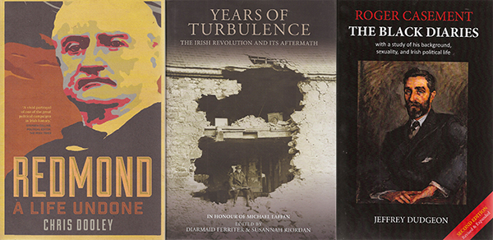Jeffrey Dudgeon, Roger Casement: the black diaries—with a study of his background, sexuality, and political life (2nd edn) (Belfast Press, €26 pb, 728pp, ISBN 9780953928736).

This issue contains articles by Paul Hyde and Angus Mitchell questioning the authenticity of the Black Diaries of Roger Casement. Jeffrey Dudgeon’s Roger Casement: the black diaries—with a study of his background, sexuality, and political life, published by Belfast Press, takes a different view. First published in 2002, this new edition includes extended versions of the 1903, 1910 and 1911 diaries, addresses the 1881 Scribbling Diary and solves the mystery of the missing US money in 1916. Much of the focus of Dudgeon’s new research has been on Casement’s time in Berlin, as well as on his companions of the time and the role of British intelligence in 1916.

