The executed Sir Roger had many virtues... but dark side of his nature must not be ignored

This British diplomat and Irish nationalist was a complex and tortured soul, says Ruth Dudley Edwards
Belfast Telegraph
8 August 2016
http://www.belfasttelegraph.co.uk/opinion/columnists/ruth-dudley-edwards/the-executed-sir-roger-had-many-virtues-but-dark-side-of-his-nature-must-not-be-ignored-34945846.html
- 3 Comments
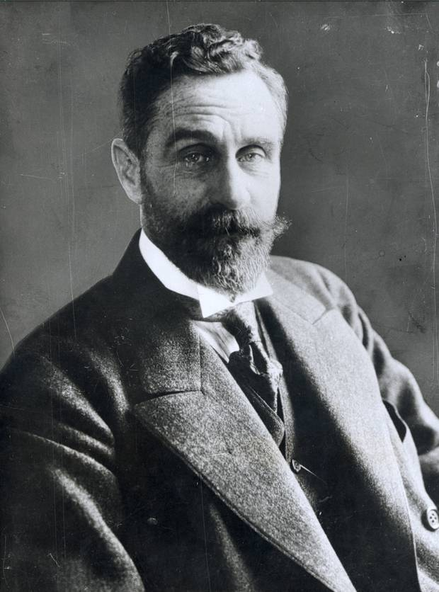
Sir Roger Casement was hanged for treason

There were commemorations last week marking the death on August 3, 1916 of Roger Casement, born in Dublin in 1864 and brought up from the age of nine in Ballymena.
Casement would achieve fame and a knighthood for his work in the British consular service exposing atrocious brutality in the Belgian Congo and the Amazonian region of Putumayo and for dying in Pentonville Prison at the end of a hangman’s rope after being found guilty of treason.
He would also be the subject of furious argument for a century between those who accepted that his graphic diaries about his homosexual encounters were genuine and those who insisted they were forgeries commissioned by the British Government to undermine the case for clemency.
In Belfast a plaque was unveiled at the gates of the GAA’s Casement Park.
In Dublin, at a wreath-laying ceremony in Glasnevin Cemetery, Charlie Flanagan, Minister for Foreign Affairs and Trade, described Casement as having been “motivated by a deep sense of the injustice he witnessed in the suffering which affected many in Irish society and an equally strong belief in the right of the people of Ireland to decide their own futures”.
In London there was a commemorative Mass for him in Westminster Cathedral, for Casement converted to Roman Catholicism the day before his execution.
Later, at the Irish Embassy, Ambassador Dan Mulhall, who does much to encourage a nuanced view of contentious aspects of Irish history, said Casement’s “greatest achievement lay not in helping pave the way for the Easter Rising, but in his courageous stand in defence of oppressed peoples in Africa and Latin America”.
He’s right.
Casement’s independence of mind and fearlessness in exposing inhumanity is greatly to be admired and can be celebrated by Irish people of all political persuasions.
And anyone who believes the gun-running at Larne in April 1914 to equip the Ulster Volunteer Force was justified is in no position to condemn Casement for his key role in arranging the delivery of guns in July to the Irish Volunteers.
Fair’s fair.
Other aspects of his conduct are more questionable.
In his admirably even-handed biography — Roger Casement: The Black Diaries — UUP Belfast city councillor Jeff Dudgeon destroyed the arguments of those who can’t accept that Casement was the author of those detailed accounts of promiscuous sex with strangers.
I’ve no problem with those who disobey unjust laws against homosexuality, but there’s no avoiding the uncomfortable truth that this great humanitarian was a predator who paid African and South American adolescents for sex.
Selfless in his work, he was deeply selfish in his sex life.
I also have a problem with what was, indeed, treachery.
I heard Shami Chakrabarti, one-time head of Liberty and recently recommended for a peerage, parroting the popular Left-wing view that Casement had opted for revolution because he hated imperialism.
In which case it was deeply perverse of him to seek help during a world war from a mortal enemy of his country that was a far nastier imperial power than the one he was betraying.
Ingloriously, Casement would spend 18 months in Germany trying unsuccessfully to persuade Irish prisoners of war to change sides. During this period he became disillusioned by the German reluctance to do much to help the planned rebellion and turned against them as he had turned against the British.
By the time he landed in Kerry off a German submarine accompanying a ship with a modest supply of arms, he was set on trying to scupper a revolution he believed would fail, but he was immediately captured.
Casement’s was a tragic life.
Like most of the leaders of the Easter Rising he had identity problems, not least because of his father’s Protestantism and his mother’s Roman Catholicism. She died when he was nine and his father four years later.
Intensely romantic in temperament, he was bipolar, and often in states of wild enthusiasm or deep despair.
We should remember his fine work with admiration, but we do him a disservice if we ignore the dark side of a complex man.

