What Lies Beneath - Niall McMonagle: Roger Casement

Roger Casement, Patriot and Revolutionary, by Sarah Purser [1848-1943], oil on canvas courtesy National Gallery of Ireland
Sunday Independent
3 August 2014
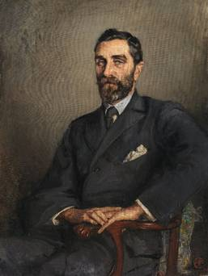
Painting by Sarah Purser
Teaching Yeats's poem Easter 1916, every teacher enjoys the pupils' astonishment and admiration for Yeats's craftsmanship on their discovering that Easter Monday, 1916, the date of this seismic event, is incorporated into the very shape of the poem on the page. Four stanzas, each being either sixteen or twenty-four lines long produce that momentous date: 24.4.16.
Another significant date in Irish history is today's date, 3 August. In 1916 it fell on a Thursday and Sir Roger David Casement, having been tried for treason, was hanged ninety-eight years ago on this day in Pentonville Prison. Born in Sandymount, orphaned at thirteen, he grew up in Ballymena, joined the British Consular Service, served in Africa and Latin America, where he condemned the exploitation of workers, and was knighted in 1911. Anti-imperialism and support for Irish Independence followed. Having joined the Irish Volunteers he went to Berlin to seek help, was captured on landing from a German U-boat on Banna Strand on 21 April 1916 and converted to Catholicism while awaiting execution. The Black Diaries, suppressed until 1959, add another complex dimension. 1n 1965 Casement was given a state funeral and reinterred in Glasnevin Cemetery though he had asked to be buried on the north Antrim coast. Sarah Purser painted many figures who feature in Ireland's nationalist, emerging story: Maud Gonne, Yeats, Edward Martyn, Douglas Hyde and this splendid, commissioned portrait of Roger Casement from 1914.
Casement, old-fashionedly handsome, is seated on an elegant, round-backed chair against a plain background. The clothes are formal as is the pose but the raised left shoulder and the hands suggest a certain unease. Nervous, sideways-glancing eyes suggest a man on the edge. The colours are mostly sombre but for the brocaded cushion and the red letter in the right-hand corner. The letter "e" meaning Deanta in Eirinn/Made in Ireland. The painting was, as was the sitter.
Sunday Indo Living
- See more at: http://www.independent.ie/entertainment/theatre-arts/what-lies-beneath-niall-mcmonagle-roger-casement-30472124.html#sthash.7bORX2ev.dpuf

