National Library releases documents from Roger Casement’s incarceration

Materials include portraits, documents relating to the degradation of his knighthood and touching letters to his family in the final days before his execution.
21 December 2012 The Journal
Yesterday, 7:45 AM 3,273 Views 18 Comments
Share Tweet27
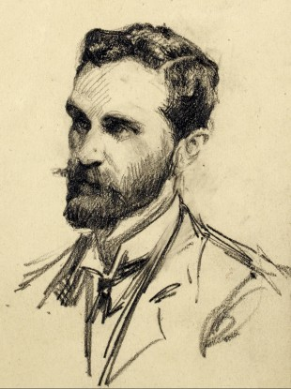
Portrait of Roger Casement.
Image: National Library of Ireland
THE NATIONAL LIBRARY of Ireland (NLI) has released a number of letters written by British diplomat Roger Casement while awaiting his execution for treason at Pentonville Prison in 1916.
Casement was one of the most controversial figures in Irish history and was a well known poet, human rights campaigner and Irish nationalist. He was born in Dublin in 1864, was bapttised a Catholic at the age of three and was later raised by Protestant relatives in Ballymena following the death of his parents.
A British consul by profession, he became famous for his reports and activities against human rights abuses in the Congo and Peru. His investigations into atrocities in the Congo let him to develop anti-Imperialistic opinions and ultimately a pro-Irish Republican stance.
Returning from Germany shortly before the Easter Rising in 1916, he was arrested on arrival in Ireland and charged with treason. He was subsequently convicted, and was hanged in Pentonville Prison on 3 August 1916 at the age of 51.
Documents
Included in the group of materials released by the NLI are a number of letters written to his family from prison before his execution, a hymn and prayer book given to him by an Irish friend during his incarceration, photographs and documents relating to the ‘degradation’ of his knighthood.
The papers had been housed in a small box marked “Not for Consultation” which the library said usually means the donors wish for the contents to be withheld from the public until all parties cited in the documents are deceased.
Among the most interesting items are letters on prison-regulated paper from Casement to his cousins about his imprisonment and impending death, thanking them for their “brave, faithful, loving hearts to me in these last horrible days”. Another letter outlines his final wishes including his hopes for Ireland and naming people to whom he wishes to be rememberd.
In his final letter to his cousins Gertrude and Elizabeth Banniser in the eve of his execution he writes: “And if I die, as I think is fated, tomorrow morning, I shall die with my sins forgiven …If it be said I shed tears – remember tears come not from cowardice, but from sorrow.”
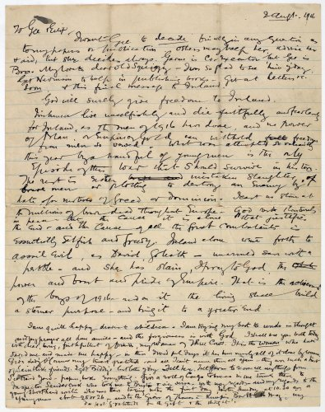
(View larger version here)
The collection includes typed copies of official papers and the Royal Ordinance stripping Casement of his knighthood and other honours. Casement’s handwritten notes on these papers include the comment: “These letters patent are letters of nobility in the peerage of Ireland! They are further letters of proof of British falsehood and hypocrisy.”
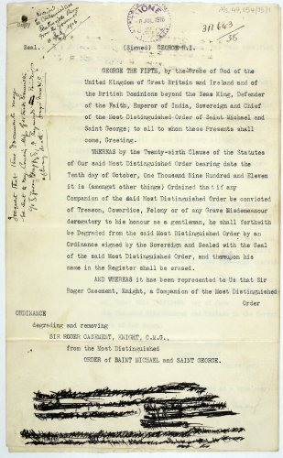
(View larger version here)
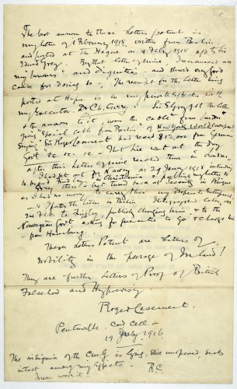
(View larger version here)
A prayer book, given to Casement by an Irish friend during his incarceration at Pentonville before his execution was also included in the documents released by the NLI.
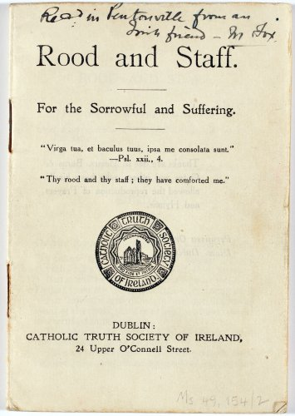
(View the larger version here)
In 1965, Casement’s body was repatriated to Ireland. During the five days while he lay in state at Arbour Hill, an estimated 500,000 people filed past his coffin. He was buried with full military honours in Glasnevin Cemetery in Dublin.
President Éamon de Valera, then in his mid-eighties and the last surviving leader of the Easter Rising, defied the advice of his doctors and attended the ceremony, along with an estimated 30,000 Irish citizens.
All of the recently released Casement material has been catalogued and key items can be viewed online today through the NLI catalogue.

