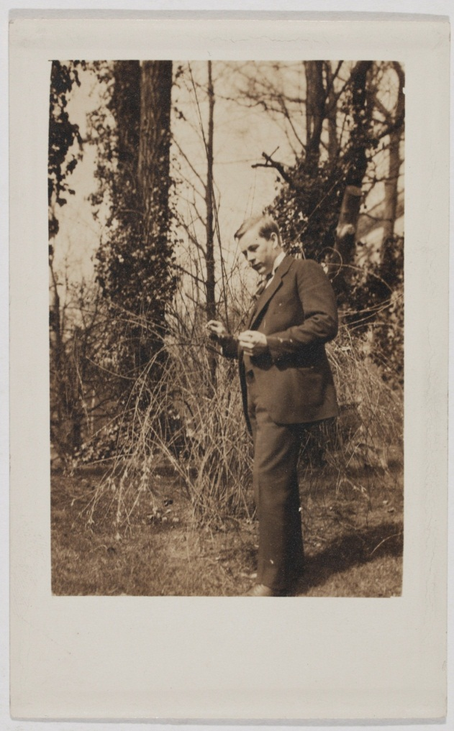

[Photocard copy of a handwritten statement by Mansfeldt de Cardonnel Findlay, H.B.M. Minister, British Legation at Christiania, Norway]

Main Author: Findlay, Mansfeldt de Cardonnel, Sir, 1861-1932
Summary: Handwritten statement by Mansfeldt de Cardonnel Findlay, H.B.M. Minister, British Legation at Christiania, Norway, promising to pay Adler ...
Format: Book
Language: English
Published: [Oslo : s.n., ca. 1914].
Subjects:
Casement, Roger, > Sir, > 1864-1916
Christensen, Adler, > 1890- > Correspondence
McGarrity, Joseph, > 1874-1940
Notes: This item is held in the Ephemera Department.

Originally this photocard copy was part of the McGarrity papers [in the NLI Manuscripts Department].

With: a photograph card [of Adler Christensen?] and an envelope that has "A. Christensen" written in pencil on it.

[Envelope not in Adler’s script]
Physical description: 1 card; 14 x 9 cm.
MARC
Call Number View in Collection
EPH A430 Prints & Drawings - Appt. only Ephemera
Reproduction rights owned by the National Library of Ireland.

