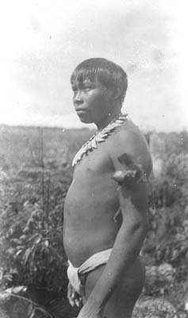

NLI CAS 21C
‘Man standing, Putumayo region of Peru/Columbia
1 photographic print 14 x 9 cm.
Man is wearing a necklace and armband’
Ricudo surely.

