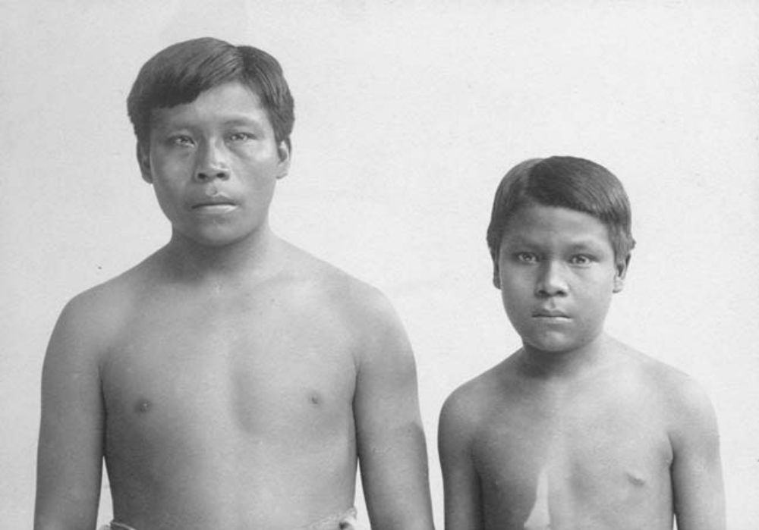

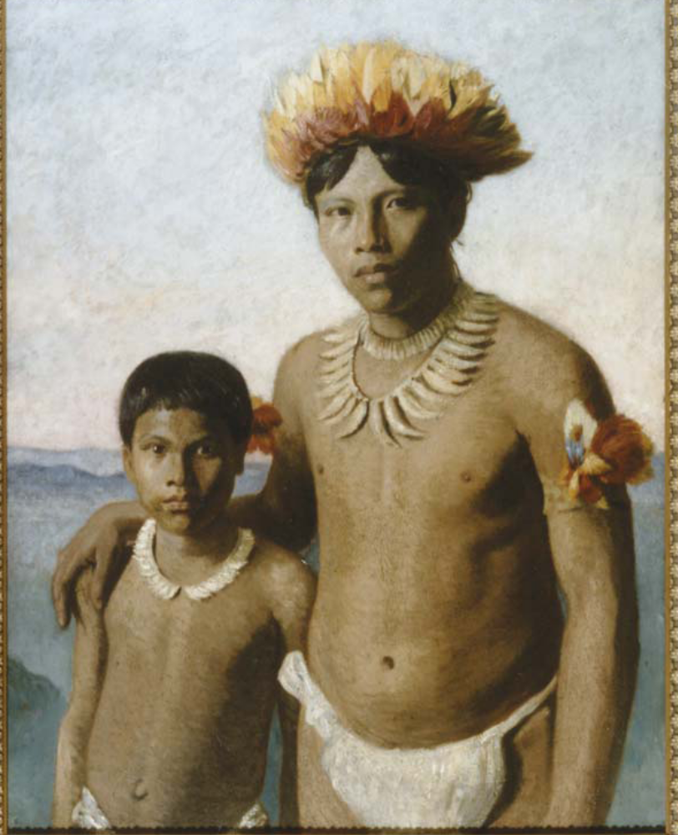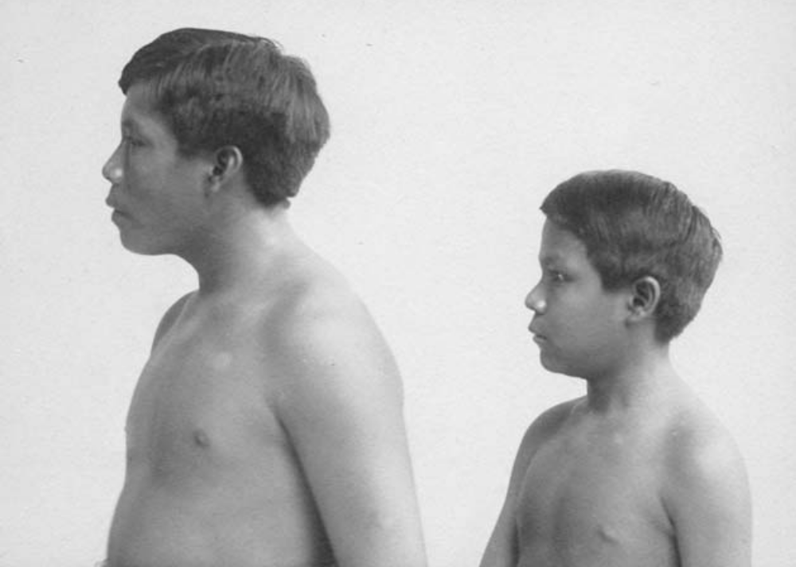Ricudo and Omarino from Lesley Wylie article

The author would like to thank the National Library of Ireland, the Museum of Archaeology and
Anthropology, University of Cambridge, and Dr Roger Sawyer for permission to reproduce the
images that appear in this article.

