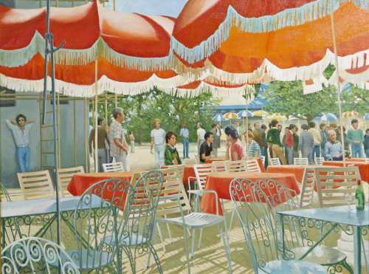

Henry Robertson Craig RHA RUA (1916-1984)
Lot 19
Café at Faro, 1970
Oil on canvas, 60 x 79cm (23.5 x 31.25")
Signed, also signed and inscribed with artist's reference 'HRC807'
Provenance: The Henry Robertson Craig/Patrick Hennessy Studio Sale, Christies 1986, Cat. No. 90
Important Irish Art Sale, James Adam & Sons, Oct 2006, Cat. No. 193 where purchased by the current owner
Exhibited: Hennessy/Craig RHA Scholarship Exhibition, The Highlanes Gallery, Drogheda, June-September 2007
€4000-6000
Important Irish Art Sale James Adam Salerooms
6 December 2010

