The US diplomat wrote that the homophobia of bill sponsor David Bahati MP was “is blinding and incurable”.
The cables also refer to anti-gay pastor Martin Ssempa and Ugandan ethics minister James Nsaba Buturo.
One said: “Bahati, Buturo, and particularly Ssempa’s ability to channel popular anger over Uganda’s socio-political failings into violent hatred of a previously unpopular but tolerated minority is chilling.”
Enock Nsubuga, 22, has been remanded to Luzira prison for the suspected murder of David Kato until the trial continues on the 17th March.
Mr Nsubuga claims he negotiated to be paid money to be used as a sexual partner by Mr Kato, but refused to pay after the pair had sex. He says he did not intend to kill Mr Kato, he was trying to defend himself from being forced to have sex.
Police arrested Mr Nsubuga on the 2nd February, and said he had been staying Mr Kato’s house after he bailed Mr Nsubuga out of prison in January. They told Reuters: “He has confessed to the murder. It wasn’t a robbery and it wasn’t because Kato was an activist. It was a personal disagreement but I can’t say more than that.”
Mr Kato, who sued Uganda’s Rolling Stone newspaper for publishing the names and photos of gay people was beaten to death on the 26th January.
Mr Kato’s funeral was disrupted when the pastor began urging gay people to repent.
10 November 2011, 2:00pm
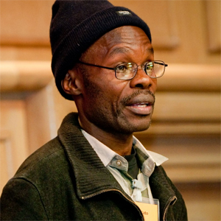David Kato was beaten to death in January
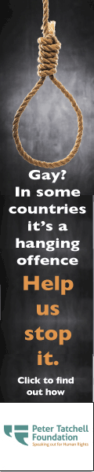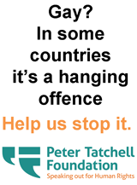
The killer of Ugandan rights campaigner David Kato, who was murdered earlier this year, has been sentenced to 30 years in prison.
The sentence was handed down to Sydney Nsubuga, also known by the name Enock, last night.
Nsubuga, 22, pleaded guilty to the murder of the gay rights activist on January 26, 2011 at his home in the Mukono district of Uganda.
Earlier this year, Nsubuga claimed Mr Kato agreed to pay him for sex, but refused to hand over any money after the act. He says he did not intend to kill Mr Kato, he was trying to defend himself.
Police arrested Nsubuga on 2 February, and said he had been staying at Mr Kato’s house after he had bailed Nsubuga out of prison.
A police spokesman had told Reuters: “He has confessed to the murder. It wasn’t a robbery and it wasn’t because Kato was an activist. It was a personal disagreement but I can’t say more than that.”
Speaking today about the sentence, human rights campaigner Peter Tatchell said: “It is good that justice has been done. The man jailed pleaded guilty, so we can assume that the police got the right person. It sends a signal that sometimes in Uganda, LGBT people get justice. Of course, many times they don’t. Homophobes often get away with violence. Not in this case.
“I hope it will encourage more LGBT Ugandans to report homophobic attacks and pursue the police until they, too, get justice.”
The announcement comes on the day Ugandan rights activist Frank Mugisha receives the Robert F Kennedy Human Rights Award for his work in the African country where he and David Kato worked.

