Ulster Museum

Gay Life and Liberation
Time/Date - 10:00 - 17:00, Tue 14 Mar 2017 - Sun 23 Apr 2017
A Photographic Record from 1970s Belfast
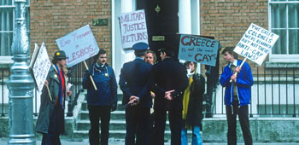
Members of NIGRA protesting at the Greek embassy in Dublin in September 1978
In response to changing attitudes to homosexuality elsewhere in the western world, a group emerged in Belfast during the early 1970s with the expressed aim of campaigning for the legal rights of thousands of gay men and women in the province. The photographs in this exhibition are a testimony to the resilience of the LGBT community and to the strong level of mutual support at this time.

Exhibition Details:
- This is a free exhibition
- This exhibition is located in: 'Belfast Room', Ulster Museum.

