Ireland is continuing to fail its gay teachers in the classroom

‘Gay community in Ireland has suffered enormously’ - Archbishop Martin
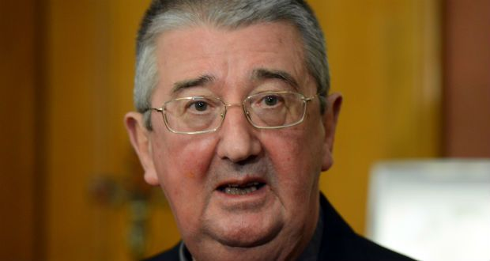
Patsy McGarry
- Topics:
- News
- Social Affairs
- Religion & Beliefs

Tue, Feb 11, 2014, 07:18
First published: Tue, Feb 11, 2014, 07:23
- 221

It is to be hoped that following their impassioned speeches in the Dáil last week about the cruel realities of life as gay men in Ireland that TDs Jerry Buttimer and John Lyons will hold their seats at the next election.
What they said prompted the Catholic Archbishop of Dublin, Diarmuid Martin, to say on RTÉ Radio 1’s This Week programme last Sunday that “the gay community in Ireland has suffered enormously. When I heard the debates in the Dáil . . . what do I say when I hear somebody spat at them? That’s a horrendous thing to happen to anybody.”
He added: “When I meet with young people at the age of 15, 16 one of the questions they inevitably ask me is why is the church against the gays? The difficulty that a young man or woman feels as they come to grips with their own sexuality . . . there’s a huge challenge there to be with them and to support them . . .”
But if Jerry Buttimer and/or John Lyons do lose their seats at the next election it is not certain that either would be able to go back to their teaching jobs at church-run schools, Catholic or Protestant.
Both are secondary school teachers but now that their being gay is such public knowledge, not even the questions of sympathetic 15- and 16-year-old students would guarantee them jobs at a church-run school, where they could be seen as a threat to its ethos. And this is entirely legal in Ireland.
Exemption
In 2000, then minister for justice John O’Donoghue applied to the European Union for an exemption to the European Equality Directive, which would have prevented this situation, on the grounds that such exemption would preserve the right of denominational schools to uphold their religious ethos when recruiting staff.
The exemption was granted. It is a State-sponsored licence to discriminate against gay people, funded by the taxpayer. It is unjust and it is wrong.
The Irish National Teachers’ Organisation (INTO) has a lesbian, gay, bisexual and transgender (LGBT) support group since 2004. A spokesman for the group spoke to this newspaper then using the pseudonym “David”. He would not use his real name or he feared losing his job.
He said: “When a child is being bullied for coming from a broken home I can intervene and talk to the bullies about the realities of family break-up. In my experience no child is ‘bad’ and most can be brought around to a reasonable way of thinking if someone takes the time to explain issues. When a child is being bullied on the grounds of his sexuality, however, I am not in a position to intervene in the same way. I am not allowed to explain the reality of homosexuality to students.”
And homophobic bullying in schools has got worse. “The problem now is that young children have the language of homophobia. When I was in school no one slagged you, using this kind of language and homophobic bullying was negligible,” he said.
But “gay” is now a favoured word of abuse among schoolchildren.
Discrimination
At the INTO annual conference last April, Minister for Education Ruairí Quinn pledged to repeal section 37 of the Employment Equality Act 1998, allowed continue in Irish law by that exemption to the EU Equality Directive of 2000. He looked “forward to seeing an end to this discrimination and I pay tribute to the INTO for ensuring that this matter remains on the political agenda”, he said. He should get on with it.
Marriage is not the only area where it is no longer tolerable that there should be one law for the general population and another for gay people. Gay people are full citizens of this State and as such are entitled to exercise fully all the rights that go with being Irishmen and Irishwomen living in Ireland.
It is beyond time that this was the reality and that those who insist otherwise, while remaining free to live by their own beliefs, accepted that others be allowed the same right.
For too long minorities on this island have been forced into compliance with the beliefs of others. It is violence and no more acceptable than agreement achieved at the point of a gun.

