Thanks Brice. There was an obituary in the Irish Times which mentioned his work on my Strasbourg case but it is inaccessible on their website. It may have been written by Tom Hadden. Of course Kevin initiated the case and did all the legal work for the Commission.
We never met after that period. He was a very private person and, although it was not mentioned, a thorn in the side of the ultras in the People's Democracy, certainly from June 1970, as I recall.
The case is still being quoted not only in the US Supreme Court but also I noticed most recently in the Irish abortion case just judged. A tribute to his work.
Jeff.

Yes, I saw the obituary. It was written by William Schabas, current Director of the Irish Human Rights Centre in Galway. The funeral is in Colchester on Monday 17 January (quite a wait). There’s a tribute from Conor Gearty here: http://therightsfuture.com/common-tracks/in-honour-of-kevin-boyle/

He’ll be much missed.

Brice.

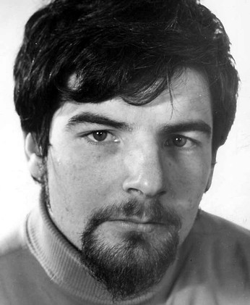
Kevin Boyle in the early 1970s

From: b.dickson@qub.ac.uk
To: jeffreydudgeon@hotmail.com
Date: Sun, 26 Dec 2010 19:18:51 +0000
Subject: RE: Some holiday reading
Dear Jeff,

Thanks for this.

In case you have not heard, Kevin Boyle died yesterday afternoon in Colchester. Funeral arrangement are not yet known.

All the best, Brice.

Amidst the tributes paid to Professor Kevin Boyle the Civil Rights activist, teacher and journalist, there is no mention of one of his most important human rights projects: To oversee homosexual law reform in Northern Ireland.
Kevin began by advising the 1974 Committee on Homosexual Reform and then the Northern Ireland Gay Rights Association to take its case to the European Court of Human Rights in Strasbourg.
In 1967 a partial reform of the law had been enacted in England and Wales (for consenting adults who were over 21 - Scotland had another arrangement - the Procurator Fiscal Office adopted a similar convention of not prosecuting men over 21).
It was agreed by NIGRA that Jeffrey Dudgeon would take the case to Strasbourg. This involved a complicated series of applications and later negotiations with the European Commission who had to decide if a case could be allowed to proceed.
The case did proceed and the Court eventually decided in Jeffrey Dudgeon's favour on the basis that the law of 1861 (life in prison for sodomy) and the 1885 (Offences Against The Person Act) had breached his right 'to a private life' - a very difficult thing for the UK government to deny as Jeffrey and his then partner's house's had been raided by the RUC, their correspondence read and then both had been interrogated by detectives about their sex lives.
Jeffrey and his partner were just two of many who had suffered, others lost their homes and livelihoods a number went into hiding or fled abroad.
The RUC campaign continued for over a year during which time no serious attempt was made to stop them by the UK government. We know now due to the release of government papers that if it had not been for the intervention of the Attorney General at the very last minute the government, the police and its prosecutors, would have sought imprisonment for Jeffrey and his then partner.
Some 25 people were affected by the RUC campaign. Those who opposed this reactionary juggernaut were Jeffrey, NIGRA and his legal team. The key member of that team was Kevin Boyle. The law was eventually changed in 1982.
Brendan O’Connell

