Monday 9 January 2012

Gay activist backs Christian free speech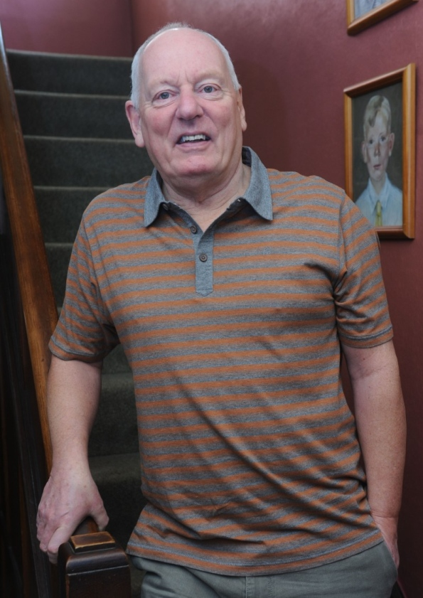
Jeff Dudgeon who is to get an MBE pictured at his Belfast Home speaks to reporter Sam McBride
Photo Colm Lenaghan/Pacemaker Press
News Letter
Monday 9 January 2012
THE man whose landmark legal challenge forced the UK to decriminalise homosexuality in Northern Ireland three decades ago has voiced his concerns over gay rights.
Jeff Dudgeon’s 1981 case at the European Court of Human Rights set world-wide precedents for legalising same-sex relationships.
In an interview with the News Letter following the release of previously classified 1981 government files relating to the case, the former civil servant said he feared that the media was now “afraid” to pursue difficult stories involving gay people lest they were accused of homophobia.
“I’m concerned that there is a nervousness in the media now to take on issues relating to gay people or other protected species. That does concern me,” he said.
“You can’t even make an off-remark without losing your job. I think it’s a danger – but this probably always happens when minorities become emancipated.”
The south Belfast man received a phone call from Ulster Unionist leader Tom Elliott to congratulate him on his recent New Years Honours List MBE – awarded for “services to the lesbian, gay, bisexual and transgender community in Northern Ireland”.
Now an Ulster Unionist member (having spent time as a communist and UK Unionist Party adviser), is he concerned at Mr Elliott’s public refusal to attend a Gay Pride event?
“It might have been wiser if he hadn’t said that it’s his choice – I don’t care. If you’re not comfortable with something you don’t want to force people to attend...
“The press, and the BBC obviously, tends to be somewhat liberal on these matters and it’s become a bit PC to be pro-gay rights.”
He has contacted prominent gay rights activist Peter Tatchell to support his backing for a Christian housing worker in Manchester who was demoted after saying that ‘gay church marriage’ was “an equality too far”.
“I endorse his [Tatchell’s] position on that – I don’t want it to become compulsory to love gays. But then the problem is that I’m always a bit of a rebel.”
He was certainly a rebel when he took his case against the government, and to Strasbourg, eventually. Ministers would not even be seen to meet him, Mr Dudgeon said, despite his belief that they had little personal opposition to changing the law.
It was a case which set a global precedent, being quoted in the US Supreme Court when it decriminalised homosexuality in several states, including Texas, and also led to the British Commonwealth inheriting laws based on the outcome of the Strasbourg case.
At the time, Ian Paisley was the face and voice of Ulster opposition to relaxing the prohibitions on homosexual conduct.
But Mr Dudgeon said that while many of the UUP’s MPs were personally relaxed about the issue, the Ulster Unionist Party was “no more open to it” than the DUP, citing problems with selling it to the Orange Order and churches.
Similarly, nationalists – led by SDLP leader Gerry Fitt – followed the Roman Catholic Church’s opposition line and every one of Northern Ireland’s 26 councils passed a motion which opposed decriminalising homosexuality.
This meant that successive governments were loathe to act in the face of strongly voiced opposition from across the sectarian divide.
The UUP’s Jim Molyneaux and Enoch Powell argued “not the substantive change”, but rather claimed that as it was a Northern Ireland matter it should wait for a Stormont parliament to be reconstituted (somewhat contradictory to their integrationist political philosophy which wanted to see Northern Ireland more closely integrated with the rest of the UK).
Having been involved in politics, including a spell as an adviser to Bob McCartney, Mr Dudgeon has met Dr Paisley on several occasions since then.
Has the former DUP leader ever brought up the case?
“No, I’m not too sure he knows... we’d have lunch with him at Stormont during the talks and theology was always what he wanted to talk about. He probably does know who I am or was told who I was at one point but he certainly never broached the subject.”
He added: “It [the campaign] proves one thing – if you’re organised, you can achieve. We were organised; he was organised and that was a clash.
“He wasn’t a hypocrite about it – he took the Iris line about it of ‘Hate the sin, love the sinner’.”
Three decades ago, could he have imagined that public attitudes to homosexuality would change so radically so quickly?
“In a sense, I’m not terribly surprised – but maybe it’s gone further than I’d have thought. Civil partnership was not in my head at that time.
“In a sense, Paisley and the DUP have always been a minority group within unionism and Protestantism... now that they are at the top they are mellowing and reflecting the broader society that is around them.”
He says that while some still believe the party is staunchly opposed to gay rights, he has detected a slight change in tone – where before it refused to use the word ‘gay’, it now uses the acronym LGBT which incorporates the word.
And, despite his past battles with the party, Mr Dudgeon said that he wants to “let bygones be bygones and not rake over the past”.

