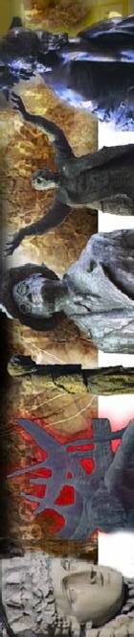
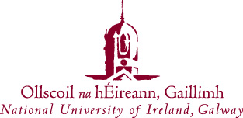

Irish Studies Seminar

“How the Advanced Nationalist Press Invented the New Journalist Sex Scandal, 1882-1895.”

Dr. Margot Backus
(University of Houston)

Thursday 5th June, 2008

3pm

Seminar Room, Centre for Irish Studies

Saorchead isteach agus fáilte roimh chách

