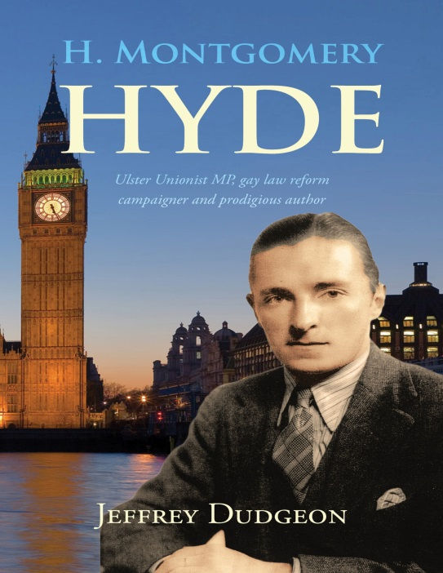
H. MONTGOMERY HYDE
Ulster Unionist MP, Gay Law Reform Campaigner and Prodigious Author
by Jeffrey Dudgeon
Belfast Press, ISBN 9780953928798 (paperback), 56 pages
1st edition January 2018; 2nd edition March 2018
Available at: http://amzn.to/2BCOp0J (Amazon paperback £5.00/$7 plus postage) http://amzn.to/2GtS705 ( Kindle)

jeffreydudgeon@hotmail.com; Tel 079 2125 1874 / 028 90664111. See also Casement 3rd edition https://amzn.to/2uJCY6r
H. Montgomery Hyde died in 1989 by which time he had become history. Only a very few remembered him or his gay campaigning role, let alone the fact he had been an Ulster Unionist MP throughout the 1950s. Thirty years later, he can hardly be conceptualised. Too many, at best, see him as an aberration for Belfast but he was a recognisable type of progressive, yet traditional, British politician. No one else played as long or as effective a part in changing the views of people towards gay people when only a handful of MPs put their head above the parapet.
"Harford" as he was known to his friends, "H. Montgomery Hyde" to his readers, and "Montgomery Hyde" to the electors of North Belfast, led the battle in the House of Commons for decriminalisation of homosexuality. And he paid as great a price as any parliamentarian could for his courage – he lost his seat.
Very much a child of the 1920s, he was dedicated to researching and writing about those two most prominent gay men of the 20th century – Oscar Wilde and Roger Casement, both Irish outlaws. None the less, he managed to publish another forty books on a wide range of subjects including perhaps his finest works 'The Rise of Castlereagh' and 'The Other Love'. A cheerful and good natured figure, Harford lived and loved well and is deserving, at the least, of this short book outlining his struggles and achievements.
