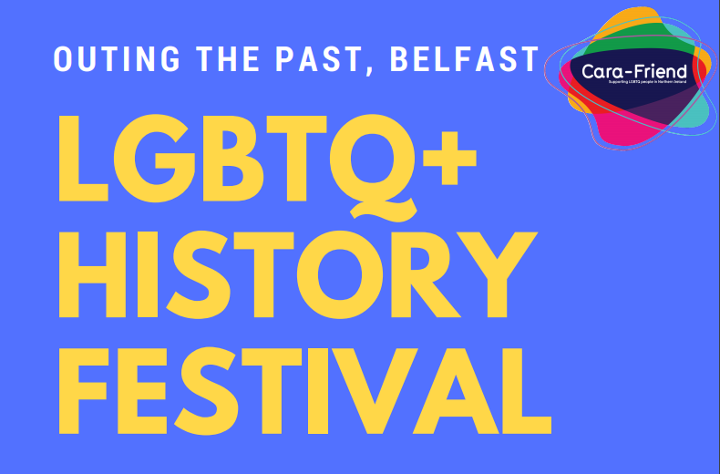
Cara-Friend is delighted, in association with Belfast City Council and the Ulster Museum, to present Ireland’s first LGBTQ+ history festival, OUTing the Past, Belfast. It will take place on Friday, February 16th and Saturday, February 17th 2018.
The schedule for the festival is as follows:
Friday, February 16th
6pm Launch of OUTing the Past, Belfast City Hall
We are delighted to have the Lord Mayor of Belfast, Cllr. Nuala McAllister, in attendance to officially launch the festival in Belfast City Hall. Also speaking on the night will be Cllr. Jeff Dudgeon (Belfast City Council) and Senator David Norris (Seanad Eireann). Belfast City Council are kindly providing a welcome drinks reception on the evening from 6pm, with the launch kicking off at 6.45pm. All are welcome to this launch – it is free and open to the public.
Saturday, February 17th
10am-4pm Popular Presentations (History Papers), Ulster Museum
A series of short presentations of LGBTQ+ history papers will be made. Each presentation will last 20 minutes, with a 10-min opportunity to ask questions of the presenter at the end. We have made every effort to ensure the collection of papers presented represent the diversity of our community. We will have papers on historical topics and events from Northern Ireland and beyond. All are welcome to this event – it is free and open to the public. Read on for the running order and a synopsis of each paper.

10.00am Cork LGBT Activism and Cork-Belfast Collaborations, by Orla Egan
This paper reveals the previously hidden history of LGBT Activism in Cork and the development of the Cork LGBT Community. It highlights crossborder connections and ollaborations between the Cork and Belfast Communities. It also shows how archives help to share and preserve this important history.
10.30am Queers Dancing with the ‘Terrorists’, by JGM Evans
This paper provides a rare insight into an event in the early 1980s when the first UK Student LGBT Conference (NUS LGBT) was held at Queens University Belfast. During which it was picketed by Rev. Ian Paisley’s Save Ulster from Sodomy Campaign and simultaneously hosted by the nationalist people of Whiterock, West Belfast.
11.00am LGBT Emigration Northern Ireland post-1967, by Nadine Gilmore
This research paper is largely based on archived source material from Belfast based activist groups including the Northern Ireland Gay Rights Association, Cara-Friend and Queerspace and a number of local grassroots publications and newsletters, including Northern Gay, NIGRA News and Gay News. This research is also based heavily on oral history interviews found in various archives throughout the UK, as well as a number of interviews conducted with members of the gay community in Belfast.
11.30am ‘Gay’ Behaviour in Gaelic Ireland: AD500-1600, by Brian Lacey
This presentation will look at the diverse evidence/sources for homosexual relations and practices in medieval Gaelic Irish culture – c.AD 500-1600 – mainly among males and because of the lack of sources to a more limited extent among females.
12.00pm Police with Pride, by PSNI LGBT Network
The personal stories of the officers who marched in the first uniformed Police contingent in Belfast Pride on 5th of August 2017. This was not only a first for Belfast but a first for the whole island, as they were joined by officers from An Garda Siochana, and neither Gardai nor the PSNI had marched in Uniform before that date. This short film and exhibition tells the stories of these officers, highlighting the positive impact the event had on them, the Police service and the LGBT community.
12.30pm Soldiers in Love, by Oswestry Town Museum
This Presentation tells of the discovery, in Oswestry (a small rural town in Shropshire) by Oswestry Town Museum, of several hundred ‘love letters’ sent by Infantryman Gordon Bowsher to Gunner Gilbert Bradley, just before and during World War Two. It tells of the impact on the museum of such a find, how it has challenged assumptions made about love between men at that time and tells of the ensuing significant media attention and interest world wide in the story
1.00pm Break for Lunch & Tea
1.30pm Cara-Friend & Lesbian Line: Combating Isolation, by Mary McKee
This presentation will demonstrate how Cara-Friend and Lesbian Line fought to combat isolation of queer people in Ireland between the 1970s and 1990s in both rural and urban areas.
2.00pm Monument to a Plague – Memorialising Ireland’s AIDS Crisis, by Tonie Walsh
Drawing on a paper delivered on World AIDS Day 2016 at Maynooth University, Walsh argues for a fuller reassessment of the loss and destruction from AIDS in Ireland during the period 1984-1996. Uncovering the archives of Gay Health Action (GHA), HIV Ireland and other HIV/AIDS organisations and advocating their digitisation is a first step towards the ritual work of reconciliation and awareness that is so important to developing a more holistic HIV health education culture. More importantly, building an Irish AIDS Memorial offers a place of memory that transmits stories of survival, previously hidden stories that become threaded into our personal and formal historical narratives.
2.30pm ‘Out of the Shadows’: 21 years in Merseyside Police, by Tracy O’Hara
Personal story of serving as a gay detective in Merseyside police for 21 years. My presentation will explore my experiences and reflect on the progress that has been made by Merseyside Police over two decades.
3.00pm DYEP: Trans* Personnel in the Armed Forces to 2009, by Emma Vickers My first paper explores my collaboration with the artist Stephen King on the photography project, Dry Your Eyes Princess’ which documented the lives of 12 trams* veterans of the British Armed Forces. I will reflect on the historical experiences of trans* personnel in the British Armed Forces before 2009 and discuss the photography project in more detail.
3.30pm Sound and Vision, by Kate Hutchinson
Sound and vision will look at the history of media portrayal and representation of the trans community. It will examine the power of positive visual role models but also the effect of negative stereotypes and how that influences public perception of the trans community.

