The Irish Times - Saturday, November 24, 2012

Public face of gay community in Northern Ireland
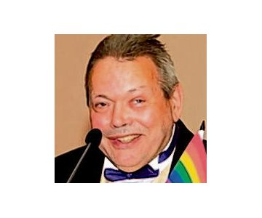
- Lawyer and academic who was an inspiration to his son, Tony Blair
PA MagLochlainn Born: March 8th 1945 Died: November 14th 2012
PA MagLochlainn, who has died unexpectedly, was for years the public face of the North’s gay community. He was an inspirational figure whose prominence helped younger gays realise they were not on their own.
MagLochlainn was his own man in everything, to his very surname.
He insisted that the authentic Gaelic spelling was MagLochlainn rather than the Mac Lochlainn used by the others of his sept.
In recent years he attended the Belfast Pride dressed as King Louis of France and riding a Motability scooter. He combined this flamboyance with a very measured style of argument when acting as spokesman for his community. This made him very effective in media appearances.
PA MagLochlainn was the first openly gay member of the executive of an Irish political party, when elected to the executive of the SDLP in the 1990s.
This did not prevent his being critical of what he considered more conservatively Catholic elements in the party.
Patrick Anthony McLaughlin was born in Dublin’s Rotunda Hospital in March 1945.
He was the eldest of nine children of Patrick McLaughlin and his wife Edith (née Corbett). His parents were natives of Dungiven, Co Derry, who moved back home when MagLochlainn was young, his father settling into farming.
MagLochlainn was educated at Dernaflaw Primary School; St Columb’s College, Derry; and Queen’s University Belfast, from which he graduated in French.
He spent some two decades as a secondary school teacher of French. His former pupils remember him as approachable, courteous and supportive.
His last teaching post was in Omagh, Co Tyrone. There, a new management decided he did not fit their vision of the school; the feeling was mutual.
He did not harbour bitterness at his treatment, instead seeing it as liberation. He moved to Belfast.
At the time, he was unaware of being gay. Coming to that realisation, he quickly became a spokesman for the community. He explained he could do so because, unlike others, his parents were dead.
Over 20 years ago, MagLochlainn was one of the organisers of Belfast’s first Gay Pride march. It was tiny, with less than 100 attending. He kept the T-shirt he wore, wearing it at every subsequent march.
In a less public role, he acted as a counsellor, both formally and informally. This work touched the lives of hundreds.
He also continued to teach, if not in a school setting. He provided training to the RUC in how they should deal with the gay community, and also in the Irish language, and how to show respect to Irish culture.
MagLochlainn was above all a man of great culture who spoke five languages, was a compulsive reader of newspapers, and was uninterested in material possessions. He did not care if the house was falling down round him, as long as he had a book before him.
He is survived by his partner, Barry; his five sisters; and two brothers. He was predeceased by his sister Vivian (Groogan).

