Peter Quigley's coffin in theatre final 'farewell' performance

http://www.belfasttelegraph.co.uk/news/northern-ireland/peter-quigleys-coffin-in-theatre-final-farewell-performance-31321903.html

By Ivan Little
23 June 2015
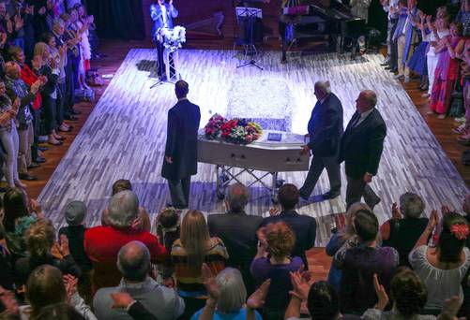
Mourners surround the stage as Peter Quigley’s coffin arrives
A Belfast theatre has staged one of its most unusual productions - a funeral send-off for an actor whose dying wish was to have his farewell 'performance' there.
And in keeping with Peter Quigley's flamboyant and unconventional lifestyle, his bejewelled white coffin was accompanied by a samba band and dancers down Ridgeway Street where bunting had been erected on lamp-posts.

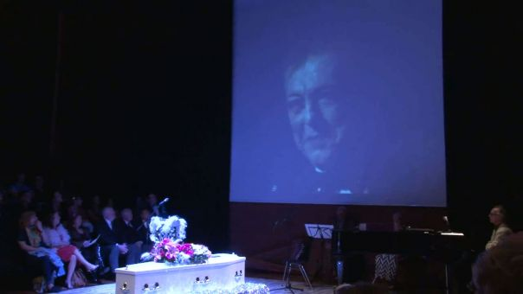
Pallbearers wore pink garlands as they carried the coffin through a guard of honour made up of scores of Peter's cheering friends and theatrical colleagues.
Many mourners shunned funereal black and instead donned brightly coloured clothes and glitter as Peter took his final bow at the Lyric.
The 65-year-old Belfast man, who was also an acclaimed director, died last week just over a month after he was diagnosed with cancer.
The veteran of dozens of plays at the Lyric and the Arts theatres had also been a pioneer of a number of cross-community drama schemes for young people and he had helped establish several ground-breaking theatre companies. Yesterday was the first time the Lyric had allowed a funeral to be held in the newly-rebuilt theatre.
"Peter lived for theatre and it was so fitting that we should give him this send-off in the surroundings he adored," said his actress friend Christina Nelson.
Inside the Lyric's Naughton studio, there was a full house for what they called Peter's glittery goodbye which he organised from his hospital bed with instructions that there should be upbeat singalongs and irreverent poems and limericks.
And they followed Peter's directions to the letter as his coffin sat centre stage on a glitter-covered plinth with a spotlight and disco ball above it.
Speaker after speaker talked of Peter's boundless abilities and director Michael Poynor said he was a superbly talented entertainer who was a great ambassador for Northern Irish theatre.
There were also references to how difficult it had been for Peter to be a gay man in the Belfast of the Seventies.
Among the mourners were TV actor Gerard McCarthy, pantomime star John Linehan and comedienne Nuala McKeever.
Not long before he died, many of Peter's friends threw a surprise 65th birthday party for him and one of them, harpist Ursula Burns, yesterday sang a song she wrote about it called So Much Fun in the Cancer Ward.
"It sounds like it was in bad taste but it wasn't and Peter would have loved it," said a friend.
The final curtain fell as mourners united to sing the classic Gloria Gaynor anthem I Am What I Am.
To a standing ovation, Peter's coffin exited stage right en route to Roselawn Crematorium wheeled away by undertakers wearing... black sparkly ties.

