UUP councillor quits over Nesbitt’s ‘dangerous’ gay marriage stance
http://www.newsletter.co.uk/news/northern-ireland-news/uup-councillor-quits-over-nesbitt-s-dangerous-gay-marriage-stance-1-7039140

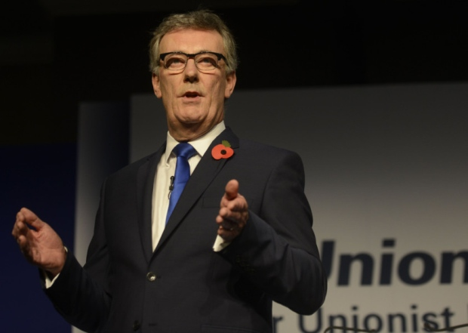
UUP leader Mike Nesbitt delivers his speech during the annual party conference at the Ramada Hotel, Belfast on Saturday. Photo Colm Lenaghan/Pacemaker Press
Sam McBride
sam.mcbride@newsletter.co.uk
17:43Thursday 29 October 2015
A Fermanagh Ulster Unionist councillor has quit his party after saying that he had become disillusioned by what he sees as its increasingly “dangerous” liberal stance on social issues.
Councillor Raymond Farrell, who replaced Tom Elliott on the council five years ago, said that the final issue which pushed him out of the party had been UUP leader Mike Nesbitt’s conference speech in which he said that those who oppose gay marriage “are on the wrong side of history”.
“I felt there was no future for me in the UUP,” he said.
But he added that he is “undecided” about whether to join another party or simply retire from political life.
The health worker also expressed concerns at how the UUP is attempting to be a ‘broad church’ politically by appealing to both liberal and conservative unionists.
He told the News Letter: “I just don’t think it’s right to take the clothes from the right of unionism and also from the liberals in our community because I don’t think we’re building on a firm foundation.”
And the councillor questioned the party’s decision to go into opposition, saying that he would like to see unionists working closer together rather than opposing each other as much as at present.
“I can’t deny that there were internal local issues that played a part in my decision.
“But ultimately, I was increasingly concerned at some of the comments and statements – particularly at the UUP conference – in terms of social issues; namely, for example, the leader’s views on same-sex marriage.
“I think they are extremely dangerous remarks to make – the danger is that you are potentially sowing the seeds of doubt in people’s minds about what is fundamentally a belief among Christians that this is something that the cannot consent to.
“I respect that there are people who hold different views on that and I don’t want to get into debate with those people...but it’s not something that I can bow the knee to, and it’s not something I feel comfortable in, because it’s a slippery slope.
“We can’t primarily base our politics on populism – we have to base it primarily on conviction.”
Although Mr Nesbitt has firmly indicated that he has no intention of ditching the UUP’s policy of allowing a free vote on issues such as gay marriage and abortion, councillor Farrell said that alone was not enough to reassure him.
“I’m not here to talk Mike Nesbitt down,” he said.
“But I think when you even make the suggestion and ask people to question things that they hold dear because they are going to be on the wrong side of history, I think that’s dangerous and politicians need to be very wise with their words.
“I’m not into bashing gay people. What Mike Nesbitt said was totally right when he said that we have to show people unconditional love. I stand behind him on that.
“But... people who hold these views [against gay marriage] don’t do it out of spite or a discriminatory mindset.”
It is not the first time that Raymond Farrell has expressed concern about Mr Nesbitt’s stance on gay marriage – and other UUP members have done so privately since the weekend.
After Danny Kinahan’s election in May, Mr Nesbitt told the News Letter that public policy in Northern Ireland was in danger of being “dictated by fundamentalist religious beliefs”.
Councillor Farrell said at the time: “I would have no time for Danny Kinahan’s views in terms of this issue. I am conscious that this might land me in trouble but there has to come a time when people do stand and let it be known that marriage is best between a man and a woman.”
A UUP spokesman said: “Raymond’s decision is regrettable. The party chairman asked to meet with him to discuss the issues he raised, but he declined.
“Tom Elliott contacted him at the beginning of the week.
“But his decision had already been made and indeed it is clear from his public comments his decision was made before the party conference and the leader`s comments on same-sex marriage.
“While we regret his decision to resign, it is a matter of fact that if anyone is confused, it is Councillor Farrell, who has not bothered to check Mike Nesbitt`s voting record on same-sex marriage debates at Stormont.”
He added that Cllr Farrell “has a litany of failures to his name”, claiming that he had “promised to attend Ulster Unionist group meetings of Fermanagh and now Fermanagh and Omagh Council”.
He added: “He failed to attend meetings of the Ulster Unionist Councillors Association. He failed to attend the Party’s Annual Conference. He failed to contact the Party Leader to alert him to his concerns.
“And in criticising the decision to leave the Northern Ireland Executive, he failed to acknowledge the decision was endorsed unanimously by the Party’s MEP, MPs, MLAs, Councillor representatives and then the Party Executive.
“On the question of same-sex marriage, it remains a matter of conscience for individual members and so the policy has not changed and will not change under Mike Nesbitt`s leadership.”

