https://www.belfasttelegraph.co.uk/sunday-life/mystery-of-northern-ireland-author-linked-to-gay-spy-ring-38818473.html

Mystery of Northern Ireland author linked to gay spy ring
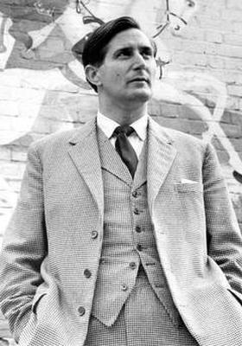
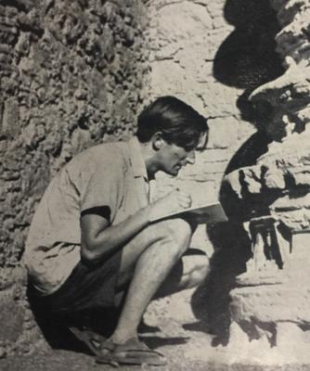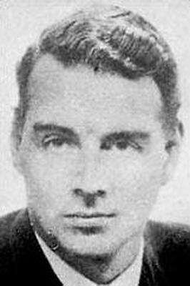
Late Belfast man Robin Bryans, who used pen name Robert Harbinson
By Noel McAdam
December 28 2019 06:49 PM
A Northern Ireland author linked to the notorious gay spy ring of Anthony Blunt and Guy Burgess is at the centre of a new literary mystery.
Belfast-born Robin Bryans, who also wrote under the name Robert Harbinson, penned 25 books in his lifetime — 17 in one decade — including his bestseller memoir No Surrender.
But a would-be biographer has found it all but impossible to track down details about the man who was once the darling of London high society.
Records of court cases in which he was involved are officially closed for another 50 years.
Now local writer Paul Wilson has issued a plea for help after years of meticulous research which seemed to always end in road blocks and dark alleys.
The Lisburn man had failed for years to find copies of Bryans’ latter four volumes of autobiography, even through the Northern Ireland Libraries system and the Linen Hall Library — which has a famous Irish section.
Bryans counted the Cambridge-educated Soviet spies Blunt — an art historian and surveyor of the Queen’s pictures — and Burgess among his friends, cultivating a highly-affected plummy English accent, mostly from listening to BBC radio.
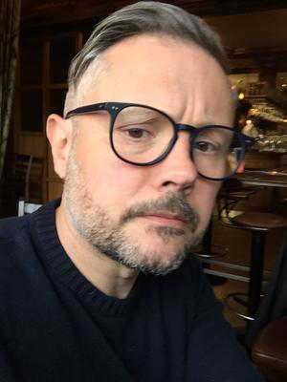
Paul Wilson
But he also made many claims in relation to the alleged cover-ups of scandals involving a largely homosexual establishment network.
“It’s become an international mystery and an extraordinary story spanning the latter half of the 20th century,” said Mr Wilson, who works at Queen’s University. “But it’s such a complicated story, I’m reaching out to anyone who might be able to flesh out the story of Robin Bryans.
“We do know it was in Bryans’ early life in Wales and south England when he first came into contact with spies, gay aristocrats and influential members of the establishment.
“He was bisexual from a young age and in 1944 he claimed to have had sex with Guy Burgess, the infamous spy and friend of Anthony Blunt. Through this circle, he moved through the ranks and was privy to many dirty and dangerous secrets.”
The spectre of Blunt would hang over Bryans until his death.
His life in high society in London was a far cry from his birth in east Belfast in April 1928. His early life included spells as a cabin boy on a dredger in Belfast Lough and shepherding in the western highlands of Scotland.
But under the wing of the well-to-do and aristocratic, he turned from adventurer to toff.
“In the 1980s and ’90s he appeared in many ‘spy catcher’ books, including The Secret Worlds Of Stephen Ward by Anthony Summers and Stephen Dorril, and The Mask Of Treachery by John Costello,” Mr Wilson went on.
“Today, Bryans is largely unknown, a sort of lost talent from Belfast. As a writer, he moved in some very well-known circles, including EM Forster. He even had TS Eliot over for tea and was a contemporary of Jan Morris and Eric Newby.
“Faber editor Charles Monteith considered him one of the most talented writers of travelogues and wrote often to him to tell him so.”
Now, however, Wilson’s persistence over a number of years is finally paying off, recently uncovering a number of long-lost, self-published books by Bryans and some previously unknown and valuable correspondence.
“It’s easy to see a conspiracy at work. However, I’ve managed to track them all down now. I am told any existing copies are mostly overseas and impossible to find, largely because they were self-published. No publisher would touch them, they were too libellous and incendiary.
“I also managed to track down some previously unseen correspondence dating from 1958-69 in the Birr Castle Archives with a woman who was Bryans’ mentor, Countess Adeline de la Feld, and was also the first translator of Chekov.”
In later years Bryans’ life was pockmarked with scandals of his own. He was twice imprisoned for contempt of court, once for throwing a jug of water at a ‘barrister’ in a High Court case and another time for a slur campaign against an MP.
In 1977, he was admitted to Sussex Hospital claiming he had been poisoned and spent his 53rd birthday in HMP Pentonville.
“He was a prolific letter-writer, and had hundreds of correspondents. I’m hoping somewhere there might be a drawer full of letters. They could be anywhere, from Belfast to Blessingbourne in Fermanagh or from Brighton to Brazil,” added Mr Wilson, who has also been a travel writer.
“It’s a remarkable never-told-before life story that on one level reads like both a spy thriller and the diary of a whistleblower — long before Edward Snowden came along. It’s also, perhaps a chance to give Bryans his place, a working-class talent from Belfast who has become lost to history.”

