http://mspcsearch.militaryarchives.ie/search.aspx?formtype=simple

http://www.militaryarchives.ie/useful-information/glossary?tx_a21glossary[uid]=140&tx_a21glossary[back]=700&cHash=8766fe25c4c0d70c9eb4f456f9179aea

http://www.militaryarchives.ie/collections/online-collections/military-service-pensions-collection

Archives will shed more light on intimidation and murder of Protestants by elements of the IRA

Confidential memo from then-director of intelligence Col Michael Joe Costello in September 1925 touches on the issue
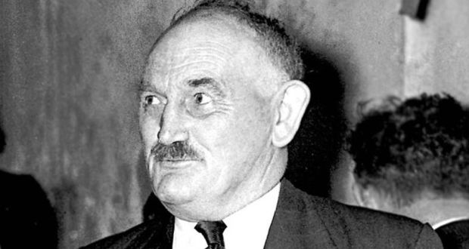
Martin Corry TD
http://www.irishtimes.com/culture/heritage/stephen-collins-7.1010733Stephen Collins
- Daniel O Neill
Fri, Jan 17, 2014, 01:00 - link
Irish Times
17 January 2014
A bitter controversy has developed in recent years about whether or not Protestants were intimidated and murdered by elements of the IRA during the War of Independence and Civil War.
A number of historians have become embroiled in the controversy, particularly in relation to claims about a massacre of Protestants in the Bandon valley in Co Cork.
The pension documents will shed light on the matter, particularly when all of the files are released. There are some hints in the initial batch about what may emerge about the targeting of Protestants and others who were regarded as opponents of the IRA campaign.
A confidential memo from the then-director of intelligence Col Michael Joe Costello (later boss of the Sugar Company) in September 1925 in relation to a pension claim by Daniel O’Neill of Enniskean, Co Cork, touches on the issue.
O’Neill had a chequered career. He resigned from the Royal Irish Constabulary during the conscription crisis of 1918 and joined the 1st battalion of the Cork No 3 Brigade led by Sean Hales.
“O’Neill is stated to be a very unscrupulous individual and to have taken part in such operations as lotting [looting] of Post Offices, robbing of Postmen and the murder of several Protestants in West Cork in May 1922. A brother of his was shot dead by two of the latter named, Woods and Hornbrooke, who were subsequently murdered.”
Costello’s assessment may have been influenced by Daniel O’Neill’s involvement with the anti-Treaty side in the Civil War but, on the other hand, Costello remained on good terms with many of the republican leaders and was promoted up the ranks to lieutenant general in the Army by the Fianna Fáil government in 1945.
Incidentally, Daniel O’Neill’s brother Denis (Sonny) O’Neill, who also fought on the Anti-Treaty side, is widely credited with being the man who shot Michael Collins at Béal na Bláth. A claim from him detailing his record in the War of Independence and the Civil War is contained in the archive, but it does not form part of the first release.
Corry statement
Eunan O’Halpin, Professor of Contemporary History at Trinity College, who was one of the academic advisors to the archives project, makes some interesting observations in an essay to accompany the initial release.
He points to a statement in the files from Martin Corry, who served in the 4th battalion of the 1st Cork brigade, and was later a long-serving Fianna Fáil TD, that “some 27 Enemy spies and Intelligence officers were captured . . . and duly executed by E Company alone.” By repute a significant number of people, many of them Protestants, who disappeared in the area were killed and their bodies buried on Corry’s farm.
O’Halpin also points to a case from the Leitrim IRA “Activities” file relating to a Protestant farmer, John Harrison, who was killed in April 1921. The file indicates this was the culmination of a dispute that began the previous October when Harrison refused to contribute to an IRA arms levy.
Mediated settlement
The IRA then took his “best cow” and forced him to hand over a revolver. A local Protestant clergyman then mediated a settlement. Harrison paid the IRA levy and got his cow back. However, the IRA believed he had a second gun so they abducted him and fired shots over him but “still he’d give up no gun”.
Harrison was released but, later, orders were given to execute him. According to a member of the IRA unit, “He begged us not to kill him [but] I said we had to carry out our orders. We told him he had to come with us. We also told [him] he needed no coat.”
Harrison was shot about 300 yards from his house and his death led to an exodus of Protestants from the area.
It wasn’t only Protestants who suffered the wrath of local IRA commanders. The “Activities” files of the South Roscommon brigade detail the case of Martin Heavy, a farm labourer and ex-soldier from Brideswell.
On the night of December 30th, 1920, he was abducted by the Curraghboy company of the IRA along with his mother, his sister and her two young children. They were imprisoned locally for two days and then moved by boat.
The last sight his family had of Heavy was of him standing with his hands bound behind him on the western shore of Lough Ree as they were rowed across the lake to the Longford side and abandoned on the shore near Ballymahon.
The “Activities” file shows that Heavy was thrown into the water with his hands bound and drowned. The identities of the IRA men who rowed the family away are recorded in the files. The IRA company was decimated by the arrests which followed the incident.

