The Loyal Dublin Volunteers.... a forgotten organisation
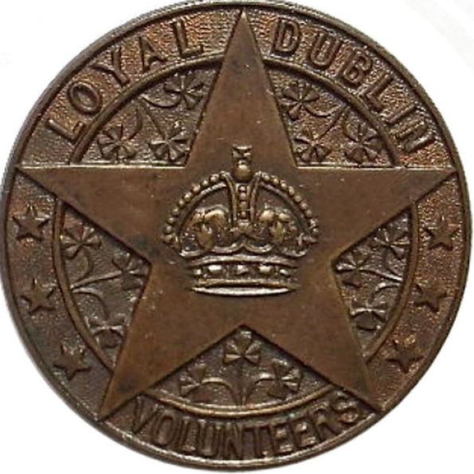
Loyal Dublin Volunteers Badge
News Letter
Wednesday 11 April 2012 08:37
By Quincey Dougan
IN June 1935, a Dublin Board of Works employee was among a group working at part of the Dublin GPO (General Post Office), the men having been assigned to remove presses from the cellar of the GPO Customs Parcels Section, located at 10 Parnell Square.
When several presses were removed however, some mortar appeared insecure, and when touched, collapsed. Upon further investigation the employee realised he had uncovered a large cavity several feet long. Within it, in perfectly dry conditions, lay a massive arms cache. He had discovered over 90 rifles and over 2000 rounds of ammunition.
The GPO, was of course, the iconic central location for the failed Easter Rising of 1916. Number 10 Parnell Square wasn’t a part of the main GPO building, but given the history of central Dublin in 1916, and indeed 1921, when the anti-treaty faction of the IRA occupied the building, the automatic conclusion would be that the weapons had belonged to Irish Republicans.
However the rifles found in the cellar were the UVF favoured weapons of Lee-Enfield and Martini-Henri, and were accompanied by packages of Bible tracts and cap badges. In actual fact, the weapons had belonged to the men of Dublin’s ‘Ulster Volunteer Force’, the Loyal Dublin Volunteers.
Number 10 Parnell Square (originally called Rutland Square) was known as Fowler Hall, named after Robert Fowler, the Archbishop of Dublin from 1779 until 1801. Prior to being forced out by the IRA it also was one of Dublin’s several Orange Halls. Dublin’s Orange history is well documented; even in 1914 there were still 11 lodges based in Fowler Hall. What is lesser known is the extent of how the city’s Protestant, Orange and Loyal community rallied against Home Rule.
In February 1912 at an anti-Home Rule meeting in Fowler Hall, Mr H.T. Barrie MP stated to a massive crowd of Dublin Orangemen that ‘the Loyalists of Ireland were going to stand or fall together’. All of the depth of feeling against Home Rule in Ulster was replicated in many areas further south, and with that feeling came the same determination to resist by all means necessary. The Ulster Volunteer Force had deliberately been constituted to consist solely of those of Ulster birth, it initially being a prerequisite that all members had to have signed the Ulster Covenant. This limitation meant that units outside it’s boundaries would be difficult to form. The Dublin answer was to form their own anti-Home Rule corps, the Loyal Dublin Volunteers.
At its peak the LDV boasted a membership of some 2000 men. Many were of Ulster birth, some 768 men and women signed the Ulster Covenant and Declaration within the city, but the vast majority were Dublin born and bred. From mid 1913 right up until the outbreak of the First World War the unit was drilling weekly under its commander Colonel Henry McMaster, also Dublin Grand Master of the Orange Order. Its commitment to opposition against Home Rule was every bit as staunch as its comrades in Ulster. As late as July 1914, a meeting in the Metropolitan Hall heard resolutions from the city’s Orangemen to ‘risk all in defence of their rights’ and calling on their leaders to take whatever steps they considered necessary. The same meeting heard how Dublin had a large body of ‘disciplined and armed’ Orangemen, full of ‘grim determination’. Those in attendance were told in no uncertain terms that the Loyal Dublin Volunteers would back up the Orange resolutions.
The same series of events unfolding in Ulster also affected Dublin however, and with the outbreak of war, massive numbers of the corps enlisted. Up to 80 members joined the Dublin ‘Pal’s Battalion’ almost immediately. What’s more interesting is despite the considerable distance to travel to enlist, many Loyal Dublin Volunteers joined their fellow ‘volunteers’ within the ranks of the 36th Ulster Division. A considerable number joined the 9th Battalion Royal Inniskilling Fusiliers (County Tyrone Volunteers), it having one entire platoon consisting of Dublin men. A William Crozier from St Stephen’s Green in Dublin applied for a commission to the 9th Battalion on the basis that he had drilled for 11 months with the Loyal Dublin Volunteers. Brigadier General Hickman endorsed the application, stating that: “This gentleman is quite the right stamp. If appointed he will be serving with and commanding some of the men he has trained during the last year.”
In September 1914 alone, 60 men are recorded as leaving Fowler Hall for Ballykinlar Camp to join the ‘Tyrones’.
The war signalled significant developments in the corps, with an estimated 600 of its 2000 members enlisting. As the emergence of an ‘Ulster’ solution to the Home Rule crisis became apparent, the determination of the men to ‘fight’ Home Rule understandably took a major blow. However the focus for their ‘fight’ simply changed, and at a general meeting of the organisation in August 1915, it was proposed that they affiliate themselves with the Irish Association of Voluntary Training Corps. To this end, 200 immediately signed up, effectively making the men a reserve army unit. They saw active service a lot quicker than they anticipated, and upon the outbreak of the Easter Rising they assisted troops from the Curragh in suppressing the violence. On the first day of the rising several Loyal Dublin Volunteers lost their lives.
When the Civil War between pro-treaty and anti-treaty elements of the IRA erupted in 1921, the Orange Order were forced out of Fowler Hall. Anti-treaty IRA seized the building as their headquarters, in the process destroying many important documents relating to both the Order and the Loyal Dublin Volunteers. This was to signal a de-facto Orange exodus from the city, with the last Orange procession in 1938 attacked as they made their way to board trains to Northern Ireland Twelfth demonstrations. Today the Loyal Dublin Volunteers are a relatively unknown organisation. The arms find of 1935 however, indicates very clearly the scale, professionalism and determination of these Dublin citizens some 20 years earlier.

