News Letter 18 March 2013

‘Unwise to block free speech law’ at Stormont - Lord Lester
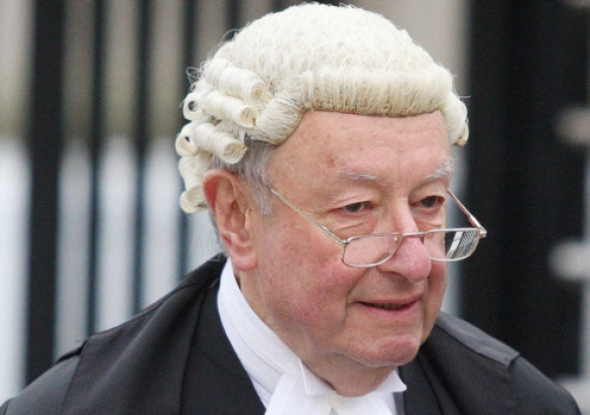
Lord Lester QC
By SAM MCBRIDE
ONE of Britain’s top legal minds has criticised Stormont’s decision to exclude Northern Ireland from a bid to strengthen freedom of speech.
Lord Lester of Herne Hill told the News Letter that the decision was unwise and he could think of no reason for Stormont blocking the Defamation Bill from Northern Ireland other than that politicians wanted “to be able to sue newspapers more readily”.
The Liberal Democrat peer and leading QC said that was not a good basis on which to formulate legislation.
Last Wednesday, the News Letter revealed that the Defamation Bill – the first reform of the UK’s libel laws since the 19th Century – had been blocked from extending to Northern Ireland by Stormont’s leaders.
However, the SDLP and Alliance Party have since said that they support the reform. And the SDLP said that the decision was not taken by the five-party Executive but by Peter Robinson and Martin McGuinness’ department.
Lord Lester – who initiated the libel law reform three years ago with a private member’s bill which won cross-party support and was then adopted by the Government – said that he could not understand Stormont’s decision.
Speaking to the News Letter from London at the weekend, the leading QC said of the decision: “Obviously, it will not be very wise or sensible.”
However, he added: “Under the devolution settlement, of course, it is for the Northern Ireland authorities, like the Scottish ones, to decide what they want to do.”
Lord Lester said that the situation was in some ways similar to Stormont’s decision to retain the common law offence of ‘blasphemous libel’ after it was abolished in the rest of the UK.
However, he added: “This would be a much more serious anomaly because it would mean that publications on both sides of the Irish Sea would have to comply with three different kinds of law; the modern code which has been worked on for three years on this side of the Irish Sea, the Irish Defamation Act itself in the Republic and the discredited common law in Northern Ireland.
“I can’t think of any good reason to do that, unless it’s because politicians in Northern Ireland want to be able to sue newspapers more readily, which doesn’t seem to me to be a very good reason.”
One of the problems which the Defamation Bill is aimed at solving is London’s reputation as the ‘libel capital of the world’, with foreigners using the British courts to sue foreign publications under the UK’s libel laws which are among the most punitive in the developed world.
Some observers fear that Belfast could take on that role if Northern Ireland remains the only part of the UK to keep the current Victorian laws.
Lord Lester said that prospect was “clearly possible and would be of great benefit therefore to a section of the Northern Irish bar but it was in fact a Northern Irish case which made me decide that we had to do something about the law.”
That case was an infamous 2007 decision by a Belfast jury to find the Irish News guilty of a £25,000 libel for a restaurant critic’s scathing review of a west Belfast pizzeria.
The decision – which if it had stood would have effectively ended all but the most complimentary food reviews – was eventually overturned on appeal but cost the newspaper a considerable sum.
Lord Lester appeared in court for the Irish News at the appeal but he pointed out that, although the paper was ultimately successful, the case had led the then Irish News food critic, Caroline Workman, to “give up entirely her profession as a journalist because of the way she had been treated”.
He said: “The whole experience convinced me, among other things, that we had to do something to reform our law. So, if that’s not done in Northern Ireland, it’s not going to be in the interests of the people of Northern Ireland who depend on the press as their eyes and ears in reporting matters of public interest.”
On Wednesday the DUP said in a statement that it was “not a matter of concern” that Northern Ireland would have significantly different libel laws to the rest of the UK, as “Scottish law will also be different”.
But Lord Lester said that was incorrect as there was a well-founded expectation that the Defamation Bill would be extended to Scotland. In October the Scottish Parliament passed a Legislative Consent Motion – the motion which Stormont blocked – to allow a section of the bill to extend to Scotland.
Earlier this week, leading Belfast lawyer Brian Garrett said that there had been “such a poor legislative programme” at Stormont and it seemed that the Defamation Bill “hasn’t been given any thought” by the Executive. He added: “That worries me.”
The News Letter approached OFMDFM for a comment on Lord Lester’s views but none had been received at the time of going to press.

News Letter Morning View on failure to extend libel law
NORTHERN Ireland has some of the most thin-skinned figures in public life in the UK.
It is not unusual for newspapers to experience threats to sue for alleged defamation on grounds that would be laughed out of court in London, despite the UK reputation as a soft touch for libel litigants.
Northern Ireland, in other words, is an even softer touch than Great Britain.
In one extraordinary incident in 2007, a negative restaurant review in the Irish News led to that publication being found guilty of libel.
The verdict, which was mocked by critics such as the late Michael Winner, was later overturned by a Northern Ireland appeal court.
It is likely that if a similar case ever came before Britain’s Supreme Court, the nation’s highest judges would enshrine the principle that negative reviews are fair comment or honest opinion, but this is not certain without further legislation.
The top QC Lord Lester tells today’s News Letter that the disturbing Irish News review episode helped persuade him of the need for a UK defamation bill.
It would protect the right to sue of anyone whose reputation has been seriously damaged, but it would ensure a fairer balance with free speech by reducing the scope of bullying or vexatious litigants to use the UK’s Victorian libel laws to rack up expensive costs with threats that even wealthy media outlets are frightened to contest.
Stormont could both show that Northern Ireland is not going to remain a soft touch on such matters and also remove any suspicion that its politicians are protecting their right to sue over minor insults by extending such legislation to the Province.

