Aristocratic rule? Unionism and Northern Ireland
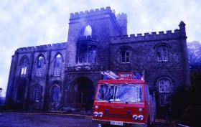
The burnt-out shell of Tynan Abbey, south Armagh, on 22 January 1981 following an IRA attack that killed 86-year-old Sir Norman Stronge and his only son, James. (Pacemaker)
On the night of 21 January 1981 the IRA broke into Tynan Abbey, south Armagh, and killed Sir Norman Stronge, eighth baronet, and his only son, James, before setting the 231-year-old mansion alight. Stronge, 86 at his death, had once been the Stormont MP for mid-Armagh (1938–69), fulfilling the duties of Speaker of the House of Commons for most of that period. James succeeded his father as MP until the prorogation of Stormont in 1972. Since then neither man had played an active role in unionist politics, although both remained members of the local Orange lodge, and James, a merchant banker, served in the reserve constabulary.
Reporting the incident—the latest in a long line of bloody tit-for-tat killings—the Irish Times remarked that Stronge had been ‘one of the ruling circle in Northern Ireland for more than 20 years’. It was a rather ambitious claim given that Stronge was never a government minister, but it did not seem unreasonable given the family’s social status. Eight generations of Stronges had lived at Tynan, many playing a role in Irish public life. Nevertheless, having retired from politics in the early 1970s, the Stronges appeared to have joined the ranks of many others in their class and bowed to the inevitable. Yet their association with unionism, as individuals and as a class, sealed their bloody fate a decade later. As the IRA claimed after the killings, ‘this deliberate attack on the symbols of hated unionism was a direct reprisal for a whole series of loyalist assassinations and murder attacks’. Why is it that the Stronges were symbols of unionism? The answer lies in their class background, and the historic prominence of that class within unionism.
Historic role
The Irish aristocracy and gentry, or ‘ascendancy’, had a long association with unionist politics. As landlords, a class long considered by some as ‘alien’, most were opposed to the political and economic aspirations of modern nationalism. If that was not bad enough, nationalists viewed them as Britain’s stooges in Ireland, its enthusiastic collaborators. Worse still, some blamed them for wooing Ulster’s Protestants away from their destiny as part of the Irish nation. The prominence of upper-class unionists in the government of Northern Ireland seemed to confirm this impression, and to demonstrate that they continued to exercise considerable power long after the demise of their class in the rest of Ireland. They supplied three of Northern Ireland’s six prime ministers. All three were loosely related and held the premiership successively for 28 years: Sir
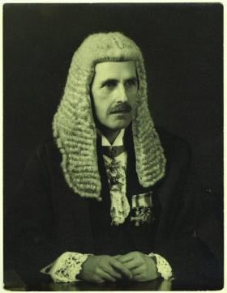
Sir (Charles) Norman Lockhart Stronge, eighth baronet, Stormont MP for mid-Armagh (1938–69) and Speaker of the House of Commons for most of that period. (National Portrait Gallery, London)
Basil Brooke (1943–63), Terence O’Neill (1963–9) and James Chichester-Clark (1969–71). Such figures were also present at ministerial level, including the seventh Marquess of Londonderry, the eighth Viscount Charlemont, the first Baron Glentoran (and third baronet), Colonel Samuel Hall-Thompson, Dame Dehra Parker and Phelim O’Neill.
Long before the creation of Northern Ireland, landlords had been highly prominent in loyalism. Orange grand masters hailed from the landlord class, including grandees such as the Earl O’Neill and the earl of Enniskillen. The aristocracy even supplied Orange folk heroes. The loyalist ballad ‘Dolly’s Brae’ recalls the pivotal role in 1849 of the third earl of Roden in a clash between Ribbonmen and Orangemen near his estate in County Down. William Johnston of Ballykilbeg and the fifth Baron Rossmore achieved a similar fame in 1867 and 1883 respectively.
Politically, landlords appeared to be instrumental figures in the creation and evolution of unionism, not only in southern Ireland but also in the north, where they were rivalled in wealth by Belfast’s industrialists. Colonel Edward Saunderson, a Monaghan landowner, helped to create and lead the ‘Ulster Party’ in 1886, a group of eighteen Tory MPs, ten of whom were landlords. Landlords were highly prominent at the 1893 Ulster Convention, and later again during the Ulster Crisis of 1912–14.
Power and influence
This image of continuity contradicts the commonly understood fate of European aristocracies in the twentieth century, including the Irish. So why was the north different? An obvious reason is that, by design, the majority of electors within the six counties were unionist. But this in itself does not explain why the landed élite continued to hold high office and enjoy local prominence. This is more puzzling given that histories of unionism explicitly state that landlord control ended well before the First World War.
These apparently conflicting stories of decline and continuity are easily reconciled if power is understood as influence rather than control. Landlords were never fully in control of unionism in the nineteenth century, despite appearances, and they did not completely lose their influence until the last decades of the twentieth century. The decline in their power is therefore less dramatic than is often supposed.
Opportunity knocks
Irish landlords had long been associated with unionism, but in the last two decades of the nineteenth century their political influence was diminishing—dramatically so in the south and west of Ireland, where nationalism swept aside old party allegiances. Landlords continued to represent Ulster at Westminster, but mainly for rural constituencies, and even here they were not without challengers. Belfast had been represented by businessmen and professionals since the mid-nineteenth century. In the countryside, landlords had to compete with Liberals, a party drawing its support largely from Presbyterian farmers. Maintaining landlord influence was made more difficult by franchise
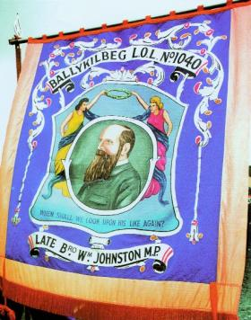
William Johnston of Ballykilbeg, one of several Orange folk heroes supplied by the aristocracy in the nineteenth century. (Neil Jarman)
reforms in 1868 and 1883, and the Secret Ballot Act of 1872. Ulster’s Tory MPs thereafter had to court popular ‘Protestant’ opinion, a task made more onerous by the watchful eye of the local press and demagogic preachers.
How, then, did landlords succeed by 1886 in placing themselves at the helm of Ulster unionism? The crisis surrounding the first Home Rule bill of 1886 had much to do with it, but the fact that landlords benefited most from this reflects their actions beforehand. Irish landlords had awoken to the dangers of Westminster legislating against their interests in the 1860s, when parliament passed land reforms benefiting tenant farmers and disestablished the Church of Ireland. The latter in particular pointed to the possibility that the Act of Union itself might be entirely repealed. Loyalists of all classes became increasingly vigilant. Ulster landlords with close connections to the government, regardless of whether it was Liberal or Tory, and those who had estates in Britain were no longer fully trusted. This risked not only their position but the political claims of all landlords.
As a result, in the early 1880s a cadre of smaller, locally based landlords—men such as Saunderson, Rossmore and Somerset Maxwell—manoeuvred to take control of the local Tory party out of the hands of the leadership at London. They achieved this through cultivating support among Orangemen, for recent electoral reforms made the harnessing of working-class support crucial to any aspiring politician. It also made it necessary to emulate the utterances of demagogues so that this new breed of political landlord appeared responsive to local concerns and prejudices. With their focus on local issues and relatively moderate wealth, smaller landlords had more in common politically with Belfast’s middle class than with titled grandees, many of whom were more concerned politically with national, international and imperial affairs.
Having made these alliances, and having hatched a deal at the 1885 general election with northern nationalists to squeeze the Liberal vote, a new group of landlord leaders assumed control of what emerged as Ulster unionism. The loyalist credentials of Liberals had already been undermined by Gladstone’s conversion to Home Rule. The Tories were now the political party of loyalism, and untitled landlords like Saunderson were its leaders. They moved to secure these developments by creating the Ulster Loyalist Anti-Repeal Union (ULARU) in January 1886. The honorary position of chairman was given to the fifth earl of Ranfurly (later governor of New Zealand), but it was men like Saunderson who coordinated the new organisation, with the professional help of Belfast Tories. The following month the ULARU invited Lord Randolph Churchill to speak at the Ulster Hall, Belfast. Churchill was a leading advocate of ‘Tory Democracy’, and his vague pledge to loyalists that the establishment would come to their rescue confirmed the ascendance of this new breed of aristocrat politician.
The burdens of leadership
To maintain their leadership over pan-Protestant loyalism, landlords like Saunderson had to accommodate Ulster Liberals. Like Liberal Unionists in Britain, Ulster Liberals were prepared to join forces with the Tories but did not give up their independence. There was always the risk, therefore, that they might again split the unionist vote,
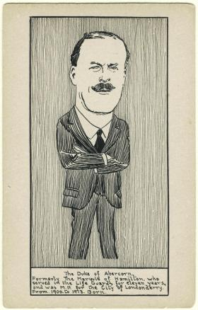
The third duke of Abercorn, first governor of Northern Ireland. (National Portrait Gallery, London)
especially on an issue that commanded considerable support in rural Ulster. When the ‘Unionist’ government at Westminster instituted a series of land reforms from the mid-1880s, the landlord leaders of Ulster unionism were torn between personal hostility to such legislation and their commitment to lead all unionists. Ulster Liberals supported the reforms and resented attempts by Ulster’s MPs to amend the various bills placed before parliament. This undermined the popular credentials of landlord MPs, and reduced their power as a consequence. Ironically, however, their inability to prevent the Unionist government’s reforms ensured that they were not all deselected as MPs at the next opportunity.
Saunderson and his fellow landlords therefore remained the leaders of unionism in Ulster, reluctantly acquiescing in Unionist-inspired land reforms and, in 1898, the creation of Irish county councils. But if they were not pushed out of their leadership positions, then their retirement, resignation and death created vacant seats for more ‘representative’ men, a relative term in the late nineteenth century. This development was evident at the Ulster Convention of 1893, an orchestrated attempt to emphasise the cross-class basis of the movement, at which prominence was given to MPs and councillors from business and the professions, as well as landlords.
The 1904 devolution crisis
The British Unionist party at Westminster had served many Ulster unionists well, with Irish land reform, the defeat of the second Home Rule bill in 1893, and its tough attitude in government to agrarian disturbances. This helped to quell criticisms within Ulster unionism about its local leadership. The increasingly sectarian atmosphere at the turn of the century created new problems for the movement, however. In response to the reunification of the Irish Parliamentary Party in 1900 and the growth of the Irish-Ireland movement, the Orange Order grew significantly in size, with some Orangemen courting controversy by adopting a more vigorous attitude to parading. Around the same time, the maverick Ulster Liberal Thomas Russell threatened to split the unionist vote at the 1900 general election through his renewed campaign for land reform.
Flickers of discontent with the Unionist leadership grew into sparks in 1903. That year, at the Belfast ‘Twelfth’, the firebrand leader of the Belfast Protestant Association, Thomas Sloan, publicly accused Saunderson and other leading figures of secretly collaborating with Dublin Castle in prohibiting controversial Orange parades. As a result of this humiliation Saunderson resigned as grand master of the Belfast Orangemen. Insult was added to injury when Sloan afterwards defeated the official Unionist candidate, Lord Arthur Hill, at a Belfast by-election called following the death of Johnston of Ballykilbeg.
Unionism appeared to be in great difficulties, largely as a result of inadequate leadership. But without any pretext it was difficult for any radical change to be implemented. Such an opportunity was provided by the so-called ‘devolution crisis’ of 1904. A group of Unionists hailing from business and the professions—including Charles Craig, J. B. Lonsdale and William Moore—deliberately inflated rumours that Dublin Castle was considering a scheme of devolution. This allowed them to claim that their restructuring of Ulster unionism was a response to an external crisis rather than to internal difficulties. In the winter of 1904–5 they established the Ulster Unionist Council (UUC), an assembly of 200 delegates controlled by an executive council. The standing committee of the executive council contained in roughly equal numbers men from the professions, business and land. It would determine policy and coordinate the wider movement, all the time receiving the sanction of an assembly designed to contain all shades of unionism. As a result, Saunderson remained ‘leader’ until his death in 1906, when he was succeeded as figurehead by another gentry MP, Sir Walter Long.
Respectable rebels
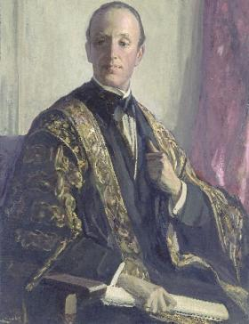
The seventh marquess of Londonderry, Northern Ireland’s first minister for education. (Ulster Museum)
The establishment of the UUC ensured that landlords became an asset rather than a liability to Ulster unionism. Their wealth, their prominence in rural districts, their contacts with British politicians and, for some, their seats in the House of Lords ensured that landlords remained highly useful figures. Their continued importance did not go entirely unquestioned, especially after some refused to oppose the 1911 Parliament Act, thus removing the power of the House of Lords to veto an imminent Home Rule bill. But many aristocrats made up for this by taking a prominent role in the militant displays of unionist defiance that followed, providing an element of respectability to an increasingly unconstitutional strategy.
One aspect of this involved the creation of a ‘provisional government’ should Home Rule be enacted. Landlords supplied some of its leading members, including the third duke of Abercorn, the sixth marquess of Londonderry, the third earl of Kilmorey, the sixth Viscount Bangor, the second Baron Dunleath and the Hon. Arthur O’Neill MP. These men, and others like Sir Basil Brooke and Oliver Nugent, were also involved in the Ulster Volunteer Force (UVF), the militia raised to emphasise the UUC’s resolve to oppose Home Rule. Many had military experience, and some allowed their estates to be used as training grounds. Landed influence over the UVF should not, however, be exaggerated. Historians argue that the UVF was established by the UUC to control potentially violent elements of its support base, and recent scholarship suggests that the majority of its officers came from far humbler backgrounds than is often supposed.
The First World War supplied a timely opportunity for unionists of all classes to demonstrate their loyalty to the Crown. But the loyalty of the landed class to the interests of Ulster Protestants once again came into doubt in the wake of the 1916 Easter Rising. A deal granting Ireland immediate Home Rule, excluding the six north-eastern counties, was supported by the majority of the UUC. But landlords with connections to southern and western Ireland, especially those in the three frontier counties of Ulster, were unhappy with what they regarded as a betrayal of unionists in the rest of Ireland. Most, however, reluctantly sided with the majority, and did so again in 1920 when the UUC once more considered six-county exclusion. In doing so, Ulster’s landlords had not only agreed to the establishment of a parliament for Northern Ireland but also secured their own place within its chambers.
A warm house for aristocrats
Landed families that played a prominent role in the pre-war mobilisation found the provincial parliament to be a warm house for their progeny. The sixth marquess of Londonderry’s son was appointed to the cabinet in 1921. His son, Viscount Castlereagh, was later elected unopposed to Westminster for County Down in 1931. The third duke of Abercorn became the first governor of Northern Ireland. His son, the eventual fifth duke, was in 1964 elected to Westminster as the Unionist MP for Fermanagh and South Tyrone. The family of Arthur O’Neill produced MPs for mid-Antrim until the 1960s; the last of them, the Hon. Terence O’Neill, became the fourth prime minister of
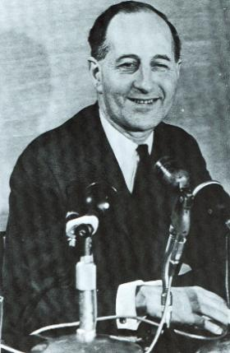
Terence O’Neill became Northern Ireland’s fourth prime minister more for his reputation as a technocrat and moderniser than for his aristocratic status. (Pacemaker)
Northern Ireland. Landed influence tended to linger longer in the socially conservative townlands of rural Northern Ireland, where the economic and educational status of the landed élite marked them out as natural leaders. One such family, the Brookes of County Fermanagh, prominent in local politics from the eighteenth century, supplied Northern Ireland’s third prime minister.
Limited influence
The high-level presence of aristocrats in the Belfast government should not disguise the limits of their power as a class. Hugh Shearman’s novel The bomb and the girl (1944) tells of the fictional Lord Drumbo’s determination to see his son adopted as the Unionist candidate for a by-election, and how his plan comes unstuck once locals learn of the son’s appearances in court in connection with ‘fast cars and fast women’. The aristocracy were certainly at home in Northern Ireland but they did not exercise the untrammelled power their forebears once had. Successive phases in the growth of democracy had curbed their influence in both town and countryside, and meant that only those who were able to successfully adapt could survive as politicians.
With many having achieved this within Ulster unionism, it is not surprising that members of the landed élite should be found in the provincial government alongside men representative of other wealthy and powerful interest groups. They were present, therefore, but landed influence was limited. The Northern Ireland cabinet, like Stormont, was overwhelmingly middle-class in composition, with working-class and upper-class Unionists largely confined to the relatively powerless senate, or ornamental positions such as governor and speaker. Aristocratic status failed to help Sir Basil Brooke, later Viscount Brookeborough, in his attempt from the early 1950s to move away from the strident loyalism he had previously espoused—he soon gave up, following howls of protest from militant Unionists and evangelical preachers. And aristocratic status, despite the claims of some critics, had little to do with the appointment of Brookeborough’s successor, O’Neill, whose victory over a rival reflected the latter’s unpopularity and O’Neill’s reputation as a technocrat and moderniser. If any ‘class’ benefited from O’Neill’s premiership it was the recently enlarged middle class.
For many aristocrats and gentry the Troubles were an unmistakable sign that their influence had completely evaporated; their sense of resignation was memorably captured by the Belfast poet John Hewitt in his ‘An Ulster landowner’s song’ (1971). Their presence within unionism stretched back to the nineteenth century, and they had always had to contend with some who challenged their status and influence, particularly during periods of crisis. But the political violence and bitter splits within unionism unleashed by the Troubles were simply too devastating a challenge for those willing to fight. James Stronge took an equivocal position in the early 1970s, refusing to side with any faction of unionism. Instead, he engaged in what the Irish Times called ‘a spot of merchant banking and a round of social life’, later joining the police reserve. He nevertheless remained, until his death, a symbol of unionism.
Neil C. Fleming lectures in Modern History at Cardiff University.
Further reading:
D.G. Boyce and A. O’Day (eds), The Ulster Crisis, 1885–1921 (Basingstoke, 2006).
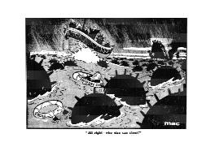
‘All right—who else can steer?’ O’Neill and
Chichester-Clark drowning in a cartoon by ‘Mac’, Daily Sketch, 1 January 1971. (British Cartoon Archive, University of Kent)
N. Fleming, The Marquess of Londonderry (London, 2005).
G. Walker, A history of the Ulster Unionist Party (Manchester, 2004).
F. Wright, Two lands on one soil (Dublin, 1996).

