News Letter Review: The nationalist narrative on Northern Ireland is challenged by writers in this badly needed book

A collection of essays is a welcome counterpoint to hostile histories of the Province, writes OWEN POLLEY:
Wednesday, 17th June 2020
By Owen Polley

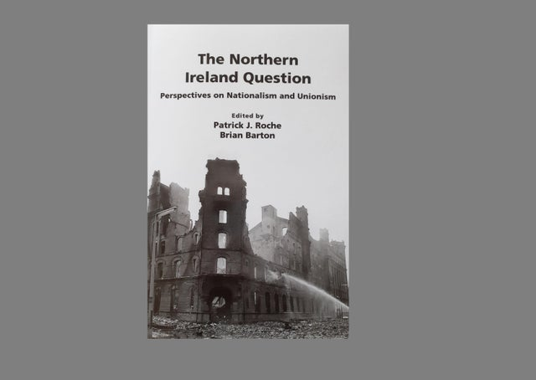

The Northern Ireland Question: Perspectives on Unionism and Nationalism
edited by Patrick J Roche and Brian Barton

Wordzworth Publishing, £15.99

"The authors marshall the evidence impressively, to provide a counterpoint to more cliched accounts of our story," writes Owen Polley
This is the latest book in a series edited by Patrick J. Roche and Brian Barton that challenges persistent myths about the history of Northern Ireland and its Troubles.
The timing is important, because we can expect the centenary of partition in 2021 to see a deluge of literature attacking the right of this part of the United Kingdom to exist.

Many of the essays in Perspectives on Unionism and Nationalism deconstruct accounts of Northern Ireland’s past that are grounded on hostility to its creation and survival.
They achieve this with precision and marshall the evidence impressively, to provide a counterpoint to more cliched accounts of our story.
When six counties of Ulster became a unique political entity in 1921, it was against a backdrop of violence and insurrection in the rest of Ireland.
In the book’s opening chapter, which is one of its best, Brian Barton explains how the “traumatic experience of this formative period left an indelible mark on the institutions and cohesion of the state”.
If unionist governments in Northern Ireland acted defensively, sometimes to their detriment, it was because they were subjected to spite and violent assaults from the very beginning.
Barton traces this rancorous atmosphere back to the Easter Rising of 1916, which “generated a culture of rebel martyrdom and national victimhood”.
The revolt showed nationalists that “out of rebellion more had been got than by constitutional methods,” particularly when the government in London responded by “veering unhappily between coercion and conciliation”.
Nationalist historians imply that unionists refused unreasonably to take up their pre-ordained place in the Irish nation, but they were subjected to the bitterest abuse by its architects.
De Valera described Protestants in the northeast as, “‘planters’, ‘an alien garrison’ and threatened that if they were obstructive ‘we will have to kick them out’”.
After Northern Ireland was founded, the new administration in Dublin sponsored the IRA’s 1922 campaign, in an attempt to make it ungovernable.
Michael Collins, who chaired the provisional government, was also seeking to avoid civil war in the south, by bringing pro and anti-Treaty republicans together in opposition to partition.
In response, for the most part London left Craig’s Stormont administration to manage its own security response.
Barton argues that when unionists are accused of having a ‘siege mentality’, it should be understood in the context of these initial assaults on Northern Ireland, as well as the longer lasting refusal of nationalists to engage with its institutions and sporadic outbursts of IRA violence that continue even to the present day.
It’s a theme developed in essays by Graham Walker and Patrick J. Roche.
Walker reflects on Northern Ireland’s experience as ‘devolution pioneers’ within the UK. He delivers a nuanced assessment of unionist government, acknowledging that ministers mishandled civil rights by stalling on reform, but he dismisses the worst allegations of discrimination and notes that “Ulster unionists had a siege mentality but there were also besiegers”.
Roche’s chapter is a devastating critique of Irish nationalism’s relationship with terror in Northern Ireland.
He picks apart claims that partition is unjust because the island of Ireland obviously constitutes ‘one nation’.
He finds that these assertions don’t meet the traditional criteria used to establish national identity and argues that “partition was a recognition of pre-existing division”.
Roche is particularly effective as he dismantles constitutional nationalism’s ambiguous attitudes to republican violence.
“The realpolitik of the SDLP,” he writes, “was that the way to end IRA terrorism was to concede the political objectives of the IRA which were also the objectives of the SDLP.”
In a chapter co-written with Andrew Charles, Roche then charts the foundation and development of the civil rights movement in Northern Ireland, and its link to the start of the Troubles.
The authors find that its formation was directed by “the combination of Marxism and traditional Irish nationalism that informed 1960s republican thinking.”
Unionists’ suspicions that the movement was motivated by hostility toward Northern Ireland were therefore not unreasonable.
Graham Gudgin contributes a tightly-evidenced chapter analysing allegations of discrimination against Catholics in employment and housing in Northern Ireland. He concludes that “discrimination was never as important in social and economic terms as it was made out to be”.
William Matchett explores counterinsurgency strategies deployed against paramilitaries in Northern Ireland, highlighting the central role of intelligence-led policing and the RUC Special Branch in defeating the IRA.
Since the Belfast Agreement, the security forces, who sowed the seeds of peace by out-manoeuvring terrorism, have become scapegoats while the insurgents are cast as ‘peace-makers’.
On a similar note, Cillian McGrattan examines how unionist and even impartial memories of the Troubles are being written out of history, due to the perceived imperative of “bringing violent republicans into the political process”.
Alongside this ‘organised forgetting’, an implicitly biased legacy process underwrites republican ‘truth creation’.
This lack of truthfulness is also a theme of Robin Bury’s essay, distilling the arguments in his book ‘Buried Lives’, which examined the fate of Protestants in the Free State / Republic of Ireland.
Meanwhile, Arthur Aughey asks how ideas that Northern Ireland’s destruction is inevitable, and indeed ideas that its survival in its current form is inevitable, shape contemporary politics.
The inevitability thesis is explored further as Esmond Birnie subjects “the economics of nationalism and unionism” to expert scrutiny and finds both wanting.
He demolishes case by case the arguments that Northern Ireland would be better off if it were absorbed by the Republic of Ireland, showing that they are based on wishful thinking and wildly improbable assumptions.
Importantly, though, he also highlights the risks for unionism of being too reliant on injections of money from Westminster.
He argues that our political parties are too wedded to spending money in the short-term, rather than investing it for longer term economic benefit.
This excellent collection of essays deserved to finish strongly, but unfortunately the last chapter, by Dennis Kennedy, is the book’s most superficial.
It canters through Northern Ireland’s post-1998 history, offering some useful insights into the effects of the Belfast Agreement.
However, it barely examines the text at all, instead placing the same reliance on context and commentary that has allowed that document to become a charter for nationalist demands.
And when Kennedy casually asserts that two countries (the UK and the Republic of Ireland) ‘found common cause in fighting the IRA during the Troubles,’ he undercuts detailed accounts earlier in the book of the Dublin government’s role in providing a safe haven for terrorists.
That can’t take away from a book that otherwise is robust, closely argued and badly needed.
These essays don’t pretend to comprise the definitive, fair-minded history that Northern Ireland’s centenary deserves, but they may be as close as we get.
https://www.newsletter.co.uk/news/opinion/columnists/review-nationalist-narrative-northern-ireland-challenged-writers-badly-needed-book-2887149

