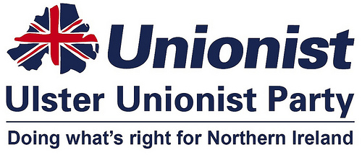
Press Release

TUESDAY 28 FEBRUARY 2017
RELEASE: IMMEDIATE

Ulster Unionists call for early decision on future of Minnowburn House

Michael Henderson, Ulster Unionist Party candidate for South Belfast, has called for urgent action to deal with the derelict former elderly residential home at the edge of the Belvoir estate which has “become a major eyesore and a significant blot on the landscape”.

The former Minnowburn House on Old Milltown Road has lain empty for a considerable period of time. Owned by the Belfast Health Trust, this extensive complex of flat-roofed buildings is boarded up and has been awaiting a new future since the opening of the Knockbracken Healthcare Park.

Alderman Michael Henderson said:
“I know the Trust has options in mind, but if they come to nothing, the site would be a perfect spot for more social housing, given the current waiting list of 250 for the Belvoir and Milltown area - 120 of whom are single people or pensioners.

“The building has acted as a magnet for anti-social behaviour. This has meant vandalism and noise problems for nearby residents as well as representing a major fire risk.”
Cllr. Jeffrey Dudgeon who represents the area added:
“Sites in South Belfast such as these represent not only potential dangers for nearby communities but opportunities to provide much needed social housing, once demolished or redeveloped. I urge the Belfast Trust to make an early decision on its future, recognising the current money being wasted for rates and security.”

ENDS
Ulster Unionist Party Press Office

https://www.facebook.com/JeffreyDudgeonforBalmoral/photos/a.645927415477907.1073741828.638305392906776/1440966459307328/?type=3&theatre
Michael Henderson, the Ulster Unionist Party candidate for South Belfast has called for “urgent action to deal with a derelict elderly persons residential home at the edge of the Belvoir estate which has become a major eyesore and a significant blot on the landscape”.
The former Minnowburn House on Old Milltown Road has lain empty for more than five years. Owned by the Belfast Health Trust, this extensive series of flat-roofed buildings is boarded up and has been awaiting a new future since the opening of Knockbracken Healthcare Park.
Alderman Henderson said, “I know the Trust has options in mind, but if they come to nothing, the site would be a perfect spot for more social housing, given the current waiting list of 250 for the Belvoir/Milltown area - 120 of whom are single people or pensioners.
The building has acted as a magnet for anti-social behaviour attracting squatters and transient youth. This has meant vandalism and noise problems for nearby residents as well as representing a major fire risk.”
Cllr. Jeffrey Dudgeon (UUP) who represents the Belvoir area added, “Sites in South Belfast such as these represent not only potential dangers for nearby communities but opportunities to provide much needed social housing, once demolished or redeveloped. I urge the Belfast Trust to make an early decision on its future, recognising the current waste of money in needless security and empty building rates.”

