Retired police officers have welcomed an apparent DUP commitment that no former RUC members should face investigation for ‘non criminal misconduct’.

News Letter

30 November 2019
A UK government legacy proposal, based on the Stormont House Agreement, would have left police alone subject to such investigations.
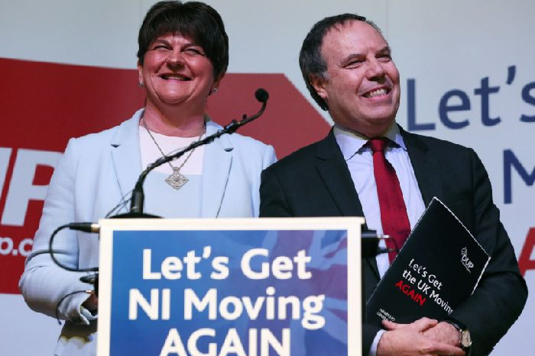

DUP leader Arlene Foster and the party's Westminster leader Nigel Dodds at the DUP's General Election manifesto launch at W5 in Belfast.
The probes would have been applicable in allegations against the RUC, even without evidence pointing to criminal conduct or breaches of existing legislation. The controversial plan angered many former officers, victims’ groups and politicians such as in the UUP.
There had been long-standing concern, including among contributors to the News Letter Legacy Scandal series of essays, that the DUP had not taken a tough enough line in opposing the new legacy proposals, which also include the creation of new Historical Investigations Unit (HIU) with full police powers.
However, speaking at the DUP’s manifesto launch in Belfast on Thursday, party leader Arlene Foster moved to allay fears. In her party’s hardest-hitting rejection to date of aspects of the legacy plan, Mrs Foster said the main focus should be on those who killed 90% of the Troubles victims, and on getting truth and justice for those victims’ families.
In response to a question from the News Letter about the DUP legacy stance, she said: “We are very clear that any historical investigations unit should not have the power to look at non criminal actions by former police officers.
“The ombudsman does not have the power to do that, why in heaven’s name would any unit that was constructed have the power to do that?”
The chair of the NI Retired Police Officers’ Association (NIRPOA), Ray Fitzsimons, said: “We welcome the statement from Mrs Foster this, morning in response to the question from the News Letter, and we look forward to further discussion with the DUP leadership.”
However, Mr Fitzsimons added: “There are further assurances we are seeking in relation to legacy issues.”
A number of unionist representatives and political commentators have expressed concerns in recent days that new legislation – including the creation of the HIU and the offence of ‘non criminal police misconduct’ – will be fast-tracked through Parliament.
The NIRPOA has also previously spoken out against the new Historical Investigations Unit with full police powers, as has the Police Federation for Northern Ireland.
Writing in the News Letter earlier this month, federation chair Mark Lindsay described the government’s legacy bill as “toxic and unacceptable”.
He said: “The proposed legislation has the potential to put officers in the dock and demonise them for how they policed Northern Ireland during a vicious and protracted terrorist campaign.”
Mr Lindsay added: “In our evidence [to the NI Affairs Committee], we told MPs that the legacy bill was perverse because it sought to equate the actions of murderers and bombers with the actions of those who worked tirelessly and courageously to bring them to justice and create the conditions for peace.”
This week, Ulster Unionist peer Sir Reg Empey said the sweeping powers of the HIU would be “used for a witch hunt” of former members of the security forces.
He said: “I appeal to the DUP to abandon the idea of a parallel police force to carry out such investigations.
“The DUP has now moved its position to have a UK-wide body to do this. That is just as wrong as having it confined to Northern Ireland.”
Ulster Unionist MLA Doug Beattie said: “The proposed new charge of non criminal misconduct against RUC officers – even deceased officers — will allow reputations to be destroyed, even though no criminal offence has been committed.”
Also addressing the NI Affairs Committee earlier this month, former assistant chief constable Chris Albiston, said: “We do not see any mention anywhere of non-criminal politicians’ misconduct or non-criminal civil servants’ misconduct or non-criminal military misconduct, or non-criminal terrorist misconduct, so why mention non-criminal police misconduct?
“Because the legislation has been drafted to satisfy the agenda of a particular political grouping within Northern Ireland, and we object to it.”
The DUP response to the government’s consultation on legacy last year raised concerns about the police misconduct element, but was less emphatic than Mrs Foster’s comments yesterday.
That submission said: “Investigations into retired officers should be for criminal behaviour. It would be an overhaul of established practice for civilians to be pursued for alleged disciplinary matters as public servants, when retired or deceased. Retired officers deserve the same protections to ensure procedural fairness as anyone else. They should be entitled to independent legal advice.”
The submission added: “There is no detail on what government is intending to capture under the term, non-criminal police misconduct, referenced liberally throughout the consultation documents. However a host of offences are already available on the statute books for significant misconduct.”
In response to a question from the News Letter about the DUP legacy stance, she said: “We are very clear that any historical investigations unit should not have the power to look at non criminal actions by former police officers.
“The ombudsman does not have the power to do that, why in heaven’s name would any unit that was constructed have the power to do that?”
Mrs Foster said: “We will not support anything in a legacy legislation that will damage innocent victims or cause them re-trauma.”
She also said: “On a very fundamental and basic level why would we impose something on the victims here, the innocent victims, which they didn’t support? And we will not be supporting something that innocent victims do not support as a way forward, that is a very fundamental point for us and something which we continue to talk to innocent victims about and as you have referenced the police.”
Mrs Foster said she will continue to engage with the NIROPA and other stakeholders . “It is important to emphasise 90% of those who lost their lives lost their lives as a result of paramilitarism and therefore we should be concentrating in how we get to the truth about those issues, and that is very important for us as well.”
Mrs Foster’s comments on legacy were warmly applauded by party members.

News Letter
30 November 2019
Ben Lowry: The scandal of ex RUC officers alone facing legacy ‘misconduct’ investigations got no almost scrutiny outside this newspaper

Ben Lowry
Saturday 30 November 2019

Imagine you wanted to destroy the record of the UK’s response to the Troubles.
You would not go after the army, the largest branch of the security forces, but after the RUC. Veterans are a far larger constituency than ex police officers.
More than 100,000 soldiers served in Northern Ireland during Operation Banner. Hundreds of thousands more ex servicemen and women who did not spend time in the Province support those who did. And tens of millions of people across the UK intuitively feel solidarity with veterans.
The ex RUC, however, is a much smaller and less influential constituency of, perhaps, 25,000 people.
The name of that former force has diminishing recognition among younger folk here, let alone among people in Great Britain.
So it is easier hound the security forces by targeting RUC before army. The former are most vulnerable in Stormont House Agreement legacy structures, because they alone face investigations for ‘non criminal police misconduct’.
This is not to suggest that most of the many architects of Stormont House in 2014 were out to ‘get’ the RUC. While some republicans are determined to chase the state, other people of goodwill from multiple perspectives did try to reach a fair compromise on legacy. But that does not mean they got it all right.
Under the mooted structures for tackling the past, terrorists who blew off people’s limbs or blinded or paralysed them, or destroyed businesses, do not face investigation unless they killed someone.
Soldiers who beat people up or behaved with excessive force when raiding homes will not face misconduct investigations either.
The army, despite its vital and widely appreciated role in preventing civil war here, has more to answer in terms of legacy than the RUC. Around 200 of the 360 state killings were by soldiers pre 1975. By then the military was becoming better trained for our conflict.
The RUC killed 55 people overall.
It ought to have been a self-evident outrage that the RUC would be singled out for ‘misconduct’ investigations given its record
Essays in our legacy scandal series (see link below) by people such as the lawyer Neil Faris or ex assistant chief constable Chris Albiston or the Ulster Unionist Jeff Dudgeon explained the injustice. Yet outside this newspaper, no media outlet took an interest in the scandal.

Ben Lowry: Perhaps some nationalists will admit that using Irish signage in places where it is unwanted hinders call for a language...
All media reported on the fate of veterans, which were widely mentioned at Westminster, including by Northern Ireland MPs, yet there was little focus on the coming trashing of reputations of ex RUC officers, including dead ones.
The trial of low-level soldiers for single shootings has caused widespread anger in the absence of trials of IRA leaders who orchestrated decades of terror. Yet who in the IRA army council faced a trial commensurate with their bloodshed?
You can see why the public might perceive there to be little appetite in the wider establishment to go after such leaders when dignitaries, including people in the political, justice and security worlds, were at the funeral of a long untouched IRA mastermind, Martin McGuinness.
But all the talk about persecution of veterans merely hastens the day that an amnesty for everyone is pushed through, while sub criminal inquiries into state forces continue via republican civil actions (lavishly funded by UK legal aid), inquests (costing tens of millions of pounds, including a huge Ballymurphy inquiry) and probes into the police.
Meanwhile, the plan for police misconduct probes sailed on towards the statute books without comment outside these pages.
When three academic supporters of Stormont House appeared before the NI Affairs Committee, MPs failed to scrutinise the legacy plan that the academics were defending. A single question to the trio about police misconduct was not followed up with more queries.
This week, the DUP made clear (in response to a question from me at their manifesto launch, see link below) they do not back police misconduct probes.
If misconduct investigations go ahead, a force that killed 55 people faces hundreds of claims, which would overwhelm legacy investigators with claims of collusion.
Over the years the public would lose sight of a key stat, that the state killed 10% of the dead, police least of all. They would assume there was widespread loyalist collusion, as indeed many people do now assume.
And they might well not ask, or even wonder, why then loyalist intelligence was so poor?
Or why so few of the most violent republicans, well known to the state, got killed?
Ben Lowry (@BenLowry2) is News Letter deputy editor
Ben Lowry: I hope RTE apology to Kevin Myers is beginning of his rehabilitation
DUP rules out support for plan to chase RUC for misconduct
Legacy scandal series of essays
Ben Lowry: Using Irish signage in places where it is unwanted hinders call for a language act

