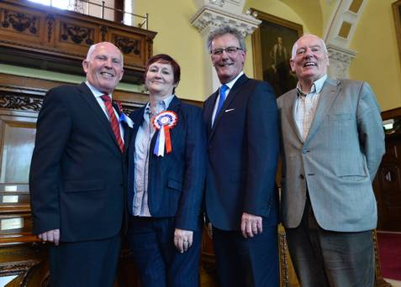
UUP's Jim Rodgers and Sonia Copeland pictured with party leader Mike Nesbitt and Jeff Dudgeon

